Impact Assessment Study on the simplification of labelling requirements for chemicals and the use of e-labelling
For the European Commission – carried out by VVA

Organisation: | A.I.S.E.
Date of interview: | 16 April 2021
Name of interviewee: | Jan Robinson | Giulia Sebastio | Valérie Séjourné
Job title /Position : | Scientific & Regulatory Affairs Director | Scientific & Regulatory Affairs Manager | Director Communications & Stakeholder outreach
Email: | Jan.robinson@aise.eu | Giulia.sebastio@aise.eu | Valerie.sejourne@aise.eu

1) Introduction

Question 1 : Please give us a short introduction about you and how your work relates to the study topic.
The “International Association for Soaps, Detergents and maintenance products” (A.I.S.E.) has been representing the detergents and maintenance products industry in Europe to EU regulators for over 65 years. Through its extensive membership network of 29 national associations, 18 corporate members and 13 value chain partners, A.I.S.E. represents over 900 companies supplying household and professional cleaning products and services across Europe. A.I.S.E. has a long history in leading voluntary industry initiatives that focus on sustainable design, manufacturing and consumption, product safety and safe use of products by consumers and professional customers. Based in Brussels, A.I.S.E. is the key industry body providing industry’s expertise to EU policy makers on regulatory matters; its role is also to support its members in the adequate implementation of such regulations. www.aise.eu and its consumer portal www.cleanright.eu

Jan is leading a team of 5 persons involved with all regulatory developments in A.I.S.E. (eg CLP, Detergent Regulation, REACH, Biocides, Chemical Strategy for Sustainability). She holds this position since Feb 2020. Before that Jan worked for over twenty-five years in the coatings industry, the last ten years for its European sector association in Brussels. Jan has been chair of DUCC (the Downstream Users of Chemicals Coordination Group, www.ducc.eu), since January 2016, and has extensive experience of working with EU institutions and agencies and with national authorities, both at EU level and in United Nations Sub-Committees of Experts.

Giulia is in charge of various dossiers in A.I.S.E., notably the Detergent Regulation and related activities (e.g. roadmap on fragrance allergens), REACH, risk assessment tools, air quality, Enzymes safe use, ingredient messaging and digitalisation. She is in A.I.S.E. since April 2018. Her background is in Chemistry, with former experiences in both technical roles and regulatory affairs across the sectors of food, agrochemicals and pharma in industry and academia.

Valérie is leading the 3-persons communication team in A.I.S.E. and has been in the association since 1997. She has had various positions there, managing also various voluntary initiatives related to sustainability and is in charge of all consumer related projects & campaigns (for the safe and sustainable use of products), including consumer research. She is in charge of the consumer portal cleanright.eu and works with her 2 colleagues above in the A.I.S.E. Digitalisation WG. She took part in the creation of the BRES project (Better Regulation and Safe use- which was started back in 2005 in A.I.S.E., in the scope of this study).

Question 2 : According to your knowledge, are there any overlaps or inconsistencies in the current legal provisions that regulate the communication of hazard and safety information and the instructions for use to product users in the CLP Regulation and Detergents Regulation? If yes could you please explain? Which stakeholder category do they cover?

Answer:
The implementation of the Detergent Regulation since 2004 has been a success particularly in terms of environmental protection (biodegradability of surfactants and phosphates-free formulations).
Nevertheless, new horizontal pieces of legislation governing the chemicals sector and subsequent labelling have been adopted in the meantime: REACH in 2006, CLP in 2008 and Biocidal product
regulation in 2012. This has resulted in several provisions that are indeed overlapping in particular in terms of redundant labelling provisions for ingredients (e.g. surfactants), allergenic fragrance substances and preservatives.

These conclusions are also clearly outlined in the Commission CLP Fitness Check study (https://eur-lex.europa.eu/legal-content/EN/TXT/PDF/?uri=CELEX:52019DC0264&from=EN ), as well as in the Staff Working Document on Detergent Regulation (https://ec.europa.eu/docsroom/documents/36289 ).

As A.I.S.E., we have also been showcasing notably in 2018 during the Cleaning & Hygiene Forum and with the European Commission Detergent Working Group in Dec 2018. All stakeholders (EU and national authorities) were supportive of the fact that opportunities for improvement existed and that a holistic approach to labelling and improvement should be sought. A.I.S.E. also presented these overlap issues at a meeting of the Products Safety committee of the consumer organisation BEUC and there was some interest in helping address these overlaps and inconsistencies.
The material that A.I.S.E. has developed to illustrate these issues can be observed via:
- ANNEX 1_PDF overview laundry label elements_Dec2018
- ANNEX 2_Poster laundry (and corresponding excel file)
- ANNEX 3_PDF Hygienic cleaner (and corresponding excel file)
- ANNEX 4_WORD doc highlighting the various label elements and thresholds (current)

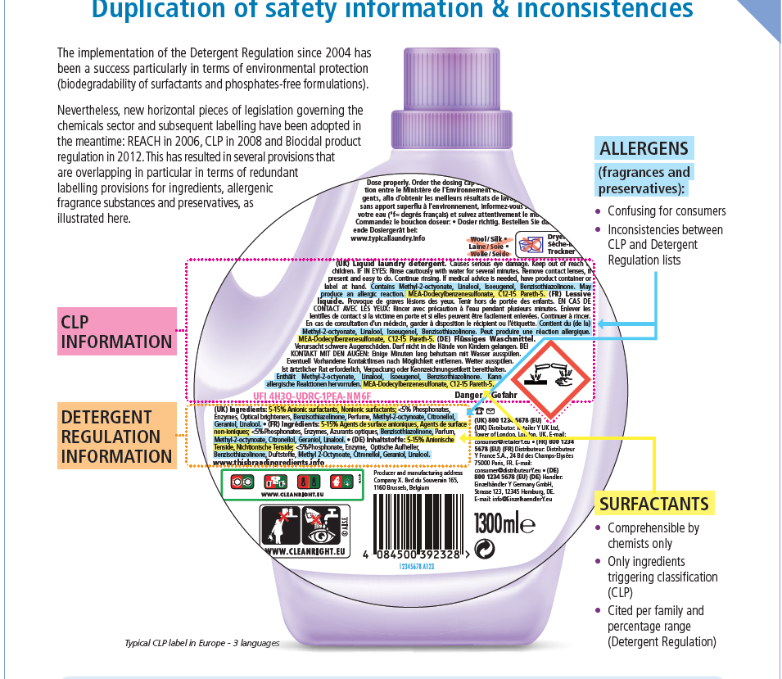

A.I.S.E. has been clearly also echoing the findings from the European Commission Cumulative Cost Assessment for the EU Chemical Industry, published in 2016, which confirmed the overly disproportionate cost of implementation of EU legislation. In particular:
1. The overall cost of compliance with legislation represents an important share of the industry’s
value-added and profits
2. The fundamental legislation that frames the industry is also the most costly
3. Administrative costs disproportionately affect the industry

See A.I.S.E. Fact Sheet on the topic (ANNEX 5_ AISEFactSheetCCA2016).

2) Users perspective on chemicals labelling, assessment of labelling requirements and needs of users

Question 3: What is the level of understanding of chemicals and detergents labels by the various categories of product users (e.g. consumers, industrial workers, professional users)? Is this level of understanding different depending on the user groups?

Answer:

We have identified various user groups (please see detailed description in ANNEX 6 _PersonaProfiles); those include: Consumers, Professional Customers/End-Users, Retailers, Member States Authorities (compliance bodies), Waste/recycling organisations, Medical Professionals.

See Report published by A.I.S.E. in Nov 2016 (ANNEX 7_BRESProject_Definingthe Problem) regarding feedback obtained.

- For consumers : (which is the main/Key target group here), there are various surveys existing, notably Eurobarometer 2016 (ANNEX 8_Eurobarometer2017) which all demonstrate the lack of reading and comprehension by consumers of the current labels.
In 2016-2017, A.I.S.E. also ran two qualitative and quantitative consumer surveys in various key representative countries of the EU. These results are available herewith, and have been subject more recently to a scientific publication.
- ANNEX 9_Quali AISE survey, 2016, full report
- ANNEX 10_Quanti AISE survey, 2017, full report
- ANNEX 11_Word report, 5 Oct2017, AISE/Insites Consulting
- ANNEX 12_Scientific publication, M Gueuns, Wiley, Feb 2021, also accessible here

The key findings are that:
- Safe use behaviour is not influenced by the back label execution
- Safe use practice is determined intuitively (e.g. experience, connotation of performance, pack design), even in case of crisis
- Consumers have some issues with comprehension of labels: critical elements of CLP labels (pictos/phrases) are poorly (or hardly) understood
- The use of icons and pictograms though is a strong enabler for people’s comprehension. The A.I.S.E. safe use icons (used broadly across the industry since 2004 voluntarily) are more easily understood than the CLP pictograms (eg A.I.S.E. “Keep Away From Children” pictogram has a very high level of consumer understanding -93%)
We notably tested 3 label examples as outlined below: one (number 3) being the current label; number 2 not determined by current regulatory requirements and number 1 with a flexible interpretation of current legal requirements.
- Even when “forced” to read the label, people don’t spend more than on average 22 sec reading the label, irrespective of content
- The proposed alternative labels are the preferred ones vs the current execution
- Still, the winning ones offer simpler and more graphical alternative labels (use of pictogram to promote safe use, possible use of visual cue for allergens, good structure of the information, provision of websites.
- NB: additional alternatives could have been tested or may be so in complementary research.
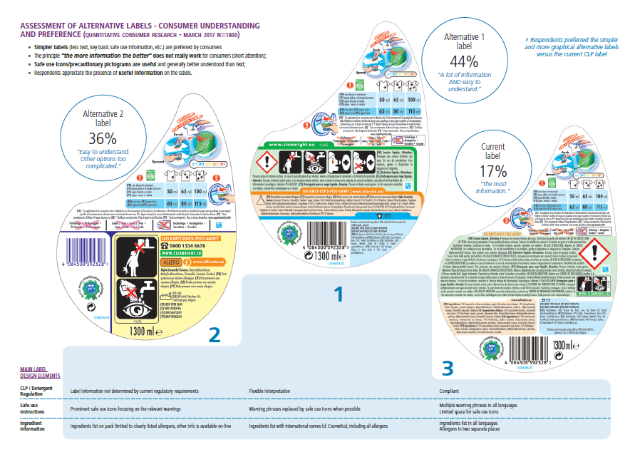
All are available from the public website of A.I.S.E.
See also ANNEX13_BRESFact sheet_2017 done on the topic, as well as presentation given in Dec 2018 by P Clohessy at the Cleaning & Hygiene Forum 2018 (link herewith).

For Professional customers:
- The SUMIs offers companies supplying to the industrial and professional cleaning industry a
- standardized way to communicate Operational Conditions and Risk Management Measures
- to their end users. Through simple communication and use of pictograms the SUMIs add
- value by summarising the information required and their goal is the facilitate bridging the
- gaps between REACH and OSH legislation. In my role as Regulatory Affairs Manager I
- followed key activities to promote these tools. These included:
- • Participation in the ECHA Pilot Project on Supply Chain Communication 2018-2019.
- • Working on the creation of guidance on this topic.
- • Providing advice to individual companies.
- • Presenting on the topic at the Twelfth meeting of the Exchange Network on Exposure
- Scenarios
- • Creating a series of training videos on the SUMIs, specifically targeted at professional
- cleaning companies to reach out to this additional key stakeholder in the supply chai
- The SUMIs offers companies supplying to the industrial and professional cleaning industry a
- standardized way to communicate Operational Conditions and Risk Management Measures
- to their end users. Through simple communication and use of pictograms the SUMIs add
- value by summarising the information required and their goal is the facilitate bridging the
- gaps between REACH and OSH legislation. In my role as Regulatory Affairs Manager I
- followed key activities to promote these tools. These included:
- • Participation in the ECHA Pilot Project on Supply Chain Communication 2018-2019.
- • Working on the creation of guidance on this topic.
- • Providing advice to individual companies.
- • Presenting on the topic at the Twelfth meeting of the Exchange Network on Exposure
- Scenarios
- • Creating a series of training videos on the SUMIs, specifically targeted at professional
- cleaning companies to reach out to this additional key stakeholder in the supply chai
- The SUMIs offers companies supplying to the industrial and professional cleaning industry a
- standardized way to communicate Operational Conditions and Risk Management Measures
- to their end users. Through simple communication and use of pictograms the SUMIs add
- value by summarising the information required and their goal is the facilitate bridging the
- gaps between REACH and OSH legislation. In my role as Regulatory Affairs Manager I
- followed key activities to promote these tools. These included:
- • Participation in the ECHA Pilot Project on Supply Chain Communication 2018-2019.
- • Working on the creation of guidance on this topic.
- • Providing advice to individual companies.
- • Presenting on the topic at the Twelfth meeting of the Exchange Network on Exposure
- Scenarios
- • Creating a series of training videos on the SUMIs, specifically targeted at professional
- cleaning companies to reach out to this additional key stakeholder in the supply chai
Professional users will often require more technical information to use products and the processes in the professional industry can be very different compared to those of consumers.

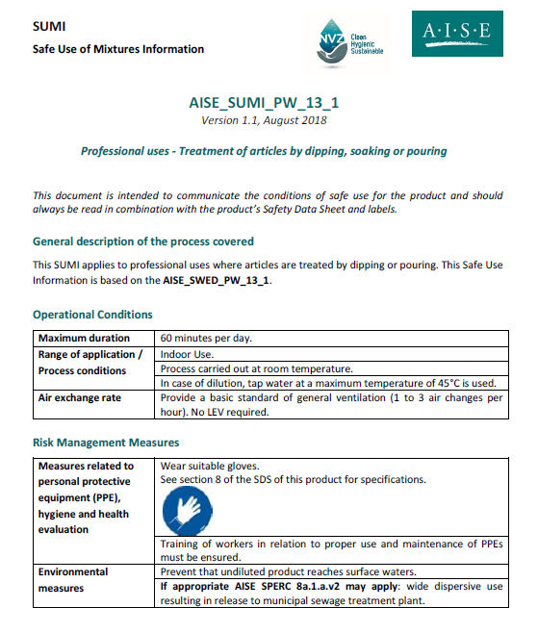
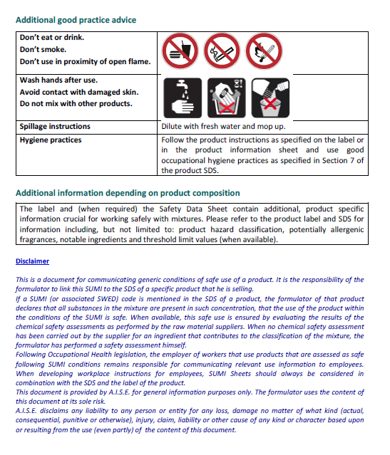
A key tool for sending information to professional users, as defined by REACH, is the Safety Data Sheet including (information from) exposure scenarios. It is then the obligation of an employer in a cleaning company, bother due to requirements of REACH and Occupational Safety and Health (OSH) legislation to use the information they received to write workplace instructions for their workers. To facilitate bridging the gaps between REACH and OSH legislation, and support supply chain communication, A.I.S.E. developed the SUMI documents (Safe Use of Mixtures Information) with other DU sectors in the DUCC platform. The SUMI offers companies supplying to the industrial and professional cleaning industry a standardized way to communicate Operational Conditions and Risk Management Measures to their end users. The target audience is people who use these products and may not have deep chemical knowledge and are not familiar with the REACH jargon used in Exposure Scenarios (ES). Through simple communication and use of pictograms the SUMIs add value by summarising the information required for safe use. In addition, A.I.S.E. have followed key activities to promote these tools. These included:

Example of a SUMI document

- Participation in the ECHA Pilot Project on Supply Chain Communication 2018-2019.
- Working on the creation of guidance on this topic.
- Creating a series of training videos on the SUMIs, specifically targeted at professional cleaning companies to reach out to this additional key stakeholder in the supply chain. This was done in collaboration with relevant stakeholders (e.g. European Federation of Cleaning industries EFCI).
Thus A.I.S.E. is working proactively to ensure professional users are able to receive information that is targeted to their needs.

Please see link herewith to access the SUMIs.

For Retailers:

We know that retailers are also very interested by the opportunity to provide labels more meaningful to consumers, notably because they are themselves responsible for many of the detergent and maintenance product market (cf private labels, whose share of the market is growing), but also because they are themselves at the “last point of contact” between the point of sale and the use of the products (and may thus be receiving questions from consumers).
We are also aware that they are keen to makes sure that this transition is organised in a way that will make sure that they can also contribute to its success, in close dialogue with all concerned stakeholders. We invite you to contact Eurocommerce (Els Bedert bedert@eurocommerce.eu) for this project.

For medical professionals:
A.I.S.E. organised an informal consultation with various Poison Control Centers back in 2016. Main conclusion are: To date, there is no indication that CLP labelling might have led to a reduction in the frequency of incidents. CLP classification as Category 1 Eye Irritant of many household products may be too conservative. The CLP label information is not normally used by PCCs to provide treatment guidance; the wide use of the “corrosive” pictogram may be counter productive. The CLP label information on pack does not guide the consumer towards safe use of the products, nor to apply the right first aid measures. PCCs prefer using a Unique Formula Identifier (UFI) linked to a database of mixture composition information over ingredient labelling on pack. (See detail in A.I.S.E. Nov 2016 report mentioned above).

- For Competent authorities:
We understand that most of the compliance check are essentially related to how the manufacturer derived the classification under CLP (cf calculation method or bridging principles). Those elements are therefore subject to specific conversations, between the authorities and the manufacturers held confidentially (and with pieces of evidence which are discussed/shared during a specific interview or on site visit, so NOT label related).
The resulting label requirements would then only be checked then afterwards. An aspect though that digitalisation can bring to them is the capacity to check products more easily and in greater quantities.

In addition, there are some label elements that are currently cited on-pack and are targeted to authorities rather than consumers. This information contributes to the over-crowding on the label. A solution could be to move some of these elements online; so the information on-pack is better read by consumers.

- For recyclers;
It is important that any future development helps address the objectives of the European Commission to the Green Deal and become the first climate neutral continent by 2050. The compaction of the products in our sector, which leads to many CO2 savings, transport savings etc, leads to the delivery of smaller packages (and thus smaller labels). It is key that this trend continues to be enabled, and that the update of recycled packaging be favoured. Modern techniques from recycling organisations to “read” the packaging are being observed (eg Holy grail). But this is really not B2C but instead, B2B information (so no need to be on the label).

Question 4 : Among the information provided on those labels, which information do you believe to be particularly important for consumers’ use and safety?
Answer:
A.I.S.E. believes that key information is the one related to the safe use /safe storage of the products as well as to its adequate use (efficacy/product performance).
To emphasise this, we encourage you to see the example of the liquid laundry detergent capsules where industry goes beyond legislation with icons on pack via its voluntary initiative. This demonstrates our responsible attitude i.e. we are not just advocating for less info on pack broadly, we do that consciously and we have evidence that we will add info on pack where we really see the need.

A.I.S.E. has started a list on the topic and proposes to send it to you during the week of 26 April.

Question 5 : Which information do you not consider essential?
Answer:
A.I.S.E. has started a list on the topic and proposes to send it to you during the week of 26 April.

Question 6: What could be removed, changed or added in terms of label content and design (e.g. font, colour, size) to improve users’ understanding and appreciation of labels?
Answer:
As you can see from the 3 label designs done above for the quanti research done for A.IS.E., we have explored options to:
Focus label with information related to safe use and dosage
Promote the use of pictograms vs languages/texts
Promoted use and visibility of websites (or other online info tools)
We would be keen to explore the feasibility of having a more international nomenclature used for listing of ingredients (cf INCI). Then, relying on pictos and such international nomenclature would be simpler and clear; and link to online info, in the language of the user would then complement this simple, clear on pack label.

Another area of work could also be that – should there still be on pack legal requirements in local languages – that they could be grouped e.g. by languages on pack altogether (now such requirements have to be grouped according to their “legal“ origin (ie CLP or Det reg or CLP).

A.I.S.E. would like to ask an extra deadline to answer to you more completely on that and proposes to send it to you during the week of 26 April.

Question 7: In your opinion, is the information currently provided on labels useful?
Answer:
Various consumer research findings demonstrated that the current on pack requirements are not useful, nor used ; and that even if people make the special effort to read them, that they are confused.

Question 8: Do you believe that there is any redundancy between information provided on labels?
Answer:
Yes- See attached ANNEX 4 WORD table overview which for example, show the various thresholds that are being asked according to various legal origins.
To note, there are at the moment other developments related to the labelling of preservatives and the extension of the list of fragrance allergens (due to the link of the Detergent Regulation to Cosmetics) that must also be taken into account as they could even worsen the current on pack requirements and consumer confusion (see attached ANNEX 14_Morerecentregulatorydevelopments_April 2021).

Question 9 Do you believe that anything could be added, changed, removed, or provided on an e-label instead?
Answer: Yes. We must make sure that labels are really consumer-focused and consumer meaningful, to allow safe use and adequate use of products. Complementary information to consumers is better provided on line as it can provide more context/explanation regarding the presence of an ingredient in a products, its function, its safety profile, regarding also the explanations on the classification symbol etc.

A.I.S.E. would like to ask an extra deadline to answer to you more completely on that and proposes to send it to you during the week of 26 April.

Question 10 In your opinion, is there any other information that should be provided on chemicals and detergent labelling?
Answer: In addition to promoting the safe use of products, A.I.S.E. has also been working over the last 2 decades to promote the sustainable use of the products so as to reduce the environmental footprint of the industry- this is also fully in line with the Green Deal objectives of the EU. This is why we believe that helping consumers guide their choice by a simpler, aggregated logo (such as the one of the Charter for Sustainable Cleaning) can be a good enabler for them, as well as providing them with adequate information on how to use the product sustainably. Here as well, agreeing on what is important to be on pack and what may be found on line would need to be agreed among stakeholders). Indeed, the sustainability profile is the outcome of numerous factors and detailed information may best be found at a digital touch point. The label could carry a simple/consolidated logo like that of the Charter if the product fulfills certain criteria but label on pack should not be seen as the place for comparing sustainability performance via elaborate label schemes.

The provision online of information on the function of ingredients as well as a common and robust source of information regarding the important regulatory environment that governs the placing on
The market of these products could be accessible on line.

Question 11 What is your perspective on multi language labels? Are multiple languages often chosen on a product label?
Answer: Multi-lingual labels are indeed common practice in our industry, notably because certain countries eg Belgium) do have various official languages in place in their countries. This is also key in Europe’s multilingual environment as well as an enabler in a number of economies of scale which cannot be under estimated, also in terms of packaging efficacy. You may wish to contact directly several industry manufacturers directly on this topic.

Besides scale which is a very important argument and the major reason of being for the multilingual packs, we would also like to add the concept of e-commerce. The products in e-shops must serve the consumers around the world, the multilingual packs will become dominant even more. Scale through multilingual packs saves money and materials, there is bigger flexibility in planning, scrapping etc. If companies had to produce quantities separately for each and every market, the exercise would be so complex that companies and products might abandon some small markets, depriving consumers from future innovation.

One other remark : we also observe several initiatives taken by some Member States which go against the single market approach and which therefore, can be an obstacle to this Single Market reality and would challenge those.

Question 12 If yes, why do you believe that are multi-languages labels are often used, even if they are not required by law?
Answer: Please see above.

Question 13 Are multi-language labels significantly cost efficient?
Answer: Please see above, and contact manufacturers directly for details. See also CCA study form 2016, highlighting already the very high costs on industry to comply with legislations.

Question 14 Could chemicals and detergents companies use single language label and what would be the implications in terms of costs and logistics?
Answer: Please see part of answer to Q6 above.

3) Analysis of IT solutions and digital tools for labelling of chemicals,
identification of information for the physical label and the e-label

Question 15: According to your knowledge, what are the existing IT solutions and digital tools that are used, or could be used, by businesses to communicate hazard and safety information?
Answer: In a general way, we should follow industry standards to encourage consistent reporting (GS1 Digital Link).
At the moment, we see essentially websites being used by companies to provide this information (eg current Det Reg on line requirements, as well as complementary sources of information regarding ingredients’ function for example). Some also use QR codes.
This complements the work that A.I.S.E. does regarding coherent consumer communication across Europe with its www.cleanright.eu portal. This aims at providing a common point of info to all EU consumers on label information, safe and sustainable use of products. It is promoted on pack and is operational since 2008 (and was subject to a major revamp in early 2020).

In the US, we’ve also seen the tool smart label being used and promoted by a vast number of brands. This can be an interesting case study in the context of this study; the only remark though is that it could make sense that the presentation of each ingredient and its function/safety profile be se subject to a central/common database (and not be fed by each individual manufacturer).
Related to this, and not necessarily led by manufacturers (as identified in your questions), A.IS.E would also like to make a comment on the proliferation of Apps that have been flourishing in Europe over the last years . We have developed a position paper on 3 March 2020 on the topic and would like to urge that this topic is also brought to the attention of the study, so as to ensure that it is only the accurate and scientifically based information which reaches consumers the information conveyed on line (see full position here- ANNEX 15_AISE POSITION ON SCORING).

Question 16: We have identified the following: QR codes, bar codes and unique product codes, mobile applications, NFC and RFID tags, augmented reality and image recognition. Are there any missing?
Answer:
Re Unique Product Identifier, you are probably aware of the UFI code which applies to all consumer or professional products subject to notification since 1 Jan 2021 (for ECHA/PCC information as per CLP Annex VIII). [It should be noted however that the UFI relates to a unique mixture composition, not a product; one UFI can relate to several products, and also vice versa - the UFI can change on a product without any other change to the label.]

In your question, it seems that you may be mixing package triggers with digital experiences/platforms. For us, the second is the priority question as a single experience could be launched from any given package trigger if we align on the identifiers (see GS1 Digital Link above). In other words, the same experience could be launched from a QR code and an RFID if each contains the same link/identifiers to direct the consumer to that experience.

Relevant Data Carriers/package triggers that we know of:
- GS1 Barcodes - EAN/UPC- 1 D Barcode
- GS1 QR Code/Datamatrix
- 2D datamatrix
- NFC (Near Field Communication)
- RFID
- Digimarc (digital watermarks)
- Image recognition

Experience technologies:
augmented reality
any other digital/website content

IT platform:
- Apps
- PWA (progressive apps)
- Websites
- blockchain

Apparently, the GS1 Digital Link which is not a data carrier in itself, but a GS1 standards based web enabled syntax, which is applied to, and therefore works in conjunction with existing data carriers printed on product packaging, such as the EAN/UPC is of potential interest

But also, other data carriers probably of less relevance:

- Blockchain
- fTrace
- RFID
- Augmented Reality Translation
- Voice Assistant recognising objects
- URL2Video
- Digital Watermark HolyGrail 2.0

One comment that we would add, is that in the assessment of the IT solution to be proposed, the technology should be assessed in relation to features that would be necessary to ensure the IT tool can be well implemented. Manufacturing of chemical products and information transfer within an industry has ample complexity; and the IT tool proposed should act to manage that complexity. Thus it must consider the needs of the industry for it to be effective.

Some features that A.I.S.E. has identified which would make an IT tool more suitable are:

- Entry points that do not overly complicate or further overcrowd the product label
- Local Language support - Information provided in local language
- User Friendliness
- Data Reliability, Transparency and Quality
- Ensure Confidentiality of certain information
- Cost Efficiency (Initial Investment, Maintenance)
- Limit manual data entry
- Availability of Digital Assets (for recognition of product and inspection)

Question 17: Which of these IT tools do you believe can be most realistically used for e-labelling of chemicals?

2D barcode (QR or 2D data matrix), RFID/NFC, or digital watermarks
Key is to follow GS1 Digital Link syntax with commonly agreed identifiers that would trigger the label (more information to come a bit later on those questions from our part).
1D barcode also would work if GTIN is all that is needed, but no more data can be added to this code
It is important that the EU COM should take into account also the possibilities of small market players when proposing an IT tool (QR, GS1,1D barcode, RFID etc.) to link product label and e-label.

Question 18 Are there any significant developments on the horizon in terms of digital tools for communication?
Answer:

Question 19: Do you have any examples of companies in which these digital tools are used, in the chemicals and detergents sector, or any other sector?
Answer:
See smart label above. QR code and bar codes are being used by our members.
Holygrail2.0 is also being piloted by some of our members (eg P&G) but that is solely for packaging waste recovery).

You may also be aware of the creation in 2019 of the informal platform called ‘Digital Information Alliance”. This groups various industry sectors who have all has common goal to promote the adequate transition to on lien information. They range from food, alcohol, wine, batteries, detergents, cosmetic, paints, aerosols, retail. See attached a presentation about the platform (ANNEX 16_Digital Information Alliance). More information can be provided also. Many of the sectors in this Alliance have pilots ongoing related to this programme. Notably, there is an interesting initiative by ETRC, the travel retail sector to provide digital information to their clients.

Question 20: If yes, can you provide some feedback on these initiatives?
Answer: Best to ask feedback directly to the companies/It contacts there.

Question 21: What are the costs and benefits of those IT tools?
Answer: Same as 20

Question 22: In your opinion, to which category of product users do these IT tools apply?
Answer: For now, a mix of B2C and B2B (retailers) probably.

Question 23 Do you have any information on user readiness to shift to such tools?
Answer: Most seem to be ready.
Very high awareness on QR codes which halos over to other 2D scannable codes with the right call to action.We also know that a consumer study on Smart label is planned for this summer (by the US FMI, The Food Industry Association and Consumer Brands to develop a comprehensive understanding of shopper awareness of it, obtain reactions to the Smart Label platform and assess its the impact related to transparency and shopper influence).

See latest data from A.IS.E on appetite to move to digital information below:
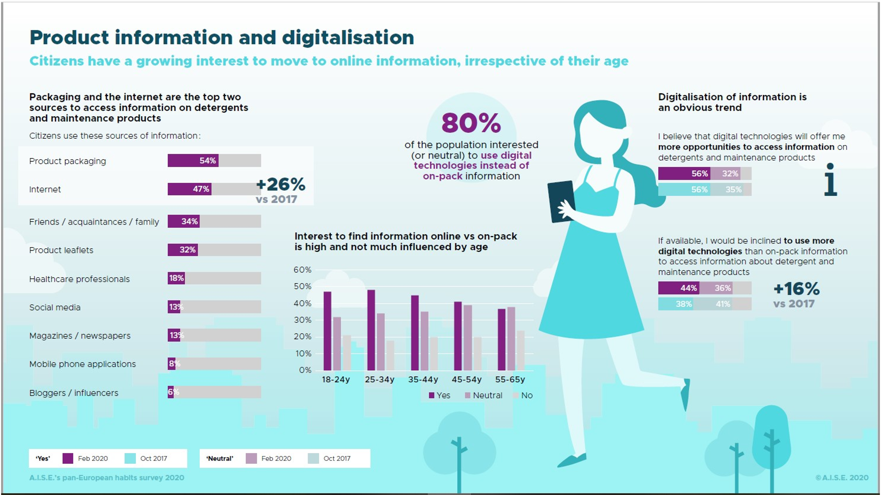

See ANNEX 17_AISEhabitssurvey2020_Summary – If you need more details on this, please contact Valérie Séjourné.

Question 24: In your opinion, which kind of information could be provided to users using IT tools, and why?
Answer: Digital labelling should not just be seen as replication of on pack labelling but instead as an improvement that would allow for intelligent use of the data that is made available. For example screening products for certain allergens if a consumer knows they have a concern. This type of “customisation” of the information thanks to e-labelling is the real benefit as we know consumers do not read the label properly and an online repetition of this information would also likely to be ignored but if we can use this to make consumer communication easier that would be a huge benefit.
To summarise, the Benefits of an e- label are:
- Opportunity for digital mechanisms to better explain context (ex. video, animation, etc.)
- Opportunity for personalization and search which allow consumers to access information on particular ingredients they care about more quickly
- Inclusive design – accessible to all consumers (blind/low vision) and even just consumers that struggle with small print

As regards more specific details on each label element to move on-line vs now, A.I.S.E. would like to ask an extra deadline to answer to you more completely on that and proposes to send it to you during the week of 26 April.

Question 25: Which kind of information should remain on a physical label, and why?
Answer: A.I.S.E. believes that key information is the one related to the safe use /safe storage of the products as well as to its adequate use (efficacy/product performance)
A.I.S.E. would like to ask an extra deadline to answer to you more completely on that and proposes to send it to you during the week of 26 April.

4) Concluding remarks

Question 26: Considering the questions above, how would you suggest improving the information on labels for consumers’ use and safety?
Answer:

A.I.S.E. would like to confirm its commitment, in the name of all industry players - to favor a fair and accurate information to consumers and other stakeholders. Since 2015 when we initiated the BRES project, our objectives have aimed at improving the effectiveness of safe use communication to consumers via labels and other possible means (e.g. digital), in order to make sure that consumers :
IN SUMMARY:
- Aim for a clean, easy to read label that provides the important info
- Focus on the consumer
- Remove ambiguity from various regulations/overlaps
- Maintain only the necessary information for safety
- Make optimal use of icons/pictograms
- Leverage digital space for the rest

- notice the safety information,
- understand it,
- take it into account and thus,
- act upon it to ensure safe use

For A.I.S.E, tackling the inconsistencies between the different labelling requirements and having a more “holistic” approach to labelling is a priority. The “silo” approach which has happened now materialises itself with complex and uncoherent labelling. This is the opportunity (as well as with the Detergent Regulation review now in progress) to be tackled. Indeed, one of the ways to create a less crowded and easier to read label is to eliminate the legislations overlapping. This may engage consumers to read labels more carefully (already substantiated in Q2).

In addition, the potential of digitalisation- one of the key priorities of the EU commission- must be taken into account so as to give priority to relevant consumer information on pack; completed by additional information online as this ca offer significant benefits; direct access in the right languages, better presentation of the information ; possibility to customise the information as per user profile, and possibility to provide complementary explanation, context and access to relevant sources of information.
We strongly believe that the LABEL INFO must be targeted to CONSUMERS.
For other users (eg enforcement authorities), provision of information through other means can be more effective and appropriate. We need to ensure that there is a consistent and clear approach as to how the product label should be assembled (taking into account the number of languages included) and the information that is seen as a priority ; also it should be emphasised that the e-label is clearly understood as an additional support for the label by all actors in the supply chain and that additional information on the product and its use/disposal etc will be provided here.

Question 27: What would be your suggestions to improve the information for professional and industrial workers’ use and safety?
Answer: For professional users, other tools like the SUMIS, with additional training, are already being enacted as more effective means of conveying information to an end-user. Labels on products for professional use could be adapted, by means of digital tools as described above, to enable connect users more readily to such information.

OTHER IMPORTANT DEVELOPMENTS:
There is also since 2018 some work ongoing at UN GHS level to consider the opportunities that Digitalisation of information can bring and to develop the principles for its implementation. This is still on the agenda of the UN and you will find in attachments (ANNEX 18, ANNEX 19, ANNEX 20 re UNGHS) respectively the two documents dedicated to the topic submitted so far by the Practical Labelling Issues working group and the work programme of the group for the 2021-2022 biennium (see paragraph 6 (c)-(f)).
It is also important to note that in 2018 UN accepted the A.I.S.E. safe use icon “Keep out of reach of children” for inclusion in Annex 3 of the GHS, for voluntary use by industry. (Included as from the 8th revised edition, see https://unece.org/ghs-rev8-2019)

IF YOU NEED OTHER RELEVANT CONTACTS FOR INTERVIEWS:
Please see ANNEX 21 where we are suggesting names in the A.I.S.E. membership for you to approach.

