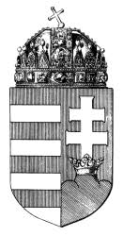
NATIONAL PUBLIC HEALTH CENTER
Department for Chemical Safety and Competent Authorities

09/07/2019, Budapest
Ref. nr: 2553-4/2019/KBKHF

HU comment on CARACAL document CA/58/2019, Future of CARACAL – draft revised Rules of Procedure for the Competent Authorities for REACH and CLP

The Hungarian CA thanks the Commission for preparing the draft document.
We find it important to clearly differentiate the rules of the CARACAL’s new task (assisting the Commission in relation to the preparation of delegated acts). Therefore we would welcome if these rules would be set separately from the ‘regular’ task of the group (eg. similarly to the REACH Committee’s RoP).
We also believe that the expert consultation should be separated from the stakeholder consultation. Therefore we agree with those Member States who suggested holding the delegated act related expert consultations at closed sessions (or at a subgroup level).
Finally, as regards the time line for distribution of documents prior to meetings (Art. 5), in the standard procedure we would prefer a longer period, 3 weeks at least.

