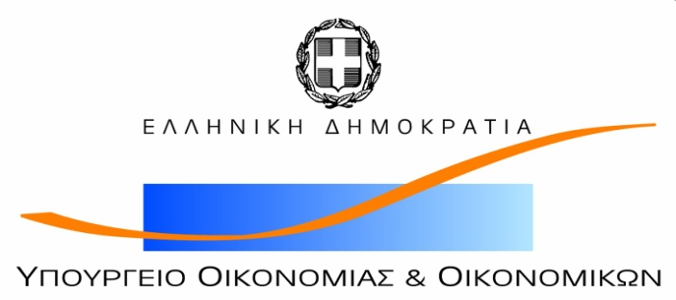

*Hellenic Republic*

****

*Independent Authority for Public Revenue  
Directorate General  
General Chemical State Laboratory  
Directorate of Energy, Industrial and Chemical Products*

Following the Commission document CA/58/2019 “Future of CARACAL – draft revised Rules of Procedure for the Competent Authorities for REACH and CLP (CARACAL)” which was presented during the 30th CARACAL meeting and the invitation to CARACAL members for providing written comments within one week, the Hellenic competent Authority for REACH and CLP would like to submit the following comments:

* We share the concerns raised by the Belgian delegation and we support that a clear distinction should be made in the text between the MSCAs’ CARACAL representatives (“Members”) and the MS experts to the CARACAL meetings dealing with the preparation of delegated acts.
* Documentation for the meeting shall be made available as early as possible to allow preparation for the meeting. With due consideration of their volume and complexity, documents should be made available no later than 4 weeks before the meeting.
* EL considers that closed sessions are necessary for discussion of issues where appropriate and, in cases of voting. Stakeholders consultation should be conducted in a previous stage of the preparation of an implementation act.