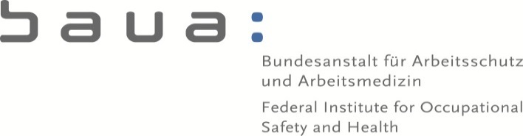

Email:
chemg@baua.bund.de

Contact:
Andreas Fleischer

49 (0) 231 - 9071 – 2535
RN: 5.0-720 34/01/2019.0070

Dortmund, 09 July 2019

30th Meeting of Competent Authorities for REACH and CLP

Agenda Item “Future of CARACAL”

A preliminary draft for modifying the CARACAL Rules of Procedures (RoPs) in view of the future discussion of delegated acts and the alignment with the horizontal rules on the creation and operation of Commission expert groups was presented during the 30th CARACAL.
CARACAL members were invited to provide written comments within one week, which the Commission takes into account for a draft which will be consulted via written procedure (envisaged deadline 19th August). We acknowledge that for modifications of the RoPs the current rule of Artikel 16 would apply which requires consensus amongst Member States.

Appropriate expert group for preparing delegated acts

Firstly we would like to point out that during the negotiations of the Regulation adapting a number of legal acts providing for the use of the regulatory procedure with scrutiny to Articles 290 and 291 of the Treaty on the Functioning of the European Union (so-called ‘Omnibus Act’) proposals were made to consider the REACH-Committee being the appropriate expert group for consultation in the preparation and drawing up of delegated acts for the CLP Regulation. The experience of discussing e.g. draft ATPs of the CLP-Regulation within the REACH-Committee is regarded as very positive, therefore we propose to continue to consult this group of experts in the preparation of delegated acts. Effectively, the current practice to discuss the consolidated list of RAC-opinions within CARACAL is considered as an important basis which provides in addition the opportunity to consult with stakeholders and should therefore be maintained.
As this option has neither been discussed nor forwarded at and to CARACAL, it would be
interesting to know the opinion and position of the other MS CAs on this issue. If the REACH-Committee is regarded for consultation in the delegated act procedure, the modifications concerning delegated acts in the draft RoPs (document CA/58/2019, highlighted in blue) are not necessary.

Horizontal rules – introducing votes by simple majority

Irrespective of the delegated act alignment the Commission introduced with the draft RoPs modifications based on the horizontal rules on the creation and operation of Commission expert groups (highlighted in yellow).
Concerning Articles 6, 8 and 16 these modifications are related to vote by simple majority of the members. We however think, that providing opinions by consensus is fundamental for the operation of the current CARACAL. The experience was very positive regarding the acceptance and general perception of these opinions. If in the past general consensus could be reached, but for some specific aspects minority positions remained, there were acceptable solutions how to communicate this in a transparent way. Introducing explicitly votes and decisions by simple majority to the RoPs would considerably change this well-established operation of CARACAL and its perception.
In our view the horizontal rules of Commission expert groups allow to set up RoPs which match the specific background of the concerned group, especially, because for delegated act consultation, no voting procedure is applicable. As there is no need for CARACAL to vote on its opinions and to decide via simple majority, all modifications proposed for Articles 6, 8 and 16 should be withdrawn.

Minutes of the meetings

Regarding the transparency of the minutes and the possibility to express a minority position we would propose to modify Article 9 by inserting as the third paragraph: “In case of minority positions during the group´s deliberations or in the course of written procedures the relevant member may propose a note to be included to the minutes expressing its individual considerations.”
Irrespective of the final decision, which expert group is appropriate for preparing delegated acts, the same should be considered for the section relating to delegated acts in the RoPs of the relevant expert group.

Timely transmission of documents

In view of an efficient discussion during the meetings we would like to highlight the need to distribute all working documents no later than 2 weeks before the meeting. This requirement is already included in the current RoPs. All efforts should be made to keep this in practice as the default situation. In addition we propose to delete the words “or discussion” in the very last phrase of Article 5.
Irrespective of the final decision, which expert group is the appropriate for preparing delegated acts, it needs to be specified that a timely transmission of all documents relating to delegated acts is considered as being at least 6 weeks before the date of the relevant meeting.

