Note agreed by Member States’ Competent Authorities for biocidal products
Note for Guidance
This document is drafted in the interest of consistency of the implementation of Regulation (EU) No 528/2012 and with the aim of finding an agreement between Member States' Competent Authorities for biocidal products on a harmonised approach. Please note, however, it does not represent the official position of the Commission and that Member States are not legally obliged to follow the approach set out in this document, since only the Court of Justice of the European Union can give authoritative interpretations on the contents of Union law.
Subject: Implementing the concept of biocidal product family

Background and purpose of the document
- In 2014, a workshop organised by industry gathered experts from Member States, industry and the Commission to reflect on a common understanding of the Biocidal Products Family (BPF) concept.
- The workshop was followed by the preparation of a Note for Guidance “Implementing the new concept of biocidal product families” that was endorsed at the 58th CA meeting in November 2014. The objective was to set the frame for how to decide whether two or more products can be included in a family based on similar levels of efficacy and risks.
- Following discussions at Coordination Group (CG) meetings on the scope of biocidal product families (BPFs), Member States agreed that clarification on certain aspects of the Note for Guidance was required in order to allow applicants to submit more robust and predictable applications and limit as far as possible the resources and time required to evaluate those applications.
- During the CG-22 meeting in March 2017, CG members decided to organise a Working Party (WP) to support the updating of the Note for Guidance.
- At the CG-24 meeting in July 2017, the CG mandated the WP to clarify the issue of ‘similarity’ and provide the Commission with recommendations that could help the smooth application of the BPF concept and the revision of the Note for Guidance.
- This note gathers the elements developed by the WP under the CG mandate. It addresses regulatory aspects that need to be considered by prospective applicants and CAs in relation to the authorisation of biocidal products grouped in a family.
- This note includes in Annex VIII the possibility of adding Q&A pairs about issues raised by evaluating bodies when dealing with BPF applications and how the CG (either through e-consultation or at CG meetings) will have addressed them. The CA meetings will discuss the CG suggestions and include them in Annex VIII when they are agreed.

Relevant provisions in the BPR and proposed way forward
- Article 3(1)(s) specifies that a group of biocidal products having:
  - Similar uses;
  - The same active substances,
  - Similar composition with specified variations, and
  - Similar levels of risk and efficacy
can be grouped in a BPF.
- Article 17(6) stipulates that ‘the authorisation holder shall notify each competent authority that has granted a national authorisation for a biocidal product family of each product within the biocidal product family at least 30 days before placing it on the market, except where a particular product is explicitly identified in the authorisation or the variation in composition concerns only pigments, perfumes and dyes within the permitted variations. The notification shall indicate the exact composition, trade name and suffix to the authorisation number. In the case of a Union authorisation, the authorisation holder shall notify the Agency and the Commission.’
- It means that once the biocidal product family is authorised, the objective is to facilitate the placing on the market of new products belonging to the biocidal product family but not explicitly identified in the original authorisation. To that effect, a notification mechanism is to be used by the authorisation holder to inform the evaluating body that they intend to place on the market such new products.
- As no other information will be requested, it implies that the SPC of the products covered by the notification shall be identical in all parts to the one agreed at the time of the authorisation of the biocidal product family.
- It is important to know precisely which products will be authorised.
- Based on the conclusions of the risk and efficacy assessment, the authorisation shall therefore provide information in a structured manner that would ensure that the competent authority could handle notifications within the required 30 days.
- BPF authorisations include three levels of information in the Summary of Products Characteristics (SPC):
  - The 1st level describes the composition and permitted variations of the authorised biocidal products family
  - The 2nd level provides the meta SPC which describes the composition and permitted variations of the sub-groups of products within the family.
  - The 3rd level provides the composition of the biocidal products belonging to the family
- Article 19(6) prescribes that ‘the assessment of the biocidal product family conducted according to the common principles set out in Annex VI shall consider the maximum risks to human health, animal health and the environment and the minimum level of efficacy over the whole potential range of products within the biocidal product family’[emphasis added].
A biocidal product family shall be authorised only if:
  - the application explicitly identifies the maximum risks to human health, animal health and the environment, and the minimum level of efficacy, on which the assessment is based, as well as the permitted variations in composition and uses referred to in point (s) of Article 3(1) together with their respective classification, hazard and precautionary statements and any appropriate risk mitigation measures; and
  - it can be established based on the assessment referred to in the first subparagraph of this paragraph that all the biocidal products within the family comply with the conditions set out in paragraph 1.
- Articles 22(1) and (2) clarify that ‘an authorisation shall stipulate the terms and conditions relating to the making available on the market and use of the single biocidal product or the biocidal product family and include a summary of the biocidal product characteristics.’
Without prejudice to Articles 66 and 67, the summary of the biocidal product characteristics for a single biocidal product or, in the case of a biocidal product family, the biocidal products within that biocidal product family, shall include the following information:
  - trade name of the biocidal product;
  - name and address of the authorisation holder;
  - date of the authorisation and its date of expiry;
  - authorisation number of the biocidal product, together with, in the case of a biocidal product family, the suffixes to apply to individual biocidal products within the biocidal product family;
  - qualitative and quantitative composition in terms of the active substances and non-active substances, knowledge of which is essential for proper use of biocidal products; and in the case of a biocidal product family, the quantitative composition shall indicate a minimum and maximum percentage for each active and non-active substance, where the minimum percentage indicated for certain substances may be 0 %.(…).
- Annex VI point 20 sets out that the information provided on the biocidal product family shall permit the evaluating body to reach a decision on whether all the products within the biocidal product family comply with the criteria under Article 19(1)(b).

Practical implementation
- This note is structured in 3 chapters addressing the following topics:
  - Best practice in pre-submission meeting
  - Assessment of similarity in BPF by applicants
  - Splitting of families for ongoing applications
Best practice in pre-submission meeting
- When applicants are in the planning phase for designing an application for a BPF, a number of considerations might arise.
- According to the BPR, Annex III recital (2) paragraph 7 of the introductory part: 'The applicant has the obligation to initiate a pre-submission consultation. In addition to the obligation set out in Article 62(2), applicants may also consult with the competent authority that will evaluate the dossier with regard to the proposed information requirements and in particular the testing on vertebrates that the applicant proposes to carry out'(emphasis added).
- In order to solve as many issues as possible and discuss the foreseen approach before the pre-submission of the application, it is essential that the applicant seeks the agreement of the competent authority (CA) to act as reference Member State (the rMS) in case of mutual recognition (MR) procedures or as evaluating CA in case of Union authorisation (UA) procedures (the "eCA"). Moreover, information on upcoming applications will enable the CA to adequately plan its future workload and adapt the necessary resources accordingly.
- Once a CA has agreed to act as rMS or eCA, it is suitable that the applicant and that authority discuss the organisation of pre-submission meeting(s) as early as possible. The formal setting of the meetings may be adapted on a case-by-case basis, ranging from physical to virtual meetings or telephone conferences.
- Although the CAs are committed to provide the applicant with all necessary information in order to enable him to prepare a robust dossier, it should be made clear that the content and quality of the dossier are under the full and sole responsibility of the applicant. A clear distinction should also be made between the role of a CA and the type of service an applicant can get from a professional consultancy. Consequently, the support provided by the CA at the pre-submission meeting(s) will have certain limitations and cannot anticipate in any way the outcomes of the evaluation.
- Annex I to this note outlines a gradual approach for the preparation of pre-submission meetings in view of finding an agreement with a CA to assess the BPF application.

Assessment of similarity in BPF by applicants

Decision tree for assessment of similarity
- According to Article 3(1)(s) of the BPR, a biocidal product family (BPF) is defined as a group of products having similar uses, the same active substances, similar composition within specified variations and similar levels of risk and efficacy.
- In order to assess whether a BPF meets the BPR definition of family concerning similarity, the steps in Figure 1 should be followed. For each step, the criteria detailed in the follow-up sections should be addressed.
Figure 1: Overview of the assessment of the similarity criteria

Similarity of composition within specified variation
Similar composition: definition of the backbone composition
- By definition, products belonging to a BPF must have a similar composition within specified variations. This has to be understood as different compositions within specified boundaries.
- To allow for deciding which individual products can be regarded as similar in composition, a so called “backbone composition” should be established within a BPF. The backbone composition is defined as follows:
- Each individual member of the BPF should contain the same basic set of ingredients, which is essential to formulate all products within the biocidal product family. Individual products may still contain additional ingredients to comply with the needs for some envisaged individual uses.
- This backbone composition should contain one or more active substance(s) and one or more co-formulant(s), which is (are) essential to formulate all the products. The pre-requisite of “essential to formulate” refers to co-formulants such as complexing agents, binders, pH-regulators, or a specific solvent needed to formulate any individual product in the BPF. It does not refer to easy exchangeable co-formulants like perfumes, pigments, dyes, skin care agents, tensides or co-formulants added to address the needs of some envisaged individual uses, for example corrosion inhibitors or scale inhibitors. Additionally, the applicant should not consider co-formulants added to ensure compatibility with a certain packaging material as essential to formulate and, therefore should not be included in the backbone composition.
- The applicant should provide a robust explanation on how the backbone composition was derived from the individual product compositions. The evaluating CA will examine such justification during the assessment of the applications in order to avoid any abuse of the concept by including “essential to formulate” co-formulants at a very low concentration (e.g. 0.1% or lower) in all products, so that any product falls within the “backbone composition” and therefore meets the criterion of similar composition.
- However, the evaluating authorities could accept the following exceptions:
  - carrier-based products as defined in CA-Nov16-Doc.4.3-Final.
  - concentrates which only consist of the active substance itself or;
  - formulations of the active substance, that do not contain co-formulants which are essential to formulate the biocidal product.
In cases b) and c), the backbone composition might consist of the active substance itself.
- The range of co-formulants that are essential to formulate belonging to the backbone composition have to be included in range starting from above 0 percent minimum content. In addition, the minimal concentration shall be set in such a manner that the presence of each co-formulant remains essential for each product included in the BPF.
- This rule can only help to address the similarity of composition of individual products within a BPF-application. Situations may occur where individual products may pass the “similar composition” criterion but may fail to pass the “similar use” or “similar levels of risk and efficacy” criteria. Only products fulfilling all provisions of Article 3(1)(s) of the BPR will be accepted to stay in the BPF.
- Several examples are presented in Annex II in order to illustrate how the proposed approach for “similar composition” can be applied.
Grouping of co-formulants
- According Article 3(1)(s) of the BPR a biocidal product family refers to a group of products having similar uses, the same active substances, similar composition within specified variations and similar levels of risk and efficacy. In order to clarify what is exactly authorised within a BPF, it is crucial to make clear which variations in compositions are allowed for the authorisation.
- Applications for BPF can contain biocidal products with varying compositions. At the 1st SPC and even 2nd SPC level of information all possible co-formulants with their concentrations ranging from 0 % to the maximum concentration can be listed.
- Grouping of products at meta-SPCs (2nd information level) and specification of a minimum concentration greater than zero and a maximum concentration of the co-formulants may help to avoid this situation by clarifiying the scope of the application.
- To facilitate the description of meta-SPCs and to avoid excessive splitting, applicants should be allowed, when appropriate, to group co-formulants having the same function (See Annex III).
- The grouping approach would also avoid that a product is notified that does not fit with the composition covered by the BPF authorisation. The declaration of a range of concentration for the grouped co-formulants (above 0% and up to the maximum level) at the 2nd level of the SPC and the declaration of the exact composition of each member of the group within that range at the 3rd level of the SPC should help to alleviate this concern.
- It should be allowed, but not mandatory, to group some co-formulants together, provided that they:
  - have the same function,
  - have the same impact on the classification (i.e. resulting in the same hazard and precautionary statements) for the whole formulation,
  - have the same impact on the level of risk and efficacy of the formulation.
- As a prerequisite for grouping, a clarification of the different functions of co-formulant in biocidal products is under development by the APCP working group and will be endorsed by the CG. Grouping might not be always possible. In any case, the applicants should demonstrate the rationale regarding their choice by using sound arguments and data where necessary.
- When grouping is applied, it is also necessary to specify if the grouped co-formulants are meant to be used together (‘and’) or if they should be used exclusively (‘or’) or if both should be possible (‘and/or’).
- Annex III illustrates how co-formulants could be grouped and identified at the meta-SPC levels 2 and 3

Similarity of uses
- The general criteria for deciding on whether a pair of uses is considered as similar is detailed in the decision tree included below. Within a given family, all possible pairs of uses should be considered as similar.
- An automated tool in the form of a matrix is under development to assist applicants and CAs in the application of the criteria referred to in the decision tree of Figure 2.

Figure 2 : Criteria to assess similarity of uses
- The general criteria for deciding on whether a pair of uses is considered as similar is detailed on the decision tree above (Figure 2).
- Same type of "object" within the same PT for main groups 1 and 2 has been considered when both uses of the biocidal products fall in one of the following categories (see references (1) in the column ‘Use object, pattern category’ of Table 2 in Annex IV):
  - Application directly on human or animal skin.
  - Hard surfaces such as for instance walls, floor, equipment, pipework, inner surfaces, soft surfaces such as for instance soft furnishing, textile disinfection, and other surfaces such as for instance hatching eggs, litter, surfaces associated with the housing and transportation of animals.
  - Construction materials and hard surfaces.
  - Laundry and textiles.
  - Air and room disinfection (vaporised biocide).
  - Products incorporated in treated articles.
  - Water (or liquid) matrix (any kind of water)
  - Surfaces in contact with water (or other liquid) and water (or liquid) matrix (other than waste water). Air condition systems, washing machines and crate washers.
  - Chemical toilets
  - Hospital waste
  - Soil
- Same type of "use pattern" for different PTs for main groups 1 and 2 has been considered when both uses of the biocidal products fall in one of the following categories (see references (2) in the column ‘Use object, pattern category’ of Table 2 in Annex IV):
  - Application directly on human or animal skin.
  - Application in pipework / inner surfaces (CIP)/ surface in contact with water (or other liquid)
  - Application on hard or soft surfaces/ instruments/ equipment (other than hatching eggs, surfaces associated with the housing and transportation of animals and application via room disinfection)
  - Application on laundry and textiles
  - Air disinfection and application for room disinfection (vaporised biocide)
  - Products incorporated in treated articles
  - Application on a water matrix (other than waste water, manure)
  - Application on waste water and manure
- Based on expert judgement and as agreed by the WP experts on the BPF concept, the following uses falling outside the criteria outlined in the decision tree of figure 2 could also be considered as similar on a case by case basis (see references (3) in the column ‘Use object, pattern category’ of Table 2 in Annex IV):
  - PT1 (Human hygiene) and the following uses:
    - PT2 and PT4: Disinfection of hard surfaces instrument and equipment.
    - PT2: Products to be incorporated in textiles, tissues and materials with the purpose of producing treated articles with disinfecting properties.
  - PT5 (Drinking water) and the following uses:
    - PT4 products used to be incorporated into materials which may enter into contact with food.
    - PT4 Disinfectants for hard surfaces/ instrument/ equipment disinfection.
  - PT2 disinfectants for pipework/inner surfaces (CIP)/ Surface in contact with water and PT3 products used for disinfection of the materials and surfaces in contact with water associated with the housing or transportation of animals (e.g. in aquaculture).
  - PT3 products for instrument/equipment disinfection and PT3 products to be directly applied on animal skin.
  - PT22 and PT1 and PT3 products used on human or animal skin
  - Insecticides used for PT8 and PT18
  - PT3 Surfaces associated with the housing and transportation of animals, PT3 soft surfaces, PT3 Hard surfaces/ instrument/ Equipment disinfection and PT4 disinfectants for pipework/inner surfaces (CIP).
  - Other use patterns that might be agreed by the CG.
  - PT2 disinfectants for pipework/inner surfaces (CIP)/ Surface in contact with water and PT2 disinfectants on a water matrix (e.g. industrial water) with the aim to disinfect both water and the industrial pipeline.
- In this context, same type of application is understood as when products corresponding to both uses are being used either as bait or used for direct kill. However, in the case of PT18 products covered by the main group 3 in figure 3 above, on a case-by-case basis it could be possible to consider as similar uses for direct kill and as a bait. This is for example the case of products in the form of sugar granules that can be diluted in water.
- Annex V describes exceptions that allows certain flexibility when assessing similarity of uses that could be accepted to reduce the number of applications to be prepared and evaluated by applicants and MSs.

Similar levels of risk and efficacy
Definition of the core
- In order to ensure a manageable size, the BPF must be defined by one core assessment. The core should include a significant proportion of the BPF.
- Furthermore, applications which are in a large part redundant should be avoided because they cause unnecessary additional cost both to applicants and eCAs. Therefore MS can accept that a core includes more than one meta-SPC if the products cannot be presented in one meta-SPC. This can in particular be appropriate in order to:
  - Include BPs into one BPF that can be covered by one core assessment but due to different H&P phrases or formulations types need to be separated into different meta-SPCs (see Example 1.1 in Annex VI);
  - Include concentrates and corresponding ready-to-use (RTU) products into one BPF (see Example 1.2 in Annex VI).
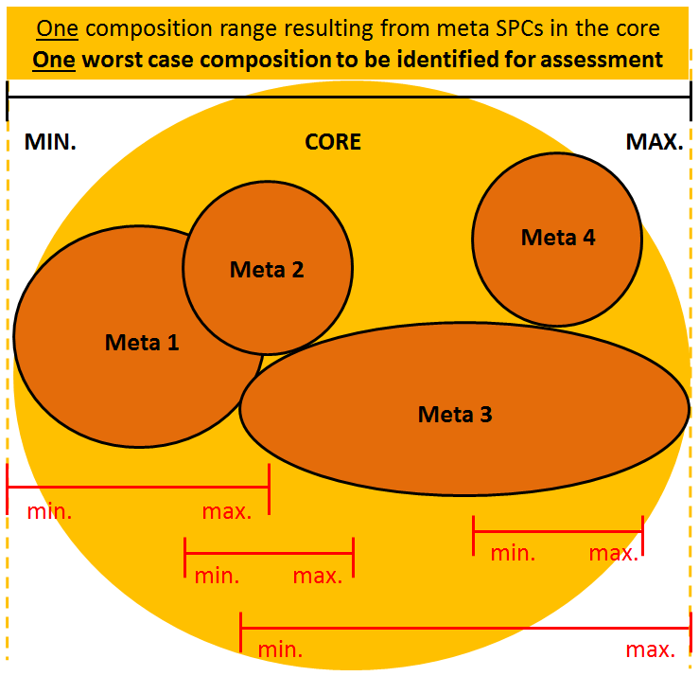
Figure 3: Example of core consisting of 4 meta-SPCs.
Section 1: Composition to be taken into account for the core assessment
- The assessment is based on one worst-case composition. This worst-case composition might be different from area to area. In order to fulfil the provisions of Article 19(6)(a) of the BPR the applicant must identify the worst and best case composition of the core to be assessed.
- The worst-case composition to be taken into account should include a significant proportion of the level 1 family range.
- Please, consider Annex VI for some examples.
Section 2: Worst case composition to be taken into account for risk core assessment
- The worst case composition to be taken into account is generally defined by e.g.:
  - Highest (in use) concentration of active substance
  - Highest (in use) concentration of co-formulants negatively affecting the risk
- Please, consider Annex VI for some examples.
- The worst-case core composition does not need to represent all highest component concentrations, nor contain all components of the formulation. These can be presented as an extension to the core (see below and example in Annex VI), if a core assessment of these would result in an overestimation of risk or significantly restrict the authorisation overall. In such case, a lower core formulation than the family Level 1 maximum can be set. However, this core formulation should still include a significant proportion of the total Level 1 BPF.
Section 3: Worst case composition to be taken into account for efficacy core assessment
- The worst case composition (e.g. representative test product(s) and expert judgement/bridging studies where applicable) to be taken into account is generally defined by e.g.:
  - Lowest (in use) concentration of active substance
  - Lowest (in use) concentration of co-formulants positively affecting efficacy
  - Highest (in use) concentration of co-formulants negatively affecting efficacy
  - Phys. chem. property (e.g. pH value) which is most unfavourable for efficacy
- Justification should be given why the chosen test product(s) covers the whole core. This can include expert judgement or bridging studies where applicable.
- In cases where the minimum concentration of active substance or associated co-formulant compositions, do not support the majority of the targets/label claims within the core, the applicant can set the worst-case composition for efficacy at:
  - another location within the Level 1 family range with products inside core formulation (evaluated as a subset - see section 8) or
  - outside the core formulation (evaluated as an extension - see section 9).
This can be an important tool in supporting para. 77 of Annex VI of the BPR.
Section 4: Risk assessment of the uses
- While there is only “one” worst-case composition to be taken into account, generally every use applied for in the SPC needs to be assessed. When assessing the uses the different parameters defining the use are taken into account. Since Article 17(6) of the BPR (addition of further BP to an authorised BPF) requires a notification only, a use within the core must have one consistent set of RMMs etc. (see examples 3.1 and 3.2 of Annex VI). Therefore, a use needs be assessed as described in the following scheme:
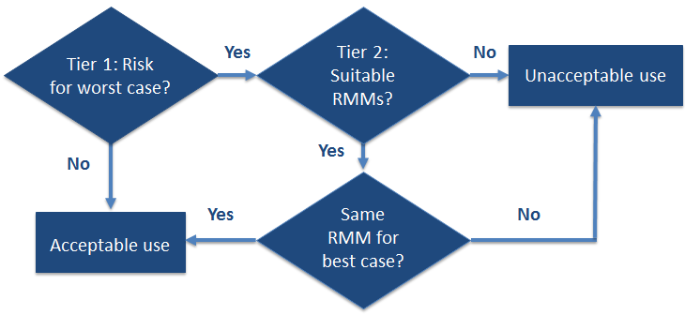
Figure 4: Workflow for risk assessment of a use.
  - In Tier 1 the worst case composition and the worst case for each parameter¹² are taken into account.
  - If there is no risk for the worst-case composition the whole use is acceptable.
  - If there is a risk a refinement is necessary (Tier 2).
  - If there are suitable RMMs it has to be kept in mind that there can be only one set of RMMs for a given use.
  - Therefore, it has to be checked if the RMMs are the same for the best case composition.
  - If the RMMs are the same for the best and worst case composition the use is acceptable.
  - If the RMMs are not the same for the best and worst case composition, level of risk of the use is considered as not similar and therefore the use should be considered as unacceptable (subject to the application of subsets – see section 7 and example in Annex VI).
Section 5 : Efficacy assessment of the uses
- While there is only “one” worst case composition to be taken into account generally¹⁴ every use needs to be assessed. When assessing the uses the different parameters defining the use are taken into account.
Section 6 : Meta-SPC
- In the context of the new BPF concept, meta-SPCs have to be understood as a way to present a group of similar products that can be covered by one (core) assessment but cannot be presented in one meta-SPC (see also section 3.2.4 ):
  - due to different H&P phrases,
  - due to different formulations types,
  - to include concentrates and corresponding RTU products into one BPF (see Example 1.2 in Annex VI).
- A BPF can consist of one or more meta-SPC. The number of meta-SPC has to be carefully considered by the applicant to ensure that the assessment by CAs does not become overly complex and difficult to manage.
- Where a meta-SPC contains several similar uses (i.e. different combinations of user category, target organism, field of use, application method, etc.), these uses will have to be clearly associated with the relevant instructions for use and RMMs in accordance with the principles agreed in document CA-May14-Doc.5.6-Final.
- All the authorised uses in a meta-SPC to which an individual product belongs do not need to be included in a label. A selection of uses can be made at the label stage. However, in accordance with document CA-May14-Doc.5.6-Final, there should be full compliance with the relevant content of the meta-SPC. For example, if one use combines different applications methods (brushing and roller) at meta-SPC level, the label shall contain the same reference to the application methods.
Section 7 : Subsets to the core
- There may be cases where the efficacy or a safe use cannot be supported over the whole composition range of the core for a specific use. In such cases it can be appropriate to set another worst-case composition for efficacy or risk at another location within the core range and manage the other target organisms/risks as subsets to the core.
- There are three possible types of subsets (see figure 5 below) which require different numbers of refinements of the core assessment:
  - Subsets in order to address different levels of risk (see subset 1 in yellow below) require a refinement of the human/animal health and/or environmental risk assessment using a different worst-case composition from within the already established core.
  - Subsets in order to address different levels of efficacy (see subset 2 in blue below) require a refinement of the efficacy assessment using a different worst-case composition from within the already established core.²⁵
  - Subsets in order to address different levels of risk and efficacy (see subset 3 in green below) require a human/animal health and/or environmental risk assessment as well as efficacy assessment using a different worst case composition from within the already established core.²⁵
- Please, consider Annex VI for an example regarding subset 1 (different level of risk) and an example regarding subset 2 (different level of efficacy).
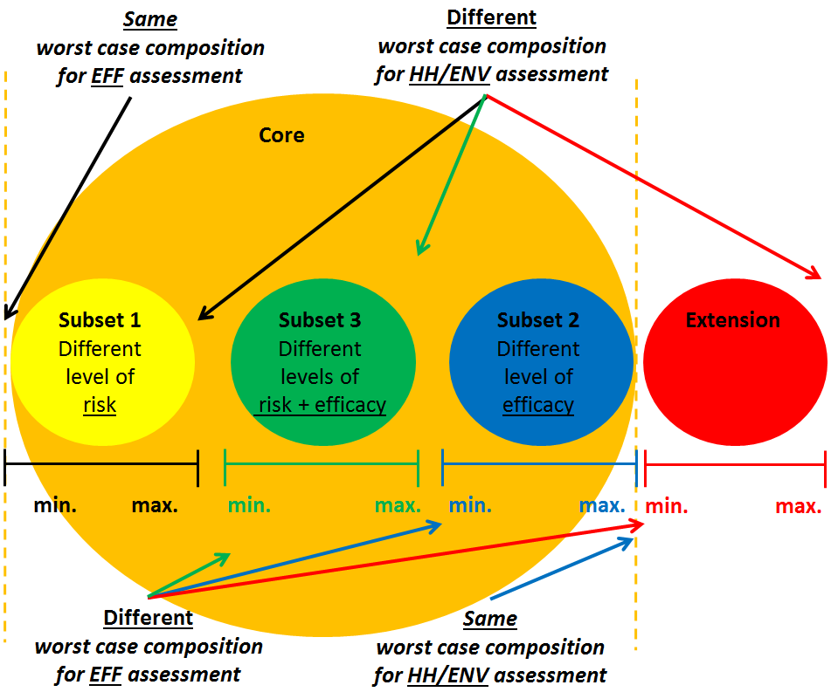
Figure 5: Visualisation of possible groups of additional products and corresponding core composition
Section 8 : Extensions to the core
- There may be cases where the inclusion of an additional group of products to the core would significantly restrict the overall authorisation. It can be appropriate to manage such differences in composition as an extension to the core (see extension in red in figure 5 above).
- Given the definition of an extension (an additional group of products outside the core) they could require a complete assessment:
  - a human/animal health and environmental risk assessment as well as efficacy assessment and;
  - an assessment of physical, chemical and technical properties as well as physical hazards and respective characteristics each with a worst case composition different from the one for the core.
- However, in order to ensure a manageable size of the BPF such extensions triggering a complete re-assessment of all BPF parameters independent from the core assessment are not acceptable. Only extensions which are limited to a number of refinements of the original core assessment are acceptable.
- Please, consider Annex VI for an example regarding an extension.
Section 9 : Assessment of the uses of the subsets and extensions
- Generally, all the uses from the subsets and extensions are assessed in accordance with section 4¹⁴. However, depending on the type/scope of the subsets, the scope of the extensions and the differences between uses in the core and the subsets/extensions, applicants and evaluating competent authorities may consider only the refinement of some aspects of the core assessment.
Section 10 : Limitation of possible number of subsets and extensions
- In order to avoid applications which are in a large part redundant MS can accept the inclusion of subsets and extensions into a BPF application. The extra workload for the eCA depends on the type/scope of the subsets (see recital 69 a) to c) above) and the range/scope of the extensions.
- Therefore, in order to still ensure a manageable size of the BPF, it is appropriate to limit the overall number of subsets and extensions that are acceptable.
- MS should generally accept only extensions and subsets requiring overall not more than three refinements per family (via subsets and/or extensions). However, subsets considered as necessary in order to support para. 77 of Annex VI of the BPR are supported and would not be included as part of these three refinements (i.e. no maximum upper limit set for para. 77 to facilitate its application by directing refinement flexibility to the other areas of the family).
Section 11: Modifications and notifications
- A more hazardous classification and labelling of a given product belonging to a meta-SPC will result in a split of the BPF. In accordance with Article 2(2) of the changes Regulation, the AHs would have to request an ECHA opinion regarding the classification of such change (minor vs major).
- The meta-SPC concept allows to present one group of similar products as a sub-group in order to avoid redundant applications. It also enables a simple post-authorisation notification process in accordance with Article 17(6) of the BPR. Therefore, at the authorisation stage, any meta-SPC should at least contain one individual product. Where an additional product does not fit into an existing meta-SPC, the AH has to apply for a change to the BPF authorisation in order to create a new meta-SPC.

Splitting of families for ongoing applications
- During the evaluation, mutual recognition or peer review of an application for product authorisation, an eCA could require the applicant to split the biocidal product family because the biocidal products within the family do not fulfil the conditions of similarity of uses, composition or levels of efficacy or risks.
- In general, equal treatment of applicants should be ensured when a decision to split the family is taken. Conversely, applicants should not take advantage resulting from the splitting of a family compared to applications for which the BPF was correctly structured from the beginning. Against that background, the following issues needs to be further detailed:
  - IT issues : The following way forward was agreed:
- ECHA will not modify the sequence of tasks in R4BP3 to address the issue. The initial application will continue, but just with the products having similar uses, composition and levels of risk and efficacy. One or more new (product or product family) application(s) for authorisation should be submitted to address the part(s) of the original BPF that are no longer covered by the initial application.
- To ensure equal treatment between applicants, when an eCA would like to shorten the timelines of the new application resulting from splitting the original BPF, that eCA would be responsible for managing the duration of each regulatory steps for the processing of the new application(s). For example:
  - the validation task can be completed on the same day as the task is initiated,
  - the evaluation of the phys-chem properties and where relevant, other parts of the assessment of the initial application, can be handed over for the assessment of the new application(s).
  - Timelines : The following way forward was agreed:
- The submission of the initial BPF application warrants that all the existing products initially covered by that BPF can benefit from the provisions of Article 89 of the BPR regarding the transitional period.
- Split product(s) that belonged to the original BPF will continue to benefit from the provisions of Article 89 of the BPR:
  - These products will continue to be allowed to be made available on the market and used in accordance with national systems;
  - The three-year deadline in Article 89(3) of the BPR would start counting as from the active substance approval date or the submission of the original application where the 3 year period is over for the relevant AS or PT.
- Applicants and eCAs will make use of their best endeavours to ensure that the split applications are handled in due time.
  - Fees : The following way forward was agreed:
- As mentioned above, in general, equal treatment of applicants should be ensured and there should not be an advantage for applications resulting from splitting of a BPF compared to applications where the BPF was correctly structured from the beginning. However, fees should be proportionate to cover the amount of work performed by the relevant eCA.
  - Fees from MSs are decided at National level.
  - ECHA fees: In case of UA procedures, the fee Regulation does not foresee any reduction when a new application is submitted. A new application for a product or product family will be treated as a new application in terms of fees.
- Other considerations : The following way forward was agreed
- The applicant may choose the most suitable product authorisation procedure for the application of the new product(s) or product family authorisation.
- In the case of an applicant changing from a Union authorisation (UA) procedure to a mutual recognition (MR) procedure (or the other way round), it is strongly recommended that the eCA/refMS for the original UA/NA application is selected as the eCA/refMS for the new procedure. This way, the new procedure(s) can benefit from the initial assessment of the original application, and, where possible, from any fee waving by the eCA/refMS.

Post-authorisation notification of new products
- In accordance with Article 17(6) of the BPR, the authorisation holder (AH) shall notify (through the R4BP3) each CA that has granted a national authorisation for a BPF of each product within that family at least 30 days before placing it on the market, except where:
  - A particular product is explicitly identified in the BPF authorisation or,
  - The variation in composition concerns only pigments, perfumes and dyes within the permitted variations in the BPF authorisation.
- In line with Article 17(6), it is proposed that the notification shall only indicate the exact composition and trade name of the product, as well as the suffix to the authorisation number (i.e. already including the BPF identifier and the meta-SPC suffix).
For that purpose, it is essential that the notification clearly identifies the meta-SPC to which the product belongs.
- Authorisation holders may support CAs by providing with the notification a draft “product-specific SPC”, which should be checked by CAs before making it available in the R4BP3 for dissemination purposes.
- Where a CA does not object to the notification within the 30-day period referred to in Article 17(6) of the BPR, that CA will have to:
  - Update the “BPF SPC” by adding to the third level information the new product details (e.g. trade name(s), specific composition within the meta-SPC ranges and authorisation number) and,
  - Make the “product-specific SPC”, as provided by the applicant and reviewed by the CA, available in the R4BP3 for dissemination purposes.
- Changes to the concentration of pigments, perfumes and dyes (PPDs) within the authorized composition ranges of the relevant meta-SPC are allowed provided that they only concerns PPDs i.e. that the changes do not affect the concentration of other co-formulants including water.
- Where an individual product of a BPF is subject to a change in PPDs not requiring notifications, the product resulting from such a change shall be placed on the market with the same authorisation number as the initial product. The same applies for the trade name, unless two or more different trade names have been allocated to the initial product and the applicant decides to place the product resulting from the change on the market with a different name.
When a product resulting from the change application is accepted by the evaluating competent authority, the new product should be listed in the amended SPC of the BPF authorisation and no further notification is required.
- This note contains an Annex VII which provides an overview of the approach to group biocidal product into a biocidal product family.

Applicability of the WG recommendations
- Applicants and competent authorities shall apply this guidance note to new applications submitted for BPF authorisation as of 01/10 2019. This guidance could be applied for applications submitted before that date if the applicants agree.
The note for guidance note of 2014 is repealed as from that date.

Annexes

Annex I
Gradual approach for preparing a pre-submission meeting

Step 1 – Contacts by the applicant and eCA agreement
- The applicant can approach several CAs and request a meeting. These contacts should start as soon as possible, and not later than 18 months before the expected date/deadline for the submission of the application.
- Once a CA has accepted to meet the applicant, the meeting should be scheduled rapidly so that the applicant has still enough time to contact and set up pre-submission meetings with another CA if the contacted CA is not willing to act as eCA. The applicant should strive to obtain a signed CA agreement at the latest 1 year before the expected date/deadline for the submission of the application.
- A first meeting should concentrate on a presentation of the BPF by the applicant, including a minimum of information concerning the structure as well as other relevant information. This information should be submitted to the approached CA at the latest 2 weeks before the meeting date.
- The CA should then inform the applicant (e.g. no later than 2 weeks) after the meeting of its decision to sign or not an eCA agreement so that the applicant could still contact other CAs in case no agreement was achieved.
- Once the applicant has the agreement of an eCA to conduct the evaluation, he/she should not contact other CAs anymore and should inform other CAs of the agreement reached with the eCA.

Step 2 – Pre-submission meetings
- After an eCA agreement has been signed, actual pre-submission meeting(s) can be organized. In general, only one physical meeting is held for an application. In this context, it is important to have a common understanding about when and how pre-submission meeting(s) should be organised, and which points need to be discussed.
- Timing: Pre-submission meetings should take place during the year before submission of the application.
- Limitations : Before the pre-submission takes place the applicant should be informed about the following limitations of the support that the eCA can provide:
  - The eCA is willing to provide all necessary support to the applicant, but it cannot and will not replace the assistance the applicant can get from his own experts or by hiring a consultancy.
  - Any recommendation provided by the eCA is based on the data provided for the meeting and does not anticipate the outcome of the dossier evaluation.
  - The eCAs’ comments are non-binding recommendations and it is still up to the applicants to decide how to implement these recommendations or even find a better solution. The applicant is fully responsible for the quality and pertinence of the data submitted with the application.
  - The eCA in general is not in the position to participate in the development of new test strategies or approaches for exposure and/or risk assessment and risk mitigation measurements. For such developments, the applicant is advised to rely on his own expertise or hire external expertise at his own expenses. However, the applicant is invited to present his intended strategy and discuss it with the eCA on a generic level.
- Content : The following issues might be relevant for discussion in relation to BPF applications:
  - 1st level: Overall information on the BPF. What is the argumentation for similar uses, similar composition and similar levels of risk and efficacy within the whole BPF?
  - 2nd level: Meta SPCs. How many meta-SPCs are planned, how are they divided and what is the argumentation for this division?
  - Are there any specific information requirements needed for the BPF?
  - Testing strategy to secure that the whole range of meta-SPCs is covered by the assessment, i.e. for:
- Physical/chemical: including definition of representative products at BPF/Meta SPCs level
- Efficacy: including definition of representative products at BPF/Meta SPCs level, co-formulant impact on efficacy and the definition of the worst case (soiling etc.). In case of lacking guidance the testing strategies need to be agreed with the eCA, possibly in a written procedure.
- Human and animal health
- Environment
  - Definition of worst case risk assessments for environment and human/animal health as well as for efficacy
  - Where relevant, Article 5(2) assessment and/or comparative assessment. – Where a BPF contains an active substance which is candidate for substitution, the intended uses within each meta-SPC will be subject to comparative assessment. As a result, all or some of those uses could be eventually prohibited or restricted where suitable alternatives meeting the conditions of Article 23(3) of the BPR are available.
  - Practical issues, such as expected CA fee for the suggested BPF (rMS should urge the applicant to contact ECHA regarding their fees), the applicant should be asked if he meets the criteria for SME status (fee relevant) and timelines regarding the application submission and authorisation process.
- Organisation: The following setting and responsibilities are suggested:
  - The applicant contacts the eCA and clarifies any relevant administrative procedure needed in preparation of the meeting (e.g. where relevant any forms to be filled-in, fees to be paid, etc…).
  - No later than two weeks before the meeting, the applicant shall propose a draft agenda (based on the proposal above) and background documents for the meeting, as well as specific questions for the different parts of the evaluation. The applicant will have to provide the overview of the BPF according to the overview Excel template agreed upon at CG-21. Against this background, the eCA can decide on the nature of experts experience required for the meeting.
  - The length of the meetings will be established by the eCA according to the draft agenda proposed by the applicant (e.g. from a few hours to a full-day).
  - At the meeting, the applicant briefly presents the intended use(s) of the products covered by the BPF and the eCA gives recommendations and advices on the identified issues. The eCA gives an indication on whether the BPF structure and the worst case(s) identified by the applicant might be acceptable or not. In case the eCA based on the presented data, disagrees during the pre-submission meeting, the applicant shall address these concerns before the submission of the application.
  - The meeting should identify specific scope or PT allocation issues, as well as technical matters for which there is no agreed harmonized approach. In these cases the eCA might need to consult the other member states (e-consultations of one of the WGs, HelpEx, or e-consultation of the CG, depending on the issue) in order to obtain a proposed way forward.
  - The applicant must prepare minutes from the meeting which are afterwards checked (and updated if necessary) by the eCA. These minutes should reflect all the items discussed and action points agreed during the meeting and the relevant deadlines.

Annex II
Examples of the proposed approach on “Similar composition”
Example #1
BPF containing PT3 Iodine products for teat disinfection:
The backbone composition is defined as
- active substance
- a complexing/solubilising agent (grouping has been applied to allow for different chemicals to be used)
- water as solvent (the solvent has been particularly specified to make clear that the BPF will only contain aqueous products)
For some specific uses additional components (i.e. non essential to formulate) can be added to the product composition, like emollients and wetting agents for teat spraying products. For teat dipping, where higher viscosity is needed a thickener will be added. These components would not be included in the backbone composition.
Example #2a
A BPF consisting of three creosote products, one of them consisting of 100 % Creosote, while the second and third members also include a solvent.
Strictly speaking the undissolved product would not comply with the provision of at least one co-formulant essential to formulate. On the other hand the applicant could argue that the exception for concentrates should apply. In this case the products containing only the active substances, which itself is already a liquid, would be regarded as a concentrate intended to be diluted with a solvent, whereas the product containing the solvents represents a ready-to-use product (or a less concentrated concentrate). In this case it is suggested, that the eCA could accept creosote as the backbone composition.
Example #3
A BPF containing Calcium Hypochlorite consisting of 3 meta-SPCs, all cover solid (powder & tablet) products. The first meta-SPC contains 100% active substance as a powder product. The second meta-SPC contains the active substance, an anti-scale agent and a dye. The third meta-SPC contains the active substance, an anti-scale agent, a dye and a formulation aid for tablet formulation (classification is different to meta-SPC 2).
All three products are solid formulations, two of them containing different co-formulants, which could be considered as not essential to formulate with the exemption for the aid for tablet formulation. The later should be discussed how essential this co-formulant should be seen.
Overall the eCA could accept the active substance as a backbone, at least for meta SPC 1 and 2, meta SPC 3 has to be discussed further and decided on a case by case basis. If a tablet could still be formed without the co-formulant (even though with somewhat different physical/structural properties), the co-formulant could be considered as not essential and not included in the backbone composition. In case of doubt, the eCA should also consider whether the criteria for similarity of uses and similar level of risk and efficacy are met.
Example #4
A BPF with CMIT/MIT as active substance, including glycol based, water based and powder based formulations.
It should be evaluated whether the solvents meet the criteria defined in the document on grouping of co-formulants. Depending on the outcome, the family should be either split into two families (solvent based and powder based) or into three families, glycol based, water based and powder based.
Example #5(a)
A BPF with isopropyl alcohol, including products with 50-70% of the active substance and different co-formulants where water is added to complete the composition up to 100%. The products can be used as RTU hand rubs with skin care agents, hand rub with a thickener (viscous liquid), sprays without co-formulants or pressurized containers delivering the product as aerosol.
Regarding similar composition the backbone composition can be defined as isopropyl alcohol and water. This will allow a range of different aqueous products considered as similar because the other co-formulants are not essential to formulate the biocidal product. The envisaged range and the different ways of applications should be addressed by the check for similar level of risk and efficacy.
Example #5(b)
A BPF with isopropyl alcohol, including products with 50-70% of the active substance and different additives where the composition is made up to 100% with water and including liquid formulations and wipes impregnated with the same formulation. In such cases, the exception for carrier-based products could apply.
Example #6(a)
A BPF with a solid active substance mainly formulated as dispersion or slurry, which can be easily incorporated into molten plastics. The BPF should also contain the solid active substance as such.
The product with the active substance would not comply with the similar composition criterion. It could be suggested to define two BPF, one with the active substance as backbone composition and one with the active substance and the co-formulants necessary to form a stable dispersion or slurry. Solid formulations and dispersion/slurry formulations would trigger two different sets of phys-chem data, most likely also different approaches for human health exposure. Therefore this set of products should be dealt with in two separate BPF.
Example #6(b)
A PT3 BPF consists of a PT liquid and gel formulations with different co-formulants that are essential to formulate a gel.
Liquid and gel formulations would lead to different dermal absorption and exposure patterns. The gel thickness might have also important implications for the efficacy assessment. Therefore the liquid and the gel formulation should be allocated in two different meta-SPC.
Example #7
A BPF consists of an aqueous solution of sodium hypochlorite and different co-formulants.
Defining the backbone composition consisting of sodium hypochlorite and water would comply with the proposed criterion. This will allow a range of different aqueous dilutions to be considered as similar. The conceivable range should be addressed by checking the criteria for similar uses and similar level of risk and efficacy.
Example #8
A BPF which consists of an aqueous solution of lactic acid and in some low concentration lactic acid products, sulfuric acid is added as a pH regulator in order to reach an appropriate pH for efficacy purposes (but not necessary for the stability of the product).
The backbone composition would be defined as water and lactic acid, as sulfuric acid is not essential to formulate stable products. If sulfuric acid would be needed in order to obtain a stable formulation, then it should be included in the backbone composition. In that case, products without sulfuric acid would need to be in a different family.

Annex III
Table 1: example of meta-SPC with grouping of co-formulants
 | Level 2 - Meta SPC |  | Level 3 - Individual Products within the meta SPC
Function | min(%) | max(%) | 1 | 2 | 3 | 4 | 5 | 6 | 7
Active Substance | 0.15 | 0.50 | 0.25 | 0.50 | 0.15 | 0.30 | 0.15 | 0.45 | 0.30
Complexing Agents | 1.00 | 3.00
A and B can only be used alternatively. The content of the complexing agent in the formulation should be in the range of 1.00 to 3.00
Complexing agent A  Complexing agent B | 0.00  0.00 | 3.00  1.90 | 1.90 | 1.00 | 1.50 | 1.00 | 3.00 | 2.50 | 2.50
Thickeners | 0.50 | 1.00
A and B can be used either alternatively or in combination. The total content of thickeners in the formulation should be in the range of 0.50 to 1.00
Thickener A | 0.00 | 1.00 |  |  | 0.1 |  | 1.00
Thickener B | 0.00 | 0.75 | 0.50 | 0.50 | 0.45 | 0.50 |  | 0.75 | 0.75
Emolients | 4.12 | 9.20
A and B can be used either alternatively or in combination. The total content of emollients in the formulation should be in the range of 4.12 to 9.20
Emollient A | 0.00 | 8.70 | 8.00 | 8.00 | 8.70 | 8.00 | 8.00 | 3.00
Emollient B | 0.00 | 0.50 | 0.50
Emollient C | 0.00 | 4.12 |  |  | 0.5 |  |  | 4.00 | 4.12
Wetting Agents | 0.15 | 2.6
A and B can be used either alternatively or in combination. The total content of wetting agents in the formulation should be in the range of 0.15 to 2.6
Wetting Agent A | 0.00 | 0.20 |  | 0.15 | 0.20
Wetting Agent B | 0.00 | 2.58 | 0.15 |  |  | 0.15 |  | 2.50 | 2.58
Wetting Agent C | 0.00 | 1.50 |  | 0.10 |  | 0.10 | 1.50 | 0.10
Solvent | 83.7 | 94.13 | ad100 | ad 100 | ad 100 | ad 100 | ad 100 | ad 100 | ad 100

Annex IV
Excel application to assist on decision regarding the similarity of uses
A tool in the form of a matrix has been developed according to the criteria described in point 3.2.3 in order to assist in the decision of considering similarity of uses. Please note that the matrix is an indication/reflection of the outcome of the decision tree. The basis for decision on similarity of uses is the general criteria included in the decision tree and its associated text.
The matrix is based on a traffic light code:
- Red: uses cannot be considered as similar.
- Yellow: uses may be considered as similar on a case by case basis.
- Green: uses can be considered as similar.
The matrix has been constructed to cover a number of possible use patterns to which the different specific uses (as described in the tables of section 4 in the SPC) can be assigned. The list of use patterns included in the matrix is given below:
Table 2:
PTs | Ref | Use object, pattern category | Use pattern
PT1 | #1 | (2)a, (3)ai, (3)aii, (3)e | Human hygiene
PT2 | #2 | (1)b, (1)h, (2)b, (3)c | Disinfectants for pipework / inner surfaces (CIP)/ Surface in contact with water
PT2 | #3 | (1)g, (1)h, (2)b, (2)g | Air condition systems disinfection
PT2 | #4 | (1)b, (1)c, (2)c, (3)ai | Hard surfaces/ instrument/ Equipment disinfection.
PT2 | #5 | (1)b, (1)d, (2)c, (3)aii | Soft furnishing/textile disinfection
PT2 | #6 | (1)d, (2)d | Laundry disinfection
PT2 | #7 | (1)e, (2)e | Air disinfection
PT2 | #8 | (1)g, (1)h, (2)g | Disinfectants and algaecides for treatment of waters other than waste water (e.g. aquarium water, swimming pool water, bathing water)
PT2 | #9 | 1(i) | Disinfection of chemical toilets
PT2 | #10 | (1)g, (2)h | Waste water disinfection
PT2 | #11 | (1)j | Hospital waste disinfection
PT2 | #12 | (1)k | Soil disinfection
PT2 | #13 | (1)c, (1)f, (2)f | Algaecides for remedial treatment of constructions materials and antimicrobial /hygienic paints
PT2 | #14 | 1(f), (2)f | Products used to be incorporated in textiles, tissues and materials with the purpose of producing treated articles with disinfecting properties
PT2 | #15 | (1)f, (2)f | Products used to be incorporated in paints with the purpose of producing treated articles with disinfecting properties
PT2 | #17 | (1)e, (2)e | Room disinfection (vaporised biocide)
PT2 | #16 | (1), (2) | Other PT2
PT3 | #18 | (1)b, (1)c, (2)c, (3)d, (3)g | Instrument/Equipment disinfection
PT3 | #19 | (1)a, (2)a, (3)d, (3)e | Disinfecting soaps
PT3 | #20 | (1)a, (2)a, (3)d, (3)e | Oral hygiene products
PT3 | #21 | (1)a, (2)a, (3)d, (3)e | Corporal hygiene products
PT3 | #22 | (1)b | Disinfection of hatching eggs
PT3 | #23 | (1)a, (2)a, (3)d, (3)e | Animal feet disinfection
PT3 | #24 | (1)a, (2)a, (3)d, (3)e | Teat disinfection
PT3 | #25 | (1)b, (1)d, (2)c, (3)g | Soft furnishing/textile disinfection
PT3 | #26 | (1)b, (2)h | Disinfection of manure and litter
PT3 | #27 | (1)e, (2)e | Room disinfection
PT3 | #28 | (1)b, (3)c, (3)g | Products used for disinfection of the materials and surfaces associated with the housing or transportation of animals (including aqua culture)
PT3 | #29 | (1), (2) | Other PT3
PT4 | #30 | (1)b, (1)c, (2)c, (3)ai, (3)bii | Hard surfaces/ instrument/ Equipment disinfection.
PT4 | #31 | (1)h | Disinfection in dish washing machines and crate washers
PT4 | #32 | (1)e, (2)e | Room disinfection (vaporised biocide)
PT4 | #33 | (1)b, (1)h, (2)b, (3)g | Disinfectants for pipework / inner surfaces (CIP)/ Surface in contact with water
PT4 | #35 | (1)f, (2)f, (3)bi | Products used to be incorporated into materials which may enter into contact with food
PT4 | #34 | (1), (2) | Other PT4
PT5 | #36 | (2)g, (3)bi, (3)bii | Disinfection of drinking water for humans or animals
PT6 | #37 | (2)f | Preservatives for products during storage
PT7 | #38 | (2)f | Film preservatives
PT8 | #39 | (2)f, (3)f | Wood preservatives
PT9 | #40 | (2)f | Fibre, leather, rubber and polymerised materials preservatives
PT10 | #41 | (2)f | Construction material preservatives
PT11 | #42 | (2)b, (2)g | Preservatives for liquid-cooling and processing systems
PT12 | #43 | (2)b, (2)g | Slimicides
PT13 | #44 | (2)g | Working or cutting fluid preservatives
PT14 | #45 |  | Rodenticides - Use as bait
PT14 | #46 |  | Rodenticides - direct kill
PT14 | #47 |  | Other PT14
PT15 | #48 |  | Avicides - Use as bait
PT15 | #49 |  | Avicides - direct kill
PT15 | #50 |  | Other PT15
PT16 | #51 |  | Molluscicides, vermicides and products to control other invertebrates - Use as bait
PT16 | #52 |  | Molluscicides, vermicides and products to control other invertebrates direct kill
PT16 | #53 |  | Other PT16
PT17 | #54 |  | Piscicides - Use as bait
PT17 | #55 |  | Piscicides - direct kill
PT17 | #56 |  | Other PT17
PT18 | #57 |  | Insecticides, acaricides and products to control other arthropods - Use as bait
PT18 | #58 | (3)f | Insecticides, acaricides and products to control other arthropods - direct kill
PT18 | #59 |  | Other PT18
PT19 | #60 |  | Repellents and attractants used directly on human or animal skin or on clothing
PT19 | #61 |  | Repellents and attractants not used directly on human or animal skin or on clothing
PT20 | #62 |  | Control of other vertebrates - Use as bait
PT20 | #63 |  | Control of other vertebrates - Other uses (direct kill)
PT21 | #64 |  | Antifouling products
PT22 | #65 | (3)e | Embalming and taxidermist fluids

Annex V
Exception for similarity of uses
It is important to note that, in all cases, when defining the structure of the family, the limitations introduced by the conditions of “similar composition” and "similar level of risk and efficacy" will need to be considered. In other words, accepting that the exception would apply does not negate the need to fulfil the condition of “similar composition” and "similar level of risk and efficacy".
Criteria for applicability of the exception
In order to avoid applications which are in a large part redundant MS can consider in each family a maximum of two pairs of uses as similar that are a priory considered as "non-similar". In this context, where applicable, a use has to be understood as a use pattern (i.e. as those listed in Annex IV).
In order to illustrate the application of this exception, we can consider the following theoretical example to assess similarity of uses of a possible family with five different uses.
Let's imagine that, according to the criteria on similarity of uses, we could construct a matrix with the outcome below that indicates in red those pairs of uses that are not similar, and in green those pairs that are similar.
 | use 1 | use 2 | use 3 | use 4 | use 5
use 1
use 2
use 3
use 4
use 5
In this example, there are more than two red cells (non-similar pairs of uses), and therefore not all five uses could be included in the same family.
One of the possible options would be having two families with the structure given below:
- Family 1:It includes “use 1”, “use 2” and “use 3” where exception (1) has been applied two times to consider as similar the pairs of uses “use 1/use 3” and “use 2/use 3”.
 | use 1 | use 2 | use 3 | Exception |  | use 1 | use 2 | use 3
use 1 |  |  |  |  | use 1
use 2 |  |  |  |  | use 2
use 3 |  |  |  |  | use 3
- Family 2: Family includes “use 4” and “use 5” where exception (1) has been applied one time to consider as similar the pair of uses “use 4/use 5”
Exceptions
 | use 4 | use 5 |  |  | use 4 | use 5
use 4 |  |  |  | use 4
use 5 |  |  |  | use 5
Other arrangements would also be acceptable as long as a maximum of two red cells would be present in each family.
Annex VI
Example of similar level of risk and efficacy

Examples of a core including more than one meta-SPC
Example 1.1: BPs that can be covered by one core assessment but due to different H&P phrases cannot be presented in one meta-SPC:
The BPF applied for includes only RTU products (10-20 % active substance dissolved in 70-85 % solvent). The products are available with different combinations of pigments, perfumes and dyes (PPD). These PPD (2.5-5 %) include a substance of concern (SoC, e.g. a preservative) which triggers a hazard-phrase (e.g. EUH 208 Contains SoC1…). These products are presented in meta-SPC 1 (see table 3 below).
Additionally, products are placed on the market which have the same active substance, solvent and PPD content. However, these PPD include a different SoC (e.g. another preservative) which triggers a different hazard-phrase (e.g. EUH 208 Contains SoC2…). These products are presented in meta SPC 2 (see table 3 below).
The core composition (see table 3 below - columns in orange) is based on the largest variations (smallest min. value and largest max. value of all the meta SPCs) of each ingredient. In this case the core composition also represents the overall Level 1 family composition range.
Ingredients | Level 1: Core  composition |  | Meta SPC 1 |  | Meta SPC 2
Reason for creation of add. meta:
CLP different to meta 1 (incl. SoC2 instead of SoC1)
 | Min | Max | Min | Max | Min | Max
Active substance | 10 | 20 | 10 | 20 | 10 | 20
Solvent | 70 | 85 | 70 | 85 | 70 | 85
PPD incl. SoC1 | 0 | 5 | 2.5 | 5 | 0 | 0
PPD incl. SoC2 | 0 | 5 | 0 | 0 | 2.5 | 5
Table 3: BPs grouped in a core that includes separate meta-SPCs because of different H&P statements
The products with different PPD combinations cannot be presented in one meta-SPC because of different H-phrases that must be entered in chapter 3 of the SPC. However, as long as all the products can be covered by the same core assessment (e.g. because the sensitising preservatives are similar) a separate application which would be in a large part redundant should be avoided. An example for the identification of the worst-case combination for such a core can be found in example 2.1.

Example 1.2 : Concentrate and corresponding RTU products in one BPF:
The BPF applied for includes concentrates (60-80 % active substance dissolved in 20-40 % Solvent 1). Before use the user dilutes the concentrates with solvent 2 (1:9 ratio). Accordingly, the in-use concentration is 6-8 % active substance. These concentrates are presented in meta-SPC 1 (see table 4 below).
Additionally, the corresponding RTU products are placed on the market. The only difference is that there is no mixing and loading step for the user. These RTU products are presented in meta-SPC 2 (see table 4 below).
The concentrates and RTU products cannot be presented in one meta-SPC because of different active substance contents which must be entered in chapter 2.1 of the SPC. For meta-SPC 1 this is 60-80%. For meta-SPC 2 this is 6-8 %.
While the core composition is normally based on the largest variations (smallest min. value and largest max. value of all the meta SPCs) of each ingredient, the inclusion of concentrate and RTU into one BPF makes it necessary to consider a „second“ core composition for the core assessment (see table 4 below (columns in orange)). This is the only scenario where MS consider more than one core composition as acceptable.
Ingredients | Level 1 |  | Core composition |  |  |  | Meta 1 |  | Meta 2
 |  |  | Concentrate |  | RTU |  | Reason for creation of add. meta:  Different AS concentration in RTU and conentrates
 | Min | Max | Min | Max | Min | Max | Min | Max | Min | Max
Active substance | 6 | 80 | 60 | 80 | 6 | 8 | 60 | 80 | 6 | 8
Solvent 1 | 2 | 40 | 20 | 40 | 2 | 4 | 20 | 40 | 2 | 4
Solvent 2 | 0 | 90 | 0 | 0 | 90 | 90 | 0 | 0 | 90 | 90
Table 4: BPs grouped in a core that includes separate meta-SPC to cover concentrates and RTU products
An example for the identification of the worst-case combination for such a core can be found in example 2.2.

Examples regarding identification of the worst-case compositions for the risk assessment
Example 2.1: BPs that can be covered by one core assessment but due to different H&P phrases cannot be presented in one meta-SPC:
- The information on ingredients and core composition is taken from example 1.1 above.
- For each ingredient a value for worst and best case must be chosen. This value might be different from area to area (here human health and environment).
- For each ingredient/value chosen a detailed justification must be provided in the PAR. An example outcome of such a justification could be:
  - Active substance: Toxicological relevant for both human health and environmental risk assessment. Min = best case. max = worst case.
  - Solvent: In this example toxicologically not relevant.
  - “PPD incl. Soc1” and “PPD incl. Soc2”: Not the PPDs (different ones in meta 1 and meta 2) but only SoC1 and SoC2 are relevant for human health risk assessment. The properties of SoC1 and SoC2 are similar. Although the core composition includes 0-5 % “PPD incl. SoC1” and 0-5 % “PPD incl. SoC2” neither meta 1 nor meta 2 can include products without SoC 1 or 2 (see Table 5 below). Accordingly, it is justified to choose 2.5 % as best case and 5 % as worst case.
- In this case the core composition also represents the overall Level 1 family composition range.
Ingredients | Justification | Core  composition |  | Meta 1 |  | Meta 2 |  | Human/animal health risk assessment |  | Environmental risk assessment
Reason for creation of add. meta:
CLP different to meta 1 (incl. SoC2 instead of SoC1)
 |  | Min | Max | Min | Max | Min | Max | Best  case | Worst  case | Best  case | Worst  case
Active substance | Always relevant | 10 | 20 | 10 | 20 | 10 | 20 | 10 | 20 | 10 | 20
Solvent | Not relevant | 70 | 85 | 70 | 85 | 70 | 85 | Not relevant
PPD  incl. SoC1 | SoC1 and SoC2 = SoC for HH  Cannot be in one meta but same effect on HH | 0 | 5 | 2.5 | 5 | 0 | 0 | 2.5 | 5 | Not relevant
PPD  incl. SoC2 |  | 0 | 5 | 0 | 0 | 2.5 | 5
Table 5: example of a best/worst case scenario when BPs have different H&P statements
Example 2.2 Concentrate and corresponding RTU products in one BPF:
- The information on ingredients and core composition is taken from example 1.2 above.
- For each ingredient a value for worst and best case must be chosen. This value might be different from area to area (here human health and environment).
- While the core assessment is normally based on one worst case composition only the dilution of the concentrate (mixing and loading step before application) makes it necessary to consider a „second“ worst case composition for the core assessment. This is the only scenario where MS consider more than one worst case composition as acceptable (see table 6 below).
- For each ingredient/value chosen a detailed justification³⁷ must be provided in the PAR. An example outcome of such a justification could be,
  - Active substance: Toxicological relevant for both human health and environmental risk assessment. Min = best case. max = worst case.
  - Solvent: In this example toxicological relevant for environmental risk assessment. Min = best case. max = worst case.
  - Solvent 2: In this example toxicologically not relevant.

Ingredients | Justification | Core  Composition |  |  |  | Human/animal health risk assessment |  |  |  | Environmental risk assessment
 |  | Mixing & loading |  | In use |  | Mixing & loading |  | In use |  | Mixing & loading |  | In use
 |  | Min | Max | Min | Max | Best  case | Worst  case | Best  case | Worst  case | Best  Case | Worst  case | Best  case | Worst  case
Active substance | Always relevant | 60 | 80 | 6 | 8 | 60 | 80 | 6 | 8 | 60 | 80 | 6 | 8
Solvent 1 | SoC for ENV | 20 | 40 | 2 | 4 | Not relevant |  |  |  | 20 | 40 | 2 | 4
Solvent 2 | Not relevant | 0 | 0 | 90 | 90 | Not relevant |  |  |  | Not relevant
Table 6: example of a best/worst case scenario when BPs includes concentrates and RTU products

Example regarding one consistent set of RMMs for a use
After having identified a worst-case composition every use is assessed. When assessing the uses the different parameters defining the use are taken into account. Every use must have one consistent set of RMMs. However, these can be use specific and differ from use to use.
Example 3.1 – Two uses with different application methods. – Each use having one set of consistent RMMs. Therefore, both uses can be part of one BPF.
Use#1 – Brush application Use #2 – Spray application
Product Type | 8
Where relevant, an exact description of the authorised use | Not relevant
Target organism(s) (including development stage) | a, b, c
Field(s) of use | A
Application method(s) | Brushing
Application rate(s) and frequency | 100 mL / m²
Category(ies) of users | Prof
Pack sizes and packaging material | 1, 2, 3
Product Type | 8
Where relevant an exact description of the authorised use | Not relevant
Target organism(s) (including development stage) | a,b,c
Field(s) of use | A
Application method(s) | Spraying
Application rate(s) and frequency | 100 mL/m²
Category(ies) of users | Prof
Pack sizes and packaging material | 1,2,3

RMMs: no PPE necessary RMMs: PPE necessary

Example 3.2 – Two uses with different in use concentrations. Each use having one set of consistent RMMs. Therefore, both uses can be part of one BPF.
Use#1 – Spray application - low application rate Use #2 – Spray application - high application rate
Product Type | 3
Where relevant, an exact description of the authorised use | Not relevant
Target organism(s) (including development stage) | a, b, c
Field(s) of use | A
Application method(s) | i
Application rate(s) and frequency | 1% BP concentrate in water  100 mL / m²
Category(ies) of users | Prof
Pack sizes and packaging material | 1, 2, 3
Product Type | 3
Where relevant an exact description of the authorised use | Not relevant
Target organism(s) (including development stage) | a,b,c
Field(s) of use | A
Application method(s) | i
Application rate(s) and frequency | 25% BP concentrate in water  100 mL/m²
Category(ies) of users | Prof
Pack sizes and packaging material | 1,2,3

RMMs: no PPE necessary RMMs: PPE necessary

Example regarding subset with different levels of risks
The BPF applied for includes one active substance (5-10 %) which is dissolved in a solvent (75-85%). In order to keep the active substance in solution co-formulant 1 (5-10%) is needed. The products of the BPF are available with different combinations of pigments, perfumes and dyes (PPD overall always 5%).
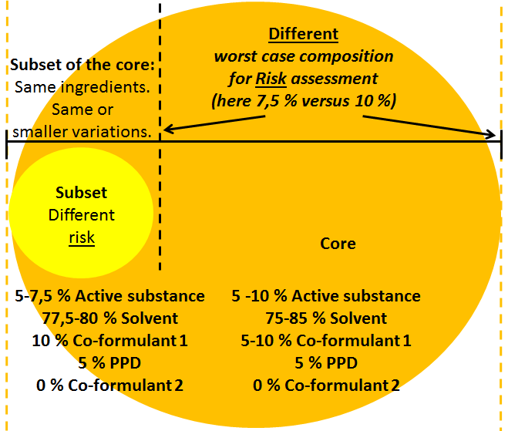
Figure 6: Visualisation of core and subset.
There is only one use for professional users (use 1, regarding the uses and an overview of the composition ranges see Table 7 below).
After having identified the relevant worst-case composition for the core, every use in the core (here use 1 only) is assessed: PPE is required and the set of RMMs is consistent (same RMMs from best to worst case (5-10 % active substance)). Furthermore, efficacy against all target organisms was proven with 5% active substance (the worst case concentration regarding efficacy).
However, there is another use (use 2) some potential products of the BPF are currently used by non-professional users against the same target organisms as professional users.
If included in the core the risk assessment this use would have to be based on the worst-case composition (10 % active substance). When using this 10% value, the result of the risk assessment would be as follows:
1. With 10 % active substance PPE would be required for the non-professional user (which is not foreseen by the BPR) and,
2. The PPE is not necessary with 5 % active substance
and so this use 2 does not meet the criterion for similar level of risk since the RMMs do not match across the whole composition range of the core (i.e. 5 to 10%) for the non-professional user (see section 4). Therefore, the non-professional use cannot be included within the core.
However, on review of the risk assessment for the non-professional use an active substance concentration of 5 to 7,5 % results in no PPE being required, thereby supporting the principles of the BPR and also the requirement for RMMs applicable to both the worst and best-case formulations to be the same (section 4).
Therefore, the use can be presented as a subset to the core because the potential products for the non-professional user include the same ingredients with the same or less variation as that of the core composition (see figure 6 above or yellow columns in Table 7 below). In this case, the core composition also represents the overall Level 1 family composition range.
Ingredients | Classification | Core  composition |  | Subset (Different risk)
 |  | Min (%) | Max (%) | Min (%) | Max (%)
Active Substance | XYZ | 5 | 10 | 5 | 7,5
Solvent | SoC ENV | 75 | 85 | 77,5 | 80
Co-formulant 1 | SoC HH | 5 | 10 | 10 | 10
PPD | - | 5 | 5 | 5 | 5
Uses |  | 1: Professional user  PPE: Gloves and mask |  | -
 |  | - |  | 2: Non-professional user  No PPE
Table 7: example of a subset refinement covering a different level of risks
This subset would make only one refinement to the core composition necessary (whether the products can be supported for the non-professional user without PPE across the composition range of 5 to 7,5 % active substance), assuming that all the other areas (environment, phys. chem/hazard and efficacy) are covered already by the assessment of the core.

Example regarding subset with different level of efficacy
The BPF applied for includes one active substance (5-10 %) which is dissolved in a solvent (75-85%). In order to keep the active substance in solution co-formulant 1 (5-10%) is needed. The products of the BPF are available with different combinations of pigments, perfumes and dyes (PPD overall always 5%).
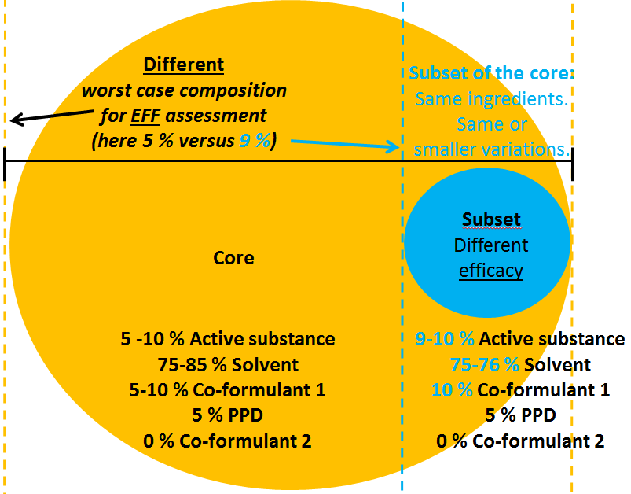
Figure 7: Visualisation of core and subset.
There is only one use against target organism 1 (regarding the uses and an overview of the composition ranges see Table 8 below).
After having identified the relevant worst-case composition for the core, every use in the core (here use 1 only) is assessed: No unacceptable risks are found. There is one consistent set of RMMs across the composition range (see section 4 of point 3.3.4), and efficacy against target organism 1 was proven with 5% active substance (the worst-case concentration regarding efficacy.
Nevertheless, there is a second use. The parameters (application method, rate etc.) of this use are the same as for use 1 apart from the target organism. Target organism 2 is more demanding. An effective treatment is only possible with products containing 9-10 % of active substance. The efficacy cannot be supported over the whole composition range of the core, therefore use 2 (i.e. target organism 2) cannot be included into the core because for the core the efficacy was proven with 5 % active substance only.
However, this second use can be presented as a subset to the core because the potential products against target organism 2 include the same ingredients with the same or less variation as that of the core composition (see figure 7 above or blue columns in Table 8 below). In this case the core composition also represents the overall Level 1 family composition range.

Ingredients | Classification | Core  composition |  | Subset (Different efficacy)
 |  | Min (%) | Max (%) | Min (%) | Max (%)
Active Substance | XYZ | 5 | 10 | 9 | 10
Solvent | SoC ENV | 75 | 85 | 75 | 76
Co-formulant 1 | SoC HH | 5 | 10 | 10 | 10
PPD | - | 5 | 5 | 5 | 5
Uses |  | 1: Against Target org. 1 |  | -
 |  | - |  | 2: Against more demanding target org. 2
Table 8: example of a subset refinement covering a different level of efficacy
This subset makes only one refinement to the core composition necessary (i.e. evaluation of a dataset to show that the products with 9 % active substance are effective against target organism 2 or not), as all the other areas (human health, environment and phys. chem/hazard) are covered already by the assessment of the core.
However, if the subset is considered as necessary in order to support para. 77 of Annex VI of the BPR then it would not be included as part of the refinements described in section 9 of point 3.2.4 for which an upper limit of three is normally applied (i.e. the three refinements described in section 9 can be used on other subsets or extensions within the family).

Example regarding extension
While the second use (target organism 2) from Table 8 can be presented as a subset, there is another use for some products similar to that of the BPF dossier prepared so far. Some of the parameters of this additional use are the same (e.g. product type, target organism, application rate and type as well as packaging) as for use 1 evaluated within the core, but the field of use is different. The conditions for this additional field of use are more demanding (e.g. outdoor instead of indoor use) and in order to be effective under these harsher conditions, co-formulant 2 needs to be added which is a substance of concern for human health. At the same time the perfumes are removed (now overall only 2.5 % PPD instead of 5% in core and subset). The products belonging to the additional use (e.g. outdoor instead of indoor use) cannot be presented as a subset to the core because they include co-formulant 2 which is not part of the core formulation, and while they still include “PPD” this is only present at 2.5% which is outside of the specified variations of the core.
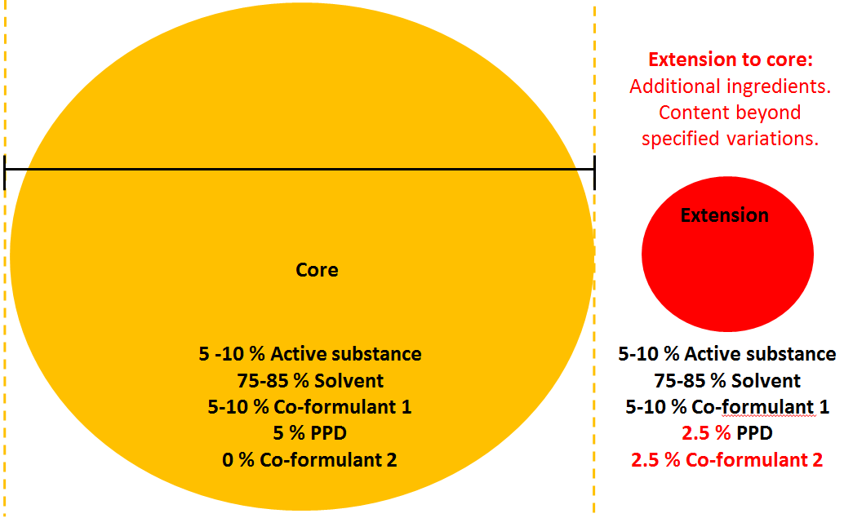
Figure 8: Visualisation of core and extension.
However, the products belonging to additional use (e.g. outdoor instead of indoor use) can be added to the BPF as an extension as the formulation range required is outside of the core composition (see section 7 above of point 3.2.4).
In this case the overall Level 1 family will be made up of a combination of both the core and extension compositions.

Ingredients | Classification | Level 1 |  | Core  Composition |  | Extension
 |  | Min (%) | Max (%) | Min (%) | Max (%) | Min (%) | Max (%)
Active Substance | XYZ | 5 | 10 | 5 | 10 | 5 | 10
Solvent | SoC ENV | 75 | 85 | 75 | 85 | 75 | 85
Co-formulant 1 | SoC HH | 5 | 10 | 5 | 10 | 5 | 10
PPD | - | 2.5 | 5 | 5 | 5 | 2.5 | 2.5
Co-formulant 2 | SoC HH | 0 | 2.5 | 0 | 0 | 2.5 | 2.5
Uses |  | - |  | 1: Against Target org. 1 |  | -
 |  |  |  | - |  | 2: Against target org. 1 but under more demanding conditions
Table 9: example of an extension of the core because of the introduction of a SoC
This extension requires three refinements to the original core assessment (using the outdoor use scenario, resulting in evaluation of a dataset/reasoned case for the targets outdoors plus an extension to the human health and environmental risk assessment).
For this example it is assumed that other areas (phys chem/hazard) are covered already by the original assessment of the core. As such, a full re-assessment of all parameters of the core is not required for this additional outdoor use and it therefore meets the criteria for similar risk and efficacy (as specified in section 8 of point 3.2.4). Three refinements to the core composition are the maximum allowed in order to define similar levels of risk and efficacy (see section 10 of point 3.2.4).
However, when this extension refinement example is applied in combination with the efficacy subset addition from section 5 of point 3.2.4 , the number of refinements to the original core composition now totals 4 (1 for the subset plus 3 for the extension), which is outside the maximum that can be applied in accordance with section 10 of point 3.2.4. In such a case it needs to be decided which refinements to the core assessment should be managed as part of a separate family application.

Annex VII
Overview of the approach to group biocidal products in a biocidal product family

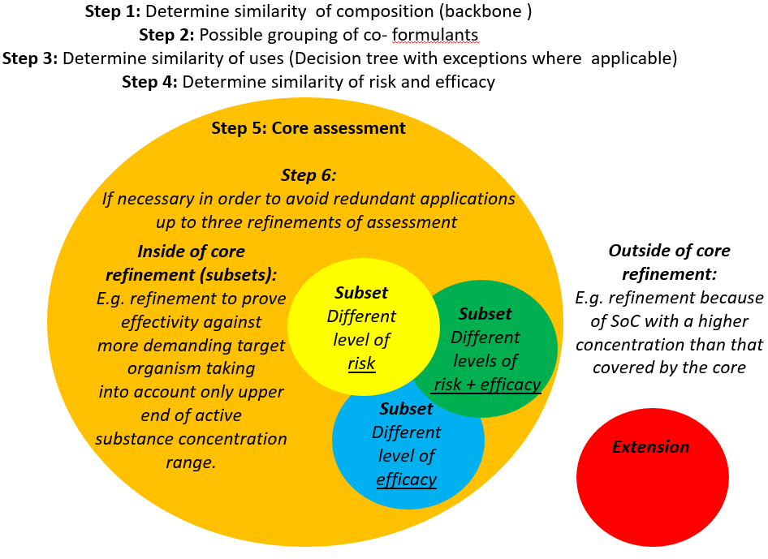

Annex VIII
Q&A on the implementation of the BPF concept

CA-Nov14-Doc.5.8
The document is available in the secured CIRCABC website of the Coordination Group
The backbone composition can be defined by either individual co-formulants, or group(s) of co-formulants with the same function, grouped together by applying the grouping concept (see section Grouping of co-formulants)
It should be noted that there are co-formulants that could be considered either as essential or non-essential on a case by case basis. For example, a complexing agent would be considered as essential if it is needed to ensure the integrity of the product. However, if the complexing agent would be included in the product in order to address a need for complexation derived from the use of the product, the complexing agent would not be considered as essential to formulate
e.g. intended to be diluted for in use concentration, see Annex II, example #2
e.g. solid products as powders or tablets containing only certain co-formulants, see Annex II, example #3.
The matrix tool will be available at: https://webgate.ec.europa.eu/s-circabc/w/browse/89efe476-1017-46af-8a31-6ad845f79d04
It is up to the evaluating CA/refMS to decide whether the core includes a significant proportion of the BPF. In any case applications which would be largely redundant should be avoided.
However, the meta-SPCs should not be used to structure the risk assessment, but only to improve the readability of the SPC. Fulfilling the requirements of Article 17(6) (one unique set of information per meta-SPC) provides clarity about the overall BPF-structure. In fact, the meta-SPCs are the result of the assessment and not the starting point.
E.g. powder, granules, tablets of same composition are all diluted to the same in use concentration.
The use of the concentrate includes only an additional mixing and loading step before application. Therefore, in cases where the concentrate and RTU products are in the same BPF, it would be acceptable to consider an additional core composition consisting of the concentrate for the mixing and loading stage (see Annex VI example 1 for an illustration of this case).
E.g. human health (HH), environment (ENV), efficacy (EFF).
Regarding concentrates, two concentrations have to be taken into account. Concerning mixing and loading (dilution step): the concentrate. Concerning the in use formulation (dilution): the RTU concentration.
For each use it should be checked whether it is already covered by a use previously assessed. The applicant is strongly encouraged to structure and present the uses applied for in an appropriate way in order to minimise the overall workload.
E.g. in use concentration(s), application rate, frequency of application, user category, field of use, application method
In this case the applicant has two options: Either the use applied (one box in the SPC) is split into uses (e.g. with different application rates) or the use is presented in a subset.
E.g. target organisms, contact times, clean/dirty conditions, in use concentration(s), application rate.
E.g. powder, granules, tablets of same composition are all diluted to the same in use concentration.
The use of the concentrate includes only an additional mixing and loading step before application. Therefore, in cases where the concentrate and RTU products are in the same BPF, it would be acceptable to consider an additional core composition consisting of the concentrate for the mixing and loading stage (see Annex VI example 1 for an illustration of this case).
E.g. for different target organisms, development stages or label claims (e.g. nest kill, shorter contact time).
E.g. for different user categories (e.g. non-professional user) or fields of use (e.g. outdoor use).
In principle, each subset can include as many meta-SPCs as the core but generally not more.
Subsets triggering a complete re assessment of all parameters from the core are not acceptable. Only re assessments with a limited number of parameters changed are acceptable.
A refinement allows refining the risk assessment by taking into account more realistic values (here e.g. an active substance concentration of only 5-10 % for products for non-professional users instead of 5-20 % for the core which includes the products for the professional user.
To be identified for the subset in accordance with section 1
This could be an important tool in supporting para. 77 of Article VI of the BPR
A refinement allows to refine the efficacy assessment by taking into account more realistic values (here e.g. an active substance concentration of 15-20% for products against an additional target organism instead of 5-20 % for the core which includes the products against three other target organisms.
E.g. where the worst-case core formulation of the core does not represent all highest component concentrations, nor contain all components of the formulation.
Refinements of: 1. Human/animal health risk assessment; 2. Environmental risk assessment; 3. Efficacy assessment
Any potential product of the additional meta SPC and every use has to fulfil the similarity criteria.
It is therefore not necessary for all products within the BPF to be placed on the market at the time of authorization
This means that the AH will have to accept the set of RMMs covering all the authorized uses for that meta-SPC. This does not mean though that all the authorized uses have to be presented on the product label (i.e. partial label-SPC correspondence) as agreed in document CA-May14-Doc.5.6 – Final.
The draft shall only contain the specific product composition in terms of active substance(s) and non-active substance(s) knowledge of which is essential for the proper use of the product. The submission of the draft is without prejudice to the formal notification in which AH shall indicate the exact product composition, trade name(s) and the suffix to the authorisation number.
i.e. AS(s), PT(s), intended use(s), user category/ies, the number of meta-SPCs foreseen and the number of products in the BPF
e.g. list of foreseen cMSs in case of MR procedures, number of existing products covered by the BPF, etc.
Available at https://echa.europa.eu/support/dossier-submission-tools/r4bp/supporting-documents
The matrix reflects the application of the agreed criteria to the currently identified patterns of use: Therefore applicants and MSs are expected to follow the outcome of the current matrix. Where a use pattern is not found in the matrix, then the criteria should be applied on a case by case basis.
Not all use patterns are specified, therefore a use pattern “other” has been included where necessary to address other uses within a given PT.
In exceptional cases MS can accept more than two red uses.
The necessary level of detail and the generally acceptable line of argument should be discussed in detail in the relevant Expert Working Groups.

