**Legal Notice**

This document contains information on how to fulfil obligations under the Transport of Dangerous Goods (TDG) legislation.

This document has been agreed by FEA on proposal from the FEA Transport Working Group.

However, users are reminded that the texts of the ADR (road), ICAO TI (air), IMDG Code (sea), RID (rail) and ADN (inland waterways) are the only authentic legal references and that the information in this document does not constitute legal advice.

This document does not cover local legislation outside the EU.

FEA does not accept any liability with regard to the contents of this document.

Reproduction is authorised provided that the source is acknowledged and the legal notice is reminded.

**Contents**

1. General Introduction 2

2. Acronyms 3

3. The General Framework (UN Model Regulations) 3

3.1. Scope and total exemptions 3

3.2. Definitions 4

3.3. Training 4

3.4. Safety Obligations 4

3.5. Security 5

3.6. Classification 5

3.7. Dangerous Goods List 6

3.8. Special Provisions 7

3.9. Exemptions 7

3.10. Packing 7

3.11. Consignment procedures 10

3.12. Construction and testing 11

3.13. Transport operations 11

4. Transport by Road/Rail according to ADR/RID 13

4.1. Introduction 13

4.2. Legal texts 13

4.3. Aerosol Specification 14

4.4. Obligations of ADR Participants 14

4.5. Accident Provisions 15

4.6. Normal regime 15

4.7. Small loads 16

4.8. Limited Quantity regime 16

4.9. Mixed Packing 17

4.10. Pallet Loads (Overpacks) 17

4.11. Full Load 17

4.12. Transport Operations and the Marking of Vehicles 18

4.13. Multimodal transport 19

4.14. Tunnels 19

5. Transport by Air 21

5.1. Introduction 21

5.2. Legal texts 21

5.3. Normal regime 21

5.4. Limited Quantity regime 22

5.5. Consumer Commodities regime 22

5.6. Marking and Labelling 23

5.7. Documentation 24

5.8. Passengers’ luggage 25

6. Transport by Sea 26

6.1. Introduction 26

6.2. Legal text 26

6.3. Normal regime 26

6.4. Limited Quantity regime 26

6.5. Documentation 27

6.6. Mixed Packing 28

6.7. Transport Operations and Marking of Transport Units 28

6.8. Stowage and Segregation 29

6.9. Emergency Response at Sea 29

7. Transport by Post 31

8. Waste Aerosols 32

8.1. Introduction 32

8.2. Limited Quantity Provisions 32

8.3. Using P207 and LP02 for Waste Aerosols 32

8.4. Use of IBCs 33

8.5. Severely Damaged Aerosols 33

8.6. Consignment Procedures 33

8.7. Transport operations 33

8.8. Sea Variations 33

8.9. Air 34

9. National derogations 35

10. Commercial restrictions and special events 36

11. Safety Data Sheets (SDS) 37

12. Frequently Asked Questions 38

12.1. Legal Texts 38

12.2. Exemptions 39

12.3. Classification 39

12.4. Packaging 40

12.5. Labels, marks and placards 40

12.6. Limited Quantities 41

12.7. Aerosol Containers 43

12.8. Security 43

12.9. Shipment by Road 43

12.10. Shipment by Air 44

12.11. Shipment by Post 44

13. Appendix 1: Limited Quantity regime across modes – Summary table 45

14. Appendix 2: Package sizes and requirements – Summary 47

# General Introduction

For its transport, any aerosol dispenser falls under the transport of dangerous goods regulations.

Except as otherwise provided in the regulations, no person may offer or accept dangerous goods for transport unless those goods are properly classified, packaged, marked, labelled, placarded, described and certified on a transport document, and otherwise in a condition for transport as required by the regulations.

# Acronyms

ADD: Aerosol Dispensers Directive 75/324/EEC

ADR: European Agreement Concerning the International Carriage of Dangerous Goods by Road

CLP Regulation: Regulation (EC) No 1272/2008 on the classification, labelling and packaging of substances and mixtures

GHS: Globally Harmonized System of Classification and Labelling of Chemicals

ICAO technical instructions: technical instructions published by the International Civil Aviation Organization

IMDG Code: International Maritime Dangerous Goods Code

RID: Regulation concerning the International Carriage of Dangerous goods by Rail

UN: United Nations

# The General Framework (UN Model Regulations)

## Scope and total exemptions

The United Nations *Recommendations on the Transport of Dangerous Goods - The Model Regulations* (usually known as the Orange Book) - set out principles by which dangerous goods may be safely conveyed.

Whilst these recommendations have no force in law themselves, the UN bodies charged with deciding the requirements for the various modes of transport use them as the basis for their respective regulatory codes and follow their structure. However, there are differences in the way in which the UN Recommendations are interpreted and implemented by these agencies.

The modal regulations have been aligned to the UN Recommendations, significantly reducing the number of variations.

This Guide covers the UN Model Regulations rev.20 (2017), which can be freely accessed at:

<http://www.unece.org/trans/danger/publi/unrec/rev20/20files_e.html>

The UN Model Regulations does not apply to the transport of dangerous goods, packaged for retail sale, that are carried by individuals for their own use.

Specific modal provisions for the transport of dangerous goods as well as derogations from these general requirements can be found in the modal regulations.

The UN Model Regulations set down five basic principles:

Classify the substance or article

Identify

Package

Mark and label

Documentation

## Definitions

Aerosols for transport are defined as:

*Aerosols or aerosol dispenser means an article consisting of a non-refillable receptacle meeting the requirements of 6.2.4, made of metal, glass or plastics and containing a gas, compressed, liquefied or dissolved under pressure, with or without a liquid, paste or powder, and fitted with a release device allowing the contents to be ejected as solid or liquid particles in suspension in a gas, as a foam, paste or powder or in a liquid state or in a gaseous state.*

## Training

All persons, whose duties concern the transport of dangerous goods, must be trained in the requirements governing the transport of such goods appropriate to their responsibilities and duties.

Employees must be trained before assuming responsibilities, and such training will be in the areas of general awareness, function specific training, and safety and security training. Employees must only perform functions for which required training has not yet been provided under the direct supervision of a trained person.

Records of all training received (including refresher training) must be kept by the employer and made available to the employee or the authorities upon request.

Records, including those for security training, must be retained by the employer for a period of one year after the employee has left the company.

A copy of training records must be provided to employees.

Training records must be verified upon commencing new employment.

For aerosols these general training provisions apply to limited quantities.

Training is mandatory for all modes of transport.

For air transport, training must be given by a qualified, approved instructor and an official examination has to be passed. The training certificate is then valid for maximum two years and has to be refreshed.

## Safety Obligations

All participants must ensure that they take all necessary actions to reduce the risk of an incident involving dangerous goods.

In general, a participant must:

* Ensure that a person employed by him or her, whose duties concern the transport of dangerous goods, has received the appropriate training;
* Keep records of such training;
* Comply with specified legal duties;
* Take appropriate measures to avoid damage or injury;
* Notify emergency services of an immediate risk to public safety.

## Security

All persons engaged in the transport of aerosols must consider security requirements for the transport of aerosols commensurate with their responsibilities.

Consignors must only offer aerosols to carriers that have been appropriately identified.

Training must include elements of security awareness, including addressing the nature of security risks, recognising security risks, methods to address and reduce such risks and actions to be taken in the event of a security breach. It must also include awareness of security plans (if appropriate) commensurate with the responsibilities and duties of individuals and their part in implementing those plans.

Deliveries of flammable propellants and highly flammable liquids in tank trucks lead to the obligation to implement proper security plans. However the transport of filled aerosols are not subject to the security provisions for high consequence dangerous goods.

## Classification

The UN Recommendations divide dangerous goods into nine hazard classes.

These are as follows:

Class 1 Explosives

Class 2 Gases:

2.1 Flammable gases

2.2 Non-flammable, non-toxic gases

2.3 Toxic gases

Class 3 Flammable liquids

Class 4 Other Flammables:

4.1 Flammable solids

4.2 Substances liable to spontaneous combustion

4.3 Substances which, in contact with water, emit flammable gases

Class 5

5.1 Oxidizing substances

5.2 Organic peroxides

Class 6

6.1 Toxic substances

6.2 Infectious substances

Class 7 Radioactive material

Class 8 Corrosives

Class 9 Miscellaneous dangerous goods and articles

The classification system provides a system for identifying the primary hazard and also subsidiary hazard(s).

Aerosols are always classified as Class 2 (Gases).

Aerosols are assigned only to divisions 2.1 (flammable) and 2.2 (non-flammable, non-toxic) within class 2 according to the primary hazard they present during transport.

As toxic gases are not allowed to be used as propellants division 2.3 (toxic) does not apply.

The transport classification of an aerosol adopts the same criteria than the UN GHS.

Within EU, the UN GHS is implemented through the CLP Regulation. The ADD sets out in full the tests required to classify aerosols that align with CLP.

* An aerosol is classified as 'flammable’ (2.1) where the contents include 85% or more by mass flammable components and the chemical heat of combustion is 30 kJ/g or more.
* It is non-flammable (2.2) if it contains 1% or less by mass of flammable components and the heat of combustion is less than 20 kJ/g.
* Otherwise testing is required to classify the aerosol, using the tests set out in the UN Manual of Tests and Criteria, Part III, Section 31 (which is also incorporated into Annex 6.3 of the ADD).

For transport, there is no distinction between flammable and extremely flammable aerosols. However aerosols may have a subsidiary classification dependent on the nature of the contents.

The UN allocates a unique number and name (the Proper Shipping Name) to each substance or article to aid identification. E.g. **UN1950 Aerosols**.

Although the classes define the dangerous goods they do not indicate the relative hazard compared to other dangerous goods in the same class (or between classes). For example, is a tin of gloss paint to decorate the home (usually a flammable liquid) as dangerous as petrol? It is probably obvious that it is not, yet both substances are classified as Class 3, or is fuming nitric acid more dangerous than hypochlorite solution (bleach), both are corrosive?

The UN therefore devised a system of degrees of danger that indicated the level of hazard presented - Packing Groups (PG) of which there are three levels:

Packing Group I: great danger

Packing Group II: medium danger

Packing Group III: minor danger.

The means of defining which packing group a substance falls into is based on the classification criteria. In turn this lead to different types of packaging.

*Note: packaging groups are not used for classification purposes in all classes.*

However, Packing Groups are not allocated to articles. Because aerosols are articles and in Class 2, they are not allocated to a Packing Group.

However, when an article needs to be in an approved packaging the UN states that the box must meet a certain packing group performance level (mainly packing group II performance level).

## Dangerous Goods List

The Dangerous Goods List contained in each dangerous goods regulation lists most commonly carried goods. Aerosols are Included in the List and must be transported in accordance with the provisions in the List.

## Special Provisions

Having identified the name “aerosols” then the number can be found in the dangerous goods list. In Column 6 of the list are Special Provisions. These generally influence the classification, packaging and labelling of the substance or article. For aerosols five are shown:

SP 63 defines classification of an individual aerosol

SP 190 requires protection against discharge and specifies the minimum size of regulated aerosols

SP 277 limits aerosols as limited quantities to 120ml if they are toxic and 1 litre for the rest.

SP 327 deals with the transport of waste aerosols

SP 344 requires aerosols to be tested in accordance with Chapter 6.2 of the Model Regulations i.e. the water bath or an approved alternative

SP 381 permits the use of large packagings meeting the packing group III performance level in accordance with packaging instruction LP02 of the 18th edition of the Model Regulations until 31/12/2022

## Exemptions

### Limited Quantity

These are relaxations from most of the UN rules provided certain conditions are met. The aerosol must not exceed 1000ml (if it has toxic contents the limit is 120ml) (see SP277). Aerosols must be packed in an outer packaging e.g. a box or placed in a shrink or stretch wrapped tray: the maximum gross mass of the pack is 30kg and 20kg respectively. It is expected that most manufacturers will wish to transport aerosols in limited quantities.

### Excepted quantity

The UN has adopted simplified provisions for very small quantities of dangerous goods (<30ml/g). The provisions do not apply to aerosols as there is already a provision to exempt non-toxic aerosols of less than 50ml (SP190).

## Packing

### Packing Instruction

For packaging▌, the following packing instruction applies:

* P207: Aerosols subject to the packing requirements set out in Packing Instruction P207 can be transported in packages of up to 400kg/450litres.

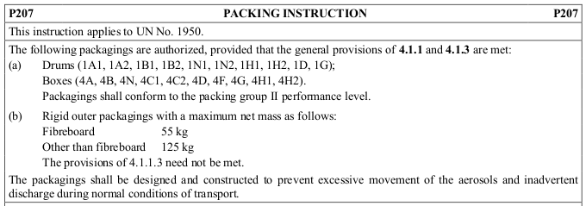

This change is intended to deal with growing trend for aerosols to be sold in display packages supplied directly from the aerosol filler (see Figure 2 and Annex A.4). These display packages will not meet the requirements of the limited quantities provisions in the various transport modes.



*Figure 2 an example of a retail display pack*

P207 is divided into two sections

Part (a) deals with packages that exceed 55/125kg, such packages will have to be UN tested in accordance with the provisions of ADR/RID/IMDG Code Chapter 6.1. Tests on the package are required and an approval given.

Part (b) deals with packages that do not contain more than 55kg (fibreboard) or 125kg (other than fibreboard).

If a company has a display box which contains a net mass of 54kg aerosols (the mass of the packaging material does not count) then Part (a) or Part (b) of P207 could be used. However a box with 60kg of aerosols will need to comply with Part (a).

In either case (part (a) or (b)) the full provisions of ADR including marking, labelling, documentation and training will apply (see Annex B.4).

* LP200: If a packaging exceeds 400kg/450 litres capacity then LP200 applies and these packagings require UN testing and must comply with all requirements of the Packing Instruction LP200.

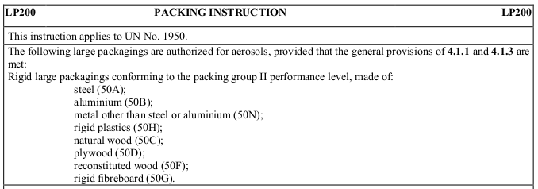

These may be suitable for large quantities of loose aerosols especially those being transported as waste.

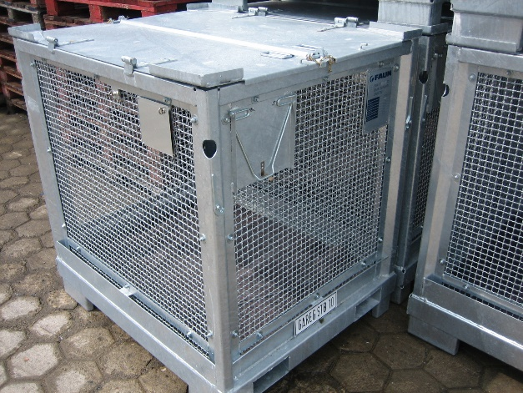

*Figure 2.1 Example of a Large Packaging for waste aerosols according to Special Provision 327 /LP200*

### Special Packing Instructions

For packagings, the following special packing instruction applies:

* PP87: If the quantity of aerosols to be moved is less than 400kg, then the provisions of P207 can be used. In addition Special Packing Provision PP87 applies to waste aerosols and requires that the package that is used shall have a means of retaining any liquid that may leak during the journey e.g. absorbent material.

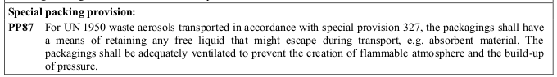

* L2: Where the quantity of aerosols to be moved exceeds 400kg then large packagings must be used and these have to be UN tested and approved. In addition Special Packing Provision L2 applies to waste aerosols and requires that the package that is used shall have a means of retaining any liquid that may leak during the journey e.g. absorbent material.

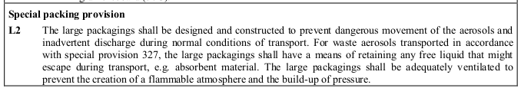

## Consignment procedures

### Marking and labelling

The UN Orange Book lays down broad guidelines for the marking and labelling of packages which are adopted, subject to certain variations, by the modal rules. Marking and labelling is primarily intended for the packagings but where overpacks are used and the marks and labels cannot be seen then they must be repeated on the outside along with the word “Overpack”

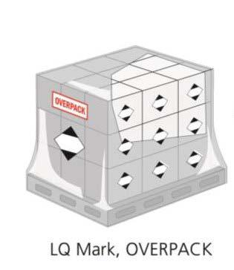

**Marks** consist of the application of the UN number and nameorthe LimitedQuantities (LQ) marking. For aerosols transported in limited quantities, the UN requires either of the following mark to be applied:

|  |  |
| --- | --- |
|  |  |
| (a) Road/Rail/Sea | (b) Air and Road/Rail/Sea (when in full compliance with the air limited quantity provisions) |

The diamond shaped mark must be 100mm x 100mm but when the package is small may be reduced to 50mm x 50mm. The line of the “diamond” shape must be at least 2mm thick.

The term mark also includes the orientation arrows required on some packages. As aerosols are articles which are leak-tight the use of orientation arrows is not needed. However they might be used to induce the way how to stack packages.

*Note: The UN number does NOT have to be displayed on limited quantity packages for Road/Rail/Sea. In Air Transport the UN number and the Proper Shipping Name has to be marked.*

**Labels** are the hazard diamond labels which are illustrated in Annex E to this Guide.Aerosols sent as limited quantities require in addition the limited quantity mark labels for air transport but not for the other modes.

Shipments in excess of limited quantities i.e. exceeding 20/30kg per package will require full marking and labelling e.g. UN1950 Aerosols + hazard diamond(s).

### Documentation

The UN Recommendations require the provision of a dangerous goods transport document and give broad guidelines as to the information that must be included. These broad principles are adopted and adapted, as appropriate, by the UN bodies responsible for the different modal rules. In the case of limited quantities for sea and air shipments the UN will require a dangerous goods note which will show the information as follows:

**“UN”+ UN number, Proper shipping name, classification, Limited Quantities**

For example:

**UN1950, Aerosols, 2.1, Limited Quantity**

There should be a description of the quantity of dangerous goods e.g.

1 x pallet of 1000 x 10kg shrink-wrapped trays

2 x 20kg fibreboard boxes

*Note: especially in sea transport the size of the cans is often requested by the operators. It is not mandatory but without this information the shipment will be rejected by the operator.*

## Construction and testing

Under the UN Model Regulations, the requirements for aerosol dispensers are specified under 6.2.4.

Each filled aerosol dispenser must be subjected to a test in a hot water bath or an approved water bath alternative.

Aerosols which need to be sterile but may be adversely affected by water bath testing are not subject to these requirements under specific conditions.

## Transport operations

Except specified in the UN Model Regulations, aerosols must not be offer for transport unless they have been properly classified, packed, marked, labelled and described and certified on a dangerous goods transport document and are in a fit condition for transport as required.

Except specified in the UN Model Regulations, a carrier must not accept aerosols for transport unless a copy of the dangerous goods transport document and other documents or information as required are provided; or the information applicable to aerosols is provided in electronic form.

The information applicable to aerosols must accompany the dangerous goods to final destination.

Packages containing aerosols must only be loaded in cargo transport units that are strong enough to withstand the shocks and loadings normally encountered during transport.

The interior and exterior of a cargo unit must be inspected prior to loading.

Aerosols transported for the purposes of reprocessing or disposal under special provisions SP 327 must only be transported in well-ventilated cargo transport unit other than closed freight containers.

# Transport by Road/Rail according to ADR/RID

## Introduction

The definition of aerosol is the same as that for UN Model Regulations.

Aerosols are classified as Class 2 (UN 1950) and assigned, according to the hazard of the contents, to one of the following Classification Codes:

|  |  |  |  |
| --- | --- | --- | --- |
| 5A | asphyxiant | 5T | toxic |
| 5C | corrosive | 5TF | toxic, flammable |
| 5CO | corrosive, oxidiser | 5TC | toxic, corrosive |
| 5O | oxidizing | 5TO | toxic, oxidizing |
| 5F | flammable | 5TFC | toxic, flammable, corrosive |
| 5FC | flammable, corrosive | 5TOC | toxic, oxidizing, corrosive |

For example, 5TF would be the entry in the dangerous goods list for an aerosol with toxic and flammable contents.

*Note:*

* *ADR does not formally recognise the divisions used in the UN system (2.1, 2.2 and 2.3) but divides gases into 7 groups above. However, it does not prohibit their use.*
* *In practice for aerosols these Classification Codes are of no relevance, except to define the Limited Quantity provision which applies. If the aerosol does not meet the Limited Quantity provisions then the Classification Code(s) define the label(s).*
* *SP 63 is incorporated into Chapter 2.2.2 (as 2.2.2.1.6) of ADR.*
* *SP 625 ‘packagings containing these articles shall be clearly marked as follows: UN1950 Aerosols’ is unique to ADR and requires the exact wording on the package but not for limited quantities. The phrase is language sensitive.*

## Legal texts

The European Agreement concerning the International Carriage of Dangerous Goods by Road (ADR) – 2017 Edition.

Relevant extracts are shown in Annex B of this guide. The full ADR 2017 text can be accessed free of charge at:

<http://www.unece.org/trans/danger/publi/adr/adr2017/17contentse0.html>

The equivalent railway rules are:

Convention concerning International Carriage by Rail (COTIF) Appendix C. Regulations Concerning the International Carriage of Dangerous Goods by Rail (RID) 2017. The full RID 2017 text can be accessed free of charge at:

<http://otif.org/en/?page_id=174>

The following notes are based on ADR. RID has the same provisions for aerosols.

The definition of aerosol is the same as that for UN (see 1.1 of this Guide) except that pyrophoric[[1]](#page18) propellants or contents are forbidden.

## Aerosol Specification

Requirements for the construction of aerosols are specified in ADR 6.2.6.1.

In summary:

The materials of which the receptacles and their closures are made must be compatible with the contents and must be sufficiently strong to prevent any loosening during carriage and to meet the normal conditions of carriage.

Aerosols containing only a gas or a mixture of gases must be made of metal. Other aerosols must be made of metal, synthetic material or glass. Metal aerosols with an outside diameter of 40 mm or more must have a concave bottom. Metal aerosols must not exceed 1000 ml capacity and synthetic material or glass aerosols must not exceed 500 ml capacity.

The release valves of aerosols and their dispersal devices must be leakproof when closed and be protected against accidental opening. Valves and dispersal devices that close only by the action of the internal pressure (e.g. so-called umbrella valves) are not permitted.

An aerosol must be filled so that at 50°C the liquid phase does not exceed 95% of its capacity. The capacity of an aerosol is the available volume in a closed dispenser fitted with the valve support, the valve and the dip tube.

The specifications for aerosols are deemed to be met if the aerosols comply with the Annex to the Council Directive 75/324/EEC as amended.

Before supply to the filler, each model of aerosol must satisfy a hydraulic pressure test carried out in conformity with ADR 6.2.6.2 (see Annex B.3 for extracts from ADR detailing these requirements. The internal pressure to be applied (test pressure) must be 1.5 times the internal pressure at 50°C, with a minimum pressure of 1MPa (10 bar).

All aerosols must satisfy a tightness (leakproofness) test in conformity with ADR 6.2.6.3.

## Obligations of ADR Participants

The law in relation to the transport of dangerous goods by road sets out duty holders/participants with responsibilities. The participants with specific legal duties are the consignor, carrier, driver and vehicle crew, packer, filler, loader, unloader, tank container/portable tank operator, consignee and the DGSA. The specific responsibilities of each participant with legal duties are outlined in subsections 3.2 to 3.10 and in Section 4.

Section 1.4 of ADR sets out the obligations of the participants to ADR. The chapter includes definitions of:

* Consignor (aerosol manufacturers or traders) who is responsible for classification, ensuring the correct packagings are used and they are marked and labelled in accordance with ADR.
* Packers and loaders are defined and are generally responsible to the consignor.
* Carriers must ensure the goods are authorised for carriage and that the vehicle is suitable and not overloaded. The carrier must ensure any markings are applied when necessary.

For example, an aerosol filler is manufacturer of the aerosol products. This means that when the dangerous goods are handed over for transport to a customer, the aerosol filler is the “consignor”. If they also employ a driver and use a company lorry, then they are also a “carrier” and the employee is the “driver”. These participant responsibilities may equally be carried out by different companies (e.g. the aerosol filler hands product to a courier, who then takes on the responsibility of “carrier”).

If any duty holder acts on behalf of a third party, a clear contract of carriage, outlining all transfers of duties under the legislation, should be agreed and signed by all parties involved.

## Accident Provisions

Chapter 1.8 of ADR requires that certain accidents or incidents taking place during an ADR journey (loading, carriage or unloading) which involve more than 333kg of aerosols and result in:

* Intensive medical treatment,
* A stay in hospital of at least one day,
* Inability to work for 3 days

or

* Material or environmental damage where the estimated amount exceeds 50,000 Euros.

must be reported to the Competent Authority in the country where the accident/incident occurs within one month.

## Normal regime

The provisions for packaging set out in the UN Model Regulations apply to consignments by ADR including the general conditions of packing of ADR 4.1.1.1, 4.1.1.2, 4.1.1.3 and 4.1.1.4 to 4.1.1.8.

If the aerosol package does not meet the limited quantity provisions then for packages <450l/400kg the requirements of packing instruction P207 must be applied.

Large packagings (>450l/400kg) are permitted under ADR for aerosols subject to the conditions in LP200.

Aerosols not consigned as limited quantities under ADR must be described on the transport document (dangerous goods note) as shown in Section 1.6 of this guide. However for ADR there is an additional requirement

**UN 1950, Aerosols, 2.1, (E)**

The (E) is the Tunnel Restriction Code and is required to be shown on the document. Only in cases where it is foreseeable that a vehicle will not travel through a tunnel the code could be left out.

As most consignors will not know the exact journey for their goods it is recommended that this data is always provided. The tunnel code is assigned based on the classification of the aerosols and relevant codes can be found in column 15 of the ADR dangerous goods list (see Annex B). All tunnels in the ADR countries should be classified by the Competent Authority and details for some can be found on the UN web site:

<http://www.unece.org/trans/danger/publi/adr/country-info_e.html>

*Note: The codes do not apply to rail shipments (RID) – the Channel Tunnel is a rail tunnel and has separate regulations.*

Where the aerosols are to be sent on a sea journey then a container/vehicle packing certificate must be prepared and sent with the goods as well as the transport document.

ADR requires that when carrying loads above the limited quantity thresholds the driver of the vehicle must be in possession of written emergency instructions concerning the goods being carried. The “Instructions in Writing” document takes the form of a card with standard emergency instructions in a language the driver understands and it is now the responsibility of the carrier to supply the document. These are available on the UN website in several languages and must be used in the format supplied.

*Note: the Instructions in Writing have been updated for 2017 and it is therefore necessary to check the versions on the UN website:*[*http://www.unece.org/trans/danger/publi/adr/adr_linguistic_e.html*](http://www.unece.org/trans/danger/publi/adr/adr_linguistic_e.html)

Where a consignment of goods is sent through the Channel tunnel by wagon load or on a trailer Eurotunnel require (for all consignments including limited quantities) the classification code from Column 3(b) of ADR. This is because there are limits imposed by Eurotunnel for certain categories of aerosol.

## Small loads

Exemptions related to quantities carried per transport unit [i.e. motor vehicle] are provided in the ADR.

The following provisions does not apply:

* Chapter 1.10 Security provisions
* Chapter 3.5 Placarding and marking
* Section 5.4.3 Instructions in writing
* Chapter 7.2 Provisions concerning carriage in packages

when below a maximum quantity (gross mass) per transport unit which depends of the aerosol classification:

* aerosols: groups C, CO, FC, T, TF, TC, TO, TFC and TOC : 20 kg
* aerosols: group F: 333 kg
* aerosols: groups A and O: 1000 kg

## Limited Quantity regime

Column 7(a) of the ADR Dangerous Goods list (se Annex B.1) indicates the appropriate maximum limited quantity provision – for most aerosols this is 1L.

*Note:*

* *Aerosols less than 50ml capacity are exempt from ADR.*
* *Gases contained in foodstuffs are exempt from ADR, but aerosols containing foodstuffs (e.g. whipped cream) are fully regulated (1.1.3.2(f) of ADR)*
* *For shipments in Limited Quantities Aerosols containing toxic substances or mixtures are limited to 120ml; the rest are 1000ml for metal aerosols and 500ml for glass and synthetic material (see 6.2.6 of ADR in Annex B.3).*
* *Aerosols shipped as Limited Quantities must be packed in accordance with Un Model Regulations provisions*

For limited quantities the package shall be clearly and durably marked with the mark illustrated.



Fig. 1 RID/ADR Journey

The package is not required to be marked UN1950 Aerosols for road/rail journeys when shipping as limited quantities, but applying the mark is not prohibited.

Where the aerosols are not transported in limited quantities the full marking and labelling regulations apply to the packages.

Packages containing aerosols that are not exempt e.g. toxic aerosols in excess of 120ml must bear labels (hazard diamonds) as indicated in column 5 of the ADR dangerous goods list.

No documentation is required for limited quantity shipments under ADR. However there is a requirement that the amount (gross mass) of limited quantity goods given to the carrier is provided in a traceable form. This does not mean a document; it could be a text message or email. No information other than the gross mass need be provided.

**Instructions in writing are not required for dangerous goods transported in limited quantities.**

## Mixed Packing

The general provisions from the UN Model Regulations apply to mixed packing of limited quantities; however if the shipment is not in this category then more prescriptive requirements exist. These are shown by MP codes in column 9(b) of the ADR dangerous goods list.

## Pallet Loads (Overpacks)

ADR has a different definition from the other modes of transport. Instead of applying only to a single consignor, it can also apply to carriers and forwarders to enable them to make-up pallets loads. It should be emphasised that this change has not been adopted by the air or sea modes, so cannot be used for these transport modes or multi-modal journeys. In general this change is aimed at forwarders and consolidators and so will not affect aerosol manufacturers.

## Full Load

Where aerosols are consigned as a ‘full load’ they may also be packed by stacking and suitably securing on pallets (see Annex A.4 (RR6)). The system described in this provision is not shrinkwrapped/stretchwrapped trays but loose aerosols on layer sheets or shrinkwrapped aerosols without trays. This facility is possibly useful for taking the cans from a filling point to a warehouse. However if they are subsequently shipped on having been removed from the pallet then they will need repacking either in accordance with limited quantities provisions or P207.

A “full load” is defined as:

“Any load originating from one consignor for which the use of a vehicle or of a large container is exclusively reserved and all operations for the loading and unloading of which are carried out with the instructions of the consignor or of the consignee.”

## Transport Operations and the Marking of Vehicles

ADR sets out conditions that must be taken into account by a carrier when moving dangerous goods in limited quantities, irrespective of the quantity. Most of the conditions are of a general nature:

* Suitable transport equipment: ADR permits the use of closed, open or sheeted vehicles or containers
* Compliance with regulatory provisions concerning the safety, security and cleanliness of all equipment at the loading and unloading points. Packages shall be loaded safely and secured by suitable means.
* Where loaded with other heavier items of goods e.g. machinery then suitable arrangements to ensure there is no damage shall be made e.g. by securing the respective loads and filling any voids
* Vehicles must be cleaned after unloading if there has been a spillage
* Smoking is prohibited during loading, unloading and handling operations
* Aerosols must not be loaded on vehicles carrying explosives except UN0161 and UN0499 of Division 1.4

For most limited quantities no vehicle markings are required. However the consignor must inform the carrier of the total gross mass of a consignment (see 2.6 above).

Vehicles with a maximum mass in excess of 12 tonnes and carrying 8 tonnes or more of aerosols shall be marked. The term “maximum mass” has not been defined in ADR. The mark to be applied is the same as that for packaging, but in a larger size.



The sign must be 250mm x 250mm front and rear of motor vehicles and on all four sides of a container. When the transport unit is carrying fully regulated ADR goods the orange plates must be displayed and the limited quantity mark is not required.

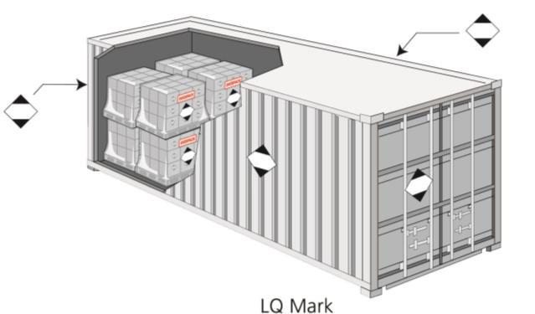

When a transport unit is marked then it shall not be permitted to travel through Category E tunnels.

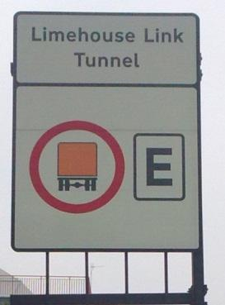

## Multimodal transport

Aerosol in limited quantities bearing the ICAO LQ mark (see below) and conforming with the provisions of the ICAO Technical Instructions for the Safe Transport of Dangerous Goods by Air, including all necessary marks and labels, shall be deemed to meet the provisions of the LQ regime by road/rail.

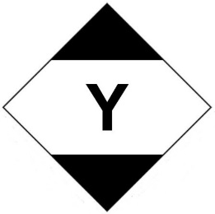

## Tunnels

Tunnels are categorised using the letters A to E. This categorisation is based on the assumption that there are three major dangers in tunnels: (i) explosions, (ii) release of toxic gas or volatile toxic liquid (iii) fires.

The tunnel category, assigned by the competent authority to a given road tunnel for the purpose of restricting the passage of transport units carrying dangerous goods, is indicated by means of road signs.

Eurotunnel (Channel Tunnel) is a railway tunnel and the ADR tunnel codes are not relevant. Eurotunnel has its own rules.

Aerosols packaged in accordance with the limited quantity restrictions set out in ADR are permitted through the Eurotunnel. The aerosol types and classification code must be supplied to the Tunnel authorities when planning to send shipments by this route.

Further information can be found at:

<http://www.eurotunnelfreight.com/uk/safety-and-security/dangerous-goods/>

At the time of writing aerosols not packed as limited quantities are limited to 1500kg per transport unit:

<http://www.eurotunnelfreight.com/uploadedFiles/xnt/ADR_2017_UK.pdf>

# Transport by Air

## Introduction

The definition of aerosol is the same as that for UN Model Regulations.

Aerosols can be classified in two ways for air transport either as UN1950 Aerosols Class 2 or ID8000 Consumer Commodity Class 9.

The following aerosols are forbidden for air transport:

Aerosols containing:

* substances of Division 6.1 in Packing Groups I or II (including tear gas devices);
* toxic gas and aerosols containing Class 8 substances in Packing Groups I or II

Aerosols, non-flammable (tear gas devices) and aerosols flammable (engine starting fluid) are, however, permitted on cargo aircraft only.

Detailed specifications for the materials and methods of construction and testing for aerosols (UN Packaging codes: IP.7, IP.7A, IP.7B, 7C) are provided. These lay down requirements relating to wall thickness, seams, pressure capabilities and maximum capacities for metal and plastic aerosols.

Large Packagings and IBCs are not permitted for air transport.

## Legal texts

ICAO Technical Instructions for the Safe Transport of Dangerous Goods by Air, 2017 - 2018 Edition, effective 1st January 2017.

IATA (International Air Transport Association) Dangerous Goods Regulations – 58th Edition, effective from 1 January 2017.

The provisions contained in the ICAO Technical Instructions (ICAO TIs) provide the worldwide basis for the regulation of the transport of dangerous goods by air. The ICAO TIs are the legal text but the world's airlines have not always found them acceptable and IATA produces its own version of the regulations which are more restrictive. In order to ensure acceptance of an air cargo consignment by an airline member of IATA, it is necessary to comply with any different or additional requirements contained in the IATA Dangerous Goods Regulations (IATA DGRs).

Where such variations exist these are indicated in the following notes together with the relevant IATA DGRs section/paragraph reference. Otherwise no reference is made to the IATA DGRs. Annex D includes several extracts from ICAO and IATA.

## Normal regime

Although the general UN Model Regulations principles apply to shipments by air there are additional requirements and the packing instruction system is different.

Under normal regime, packing instruction 203 applies, or, in the case of aerosols containing heat sensitive pharmaceuticals, Packing Instruction 204, and would normally require UN tested packages. The majority of aerosols should however be able to use the limited quantity regime.

*Note: Aerosols that are shrink/stretch-wrapped on trays are not permitted in air transport for any shipments*

The maximum net quantity per package is 75kg for passenger aircraft and 150kg for cargo aircraft.

## Limited Quantity regime

Under Limited Quantity regime, packing instruction Y203 applies or, where they contain heat sensitive pharmaceuticals, Packing Instruction Y204.

Y203 indicates that limited quantities are permitted and must follow this packing instruction. The majority of aerosols should be able to use the “Y” packing instructions.

*Note: Aerosols that are shrink/stretch-wrapped on trays are not permitted in air transport for any shipments*

This relaxation applies to aerosols as follows:

* Metal aerosols up to 1000ml.
* Plastic aerosols:
  + with non-flammable non-toxic gas and contents up to 500ml
  + with flammable and/or toxic gas and contents up to 120ml.

The gross mass per package must not exceed 30 kg.

The package must be of the same standard as one that is UN tested and approved i.e. be able to pass a 1.2 metre drop test, but no approval is required.

In addition, there are certain airlines which will not accept 'limited quantity' consignments e.g. Gulf Air, Lufthansa. Prior confirmation of a carrier's acceptance of such consignments is therefore recommended. Airlines not accepting limited quantities consignment do accept aerosols shipped as consumer commodities.

## Consumer Commodities regime

There can be an exception to the general rules of classification that applies to a number of dangerous goods, including aerosols, certain drugs, medicines and personal care products for retail sale. These can be consigned under the 'Consumer Commodity' provisions where the classification is:

Class 9 Consumer Commodity ID8000

“Consumer commodities are materials that are packaged and distributed in a form intended or suitable for retail sale for purposes of personal care or household use. These include items administered or sold to patients by doctors or medical administrations.”

Only non-toxic aerosols and aerosol products containing non-toxic solutions ▌are allowed to be shipped under these provisions.

These Consumer Commodity provisions are particularly useful when sending goods to and from the USA by air.

Consumer commodities are now a sub set of limited quantities. Aerosols consigned as consumer commodities must be packed in accordance with Packing Instruction Y963.

In summary:

* Aerosols must contain non-toxic compressed or liquefied gas propellants
* Non-flammable metal aerosols are limited to 820ml capacity
* Flammable metal aerosols are limited to 500ml capacity
* Non-metal aerosols are limited to 120ml capacity

Each completed package as prepared for shipment must not exceed 30 kg gross mass.

The package must be of the same standard as one that is UN tested i.e. be capable of withstanding a 1.2 metre drop test, but no approval is required.

## Marking and Labelling

Packages must be marked with the UN number ('UN 1950') or the ID number (ID 8000) and the 'proper shipping name' (see 5.5.2 of this Guide) appropriate to the consignment.

### Marking

The proper shipping name is that which is shown in bold type in the List of Dangerous Goods in the IATA DGRs for the particular aerosols being consigned e.g. Aerosols, flammable (Annex D.1).

*Note: Unlike the other modes the air regulations require a more detailed description for aerosols*

The name and address of both the consignor and consignee must appear on the package.

Each package (except 'limited quantity’ or ‘consumer commodity’ consignments) must bear an appropriate UN packaging specification marking, indicating that the package is of an approved and tested design type.

Packages containing aerosols in 'limited quantities' and consumer commodities must be marked to indicate that this is the case with the following mark:



By applying the mark the consignor is making a “statement” that the package meets all the additional packaging requirements set down in the ICAO Technical Instructions. For most purposes aerosols manufactured in accordance with the Aerosol Directive and or the UN/ICAO provisions will meet the additional requirements.

Where an overpack is used it must be marked with the word “OVERPACK”.

Where the packages within cannot be seen then the proper shipping names,

UN numbers the mark illustrated above must appear (see 1.4 of this Guide).

### Labelling

Packages containing aerosols must be labelled with the appropriate hazard class label(s). (See Annex E).

For packages of flammable aerosols (Division 2.1): the red flammable gas diamond.

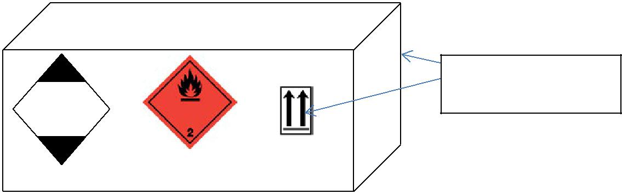

**UN1950 AEROSOLS Flammable**

**Y**

Two opposite sides

Consignor’s name and address

Consignee’s name and address

For packages of non-flammable aerosols: the green non-flammable gas diamond (Division 2.2) is used.

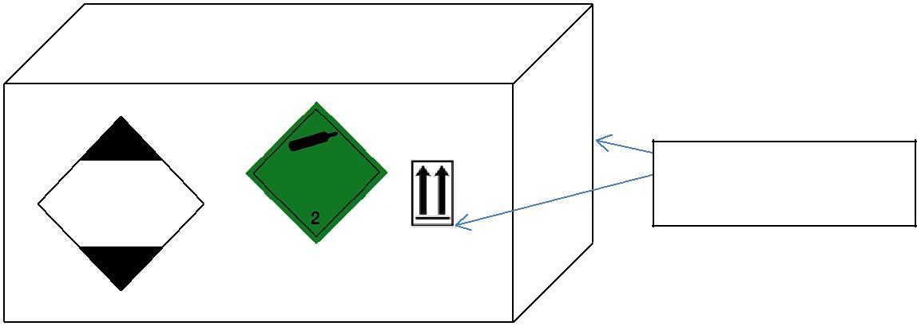

**UN1950 AEROSOLS**

**Y**

Consignor’s name and address

Consignee’s name and address

Two opposite sides

Where applicable, the appropriate subsidiary risk label(s) must also be applied to the package.

Where a package may only be transported on a cargo aircraft e.g. where the gross weight exceeds that permitted on a passenger aircraft, the 'Cargo aircraft only' handling label must also be affixed.

Package orientation ('This Way Up') handling labels ( black or red arrows) should be affixed to at least two opposite sides of the package, except where the package contains flammable liquids in receptacles with a capacity not exceeding 120 ml.

For Consumer Commodities the Class 9 (Miscellaneous) diamond label must appear on the package with the class number '9' in the bottom corner as well as the limited quantity mark and the marking “ID 8000 CONSUMER COMMODITY”.

## Documentation

Consignments of aerosols must be described on a dangerous goods transport document (shipper's declaration) and in order to be acceptable to an IATA member airline, the document must conform to the format and style specified in the IATA DGRs.

The description must include:

* the UN number, proper shipping name, class and division (in that order), subsidiary risk(s) (where appropriate), followed by a description of the number and type of packages and the relevant Packing Instruction
* the proper shipping name specified (as appropriate for the aerosols being consigned) in bold type in the List of Dangerous Goods in the IATA DGRs.

Example:

UN 1950, Aerosols, flammable, containing substances in Division 6.1 in packing group III, 2.1, (6.1), 1 Fibreboard Box x 25 kg, PI Y203

The words in the 'passenger aircraft or cargo aircraft' or 'cargo aircraft only' boxes of the form must be deleted as appropriate to indicate the manner in which the consignment has been packed.

For Consumer Commodities the description of the consignment on the shipper's dangerous goods declaration should be in the format of the following example:

ID 8000 Consumer Commodity, 9, 1 Fibreboard Box 10 kg, PI Y963

## Passengers’ luggage

On arrival at an airport a passenger has to comply with two sets of rules: firstly the security provisions which are not covered in this Guide but relate primarily to hand baggage, and secondly, the quantities of dangerous goods permitted. These second set of rules that the airlines impose, and which are briefly discussed below, are more generous than the security allowances.

Aerosols in the medicinal and toiletry categories e.g. hair sprays, perfumes, colognes and medicines containing alcohols, may be carried by passengers in checked or carry-on baggage.

Non -flammable (in Division 2.2) aerosols with no subsidiary risk for sporting or home use are also permitted, but only as checked baggage.

*Note: This is an ICAO provision and most IATA airlines will not accept such aerosols.*

The total net quantity of all articles classed as Dangerous Goods (including the aerosols) carried by each person must not exceed 2 kg or 2 litres and the net quantity of each aerosol must not exceed 0.5 kg or 0.5 litres.

The provisions above relate to the ICAO dangerous goods rules. However, security provisions introduced in 2006 take precedence over these. Currently restrictions are applied in most countries covering the size and quantity of aerosols and other liquids which may be placed in carry-on luggage. Security provisions do vary: the EU rules and USA rules are slightly different and so it is advisable to seek up to date local advice.

# Transport by Sea

## Introduction

The definitions of an aerosol is the same as that for UN Model Regulations.

Aerosols are classified as Class 2 (UN 1950).

*Note: The IMDG Code has adopted the provisions for the GHS classification of pollutants to the aquatic environment in line with the other modal regulations. If the aerosol contains a pollutant in accordance with the new classification rules or is a pollutant based on the old criteria it remains in class 2. However as aerosols are less than 5l in capacity there are no obligations to do this classification although it may be done to meet use regulations.*

## Legal text

The transport of dangerous goods by sea is globally regulated by the International Maritime Dangerous Goods (IMDG) Code. Amendment 38-16.

## Normal regime

Aerosols which do not fall under the limited quantity provisions must be packed in accordance with P207.

Large packagings are permitted under the IMDG Code for aerosols using LP02.

## Limited Quantity regime

Column 7(a) of the IMDG Code Dangerous Goods list indicates the appropriate limited quantity provision. This list refers to SP 277; this limits aerosols to 1000ml.

The aerosols must be packed in combination packaging not exceeding 30 kg gross mass or in shrink wrapped or stretch wrapped trays not exceeding 20 kg gross mass.

For limited quantities the package shall be clearly and durably marked with the mark illustrated (see 1.5 of this Guide)



Fig. 2 Sea Journey

The pack is not required to be marked UN1950 Aerosols for sea journeys, but applying this mark is not prohibited.

For ‘aerosols’ exceeding 1 litre (or toxic aerosols exceeding 120ml) the mark UN1950 and the word Aerosols must be applied to the pack. Labels will also be needed appropriate to the classification of the aerosols as specified in SP63.

The Marine Pollutant mark does not have to be applied to packages of aerosols.

## Documentation

Whenever aerosols are being offered for shipment by sea, two documents have to be available:

* a dangerous goods transport document and
* a container/vehicle packing certificate must be prepared. In practice this is a single document but possibly requiring two signatures, one for the dangerous goods declaration and the other for indicating the transport unit was fit for purpose, they may be different signatures.

Aerosols must be described on the transport document (dangerous goods note) in the way shown in 1.6.

*Note: For the IMDG Code the shipping details must include the class and division number for the aerosol i.e. 2.1, 2.2, or 2.3.*

For aerosols in limited quantities the same information is used but it should also include the words “limited quantity” or “Ltd Qty”.

e.g. UN1950, Aerosols, 2.1, Ltd Qty

Where the aerosol contains a marine pollutant the words “MARINE POLLUTANT” followed by the chemical name of the principal constituent.

The container/vehicle packing certificate serves a separate function to the dangerous goods transport document, and the two are very often signed by different people. The container vehicle packing certificate is the responsibility of the person who loads the transport unit (vehicle or freight container). Where a consignor loads the complete container then the duty lies with the consignor and his staff. Where shipments are LCL (less than container load) and individual consignors load groupage into a container the issue of signing the certificate is more complicated. The following offers some guidance:

Where a consolidator collects groupage and loads a container with the various goods the duty lies with the consolidator.

The declaration for the container packing certificate is acknowledging by the following

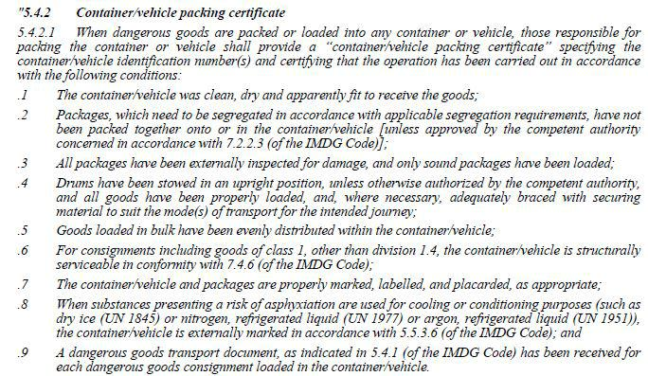

## Mixed Packing

Other dangerous goods may be packed with aerosols providing they do not react dangerously with one another if they leak. In addition to that the strict segregation requirements of the IMDG Code do apply. However aerosols up to 1000ml are segregated as if they are in class 9 (making them compatible in gift packs with flammable liquids).

## Transport Operations and Marking of Transport Units

### Packing Cargo Transport Units

There is an overall duty on the loader of a transport unit (this term includes road vehicles, rail wagons and freight containers) to ensure that they will be safe during sea voyages (ADR has similar but more general requirements). Part 7 of the IMDG Code (see Annex C) provides the general legal requirements but refers the reader to the IMO/ILO/UNECE “Guidelines on Packing Cargo Transport Units”, this is a large document but can be downloaded from the internet.

It is not possible to give detailed advice on this subject because shipments vary in size and methods of packing. Similarly cargo transport units vary.

Readers should take the text in Annex C as guidelines when packing for sea journeys.

### Marking Cargo Transport Units

The IMDG Code requires transport units carrying Limited Quantities to show the following mark (250mm x 250mm):



For a freight container or a semi-trailer one on each side and one on each end of the unit;



Where aerosols in limited quantities are carried with other dangerous goods that are not subject to the Limited Quantity Provisions, the transport unit must be placarded (large labels) with the hazards of those goods and the above mark is not required.

## Stowage and Segregation

This is the position where the goods are stowed on the ship. Limited Quantities are Stowage Category A, the most relaxed conditions. Aerosols as limited quantities are therefore able to travel on most ships.

The very strict segregation requirement of the IMDG Code do apply. It is important to know, that aerosols not exceeding 1000ml are segregated as if they are in class 9. Only aerosols above 1000ml have to be segregated according to their class (2.1 or 2.2).

## Emergency Response at Sea

The IMDG Code does not require Instructions in writing.

There is provision for emergency response in the Code. This is covered in three ways:

* Emergency Schedule (EmS) fire F-D
* Emergency Schedule (EmS) spillage S-U
* Medical First Aid Guide (MFAG)

None of this data is required to be supplied by the consignor. The ship will generate all the information they need from their copy of the IMDG code and the IMDG Code Supplement.

# Transport by Post

International post shipment of aerosol products is prohibited.

Shipment by post is only allowed in the UK.

Only UK and Germany have specific national regimes.

UK – Royal Mail (domestic post):

* **Restricted item**: Aerosols for personal grooming or medicinal purposes.
* **Detailed information**: Including deodorants, body sprays, hair sprays, shaving and hair removal creams, medicinal aerosols for prevention or cure such as flea sprays, etc.).

Valves must be protected by a cap or other suitable means to prevent inadvertent release of the contents during transport.

Aerosols must be tightly packed in strong outer packaging and must be secured or cushioned to prevent any damage.

Volume per item must not exceed 500ml. No more than two aerosols can be sent in any one package.

An ID8000 label must be applied – see [Example ID8000 Label](http://www.royalmail.com/business/sites/default/files/Example-ID8000-Label-December-2014.pdf).

The sender’s name and return address must be clearly visible on the outer packaging.

All other aerosols, including those containing spray paints, lacquers, solvents, air fresheners and oven cleaners are prohibited.

Please see [www.royalmail.com/business/prohibitedgoods](http://www.royalmail.com/business/help/sending/prohibited-goods).

Germany – DHL (domestic parcel shipping)[2]:

In *DHL Paket* shipments, only aerosols packed in limited quantities and permitted pursuant to ADR 3.4 may be shipped.

* For classification codes 5A[3], 5F[4], and 5O[5], aerosols with a maximum capacity of 1 litre and a maximum of 10 litres per package. Aerosol dispensers shall be provided with protection against inadvertent discharge.
* For classification codes 5C[6], 5CO, and 5FC, aerosols with a maximum capacity of 500 ml and a maximum of 2 litres per package, Aerosol dispensers shall be provided with protection against inadvertent discharge.
* For classification codes 5T[7], 5TC, 5TF, 5TFC, 5TO, and 5TOC, aerosols with a maximum capacity of 120 ml and maximum 500 ml per package. Aerosol dispensers shall be provided with protection against inadvertent discharge.

# Waste Aerosols

## Introduction

The management of the disposal of full or part -full waste aerosols is covered by national requirements.

In terms of transporting waste aerosols the UN dangerous goods transport regime does not distinguish between “new” or “waste” chemicals. Whatever the origins of an aerosol it is subject to the same rules. The only permitted concession is that the word “waste” can appear before the proper shipping name e.g. Waste Aerosols.

The UN recognised however, that large quantities of waste aerosols could present problems in transport, especially if caps are missing and adopted provisions in the form of Special Provision 327 and particular packing requirements for P207 and LP02.

## Limited Quantity Provisions

Waste aerosols can only be carried as limited quantities as set out in the earlier chapters if they are in full compliance with those provisions i.e. shrink-wrapped trays or boxes. The provisions in P207 and LP02 allow the bulk movement of aerosols as waste.

## Using P207 and LP02 for Waste Aerosols

The provisions in the regulations are intended to deal with movement of large quantities of waste aerosols. Special provision 327 applies to both packing instructions and requires that the aerosols can be moved without caps provided there is:

* protection against inadvertent discharge,
* protection against pressure build in the event the gas escapes e.g. there must be suitable vents on the packagings used (remember gas may accumulate at low level)
* the aerosols are not severely deformed and leaking badly.

### P207

If the quantity of aerosols to be moved is less than 400kg, then the provisions of P207 can be used.

In addition Special Packing Provision PP87 applies to waste aerosols and requires that the package that is used shall have a means of retaining any liquid that may leak during the journey e.g. absorbent material.

### LP02

Where the quantity of aerosols to be moved exceeds 400kg then large packagings must be used and these have to be UN tested and approved. In addition Special Packing Provision L2 applies to waste aerosols and requires that the package that is used shall have a means of retaining any liquid that may leak during the journey e.g. absorbent material.

## Use of IBCs

Intermediate bulk containers (IBCs) are not authorised in the regulations for the transport of articles such as aerosols.

## Severely Damaged Aerosols

Where one or more aerosol(s) are so badly damaged that there is a leakage of gas or contents, the item must be carried in accordance with the provisions for salvage packagings.

Salvage packagingsare specially tested packagings generally of about 300 L capacity and are unlikely to be readily available for small scale collections of damaged aerosols. However 4.1.1.18.2 of the Regulations does not prohibit the use of other packagings e.g. steel drums which had an appropriate venting requirement for waste aerosols.

## Consignment Procedures

Whether using P207 or LP02 packaging, waste aerosols are subject to the full requirements of the regulations (ADR and IMDG). This means transport documents must be prepared.

Depending of national requirements related to the management of waste, there might also be a requirement for a waste consignment note

For road journeys, Instructions in Writing are required for the driver. They must be supplied by the carrier.

## Transport operations

Drivers carrying waste aerosols will require driver training certificates in accordance with ADR.

Vehicles will require:

Fire extinguishers (number depends on the vehicle size)

Orange plates front and rear (if the load is below the thresholds – 333kg for flammable aerosols / 1000kg for non-flammable aerosols – these are not required)

Vehicles must be well ventilated when carrying waste aerosols (See Annex A.5)

## Sea Variations

All the provisions above apply to the carriage of waste aerosols by sea but the IMO has added a Special Provision 959 which limits carriage to short international voyages.

## Air

Air transport does not permit the shipment of waste aerosols.

# National derogations

The national regulations specify additional “national” exemptions for carriage of dangerous goods within the country only.

These national derogations are also laid down in Commission Implementing Decisions authorising Member States to adopt certain derogations pursuant to the inland TDG Directive 2008/68/EC, regularly published in the Official Journal of the European Union.

For a defined period of time, ADR also allows bilateral and multilateral agreements.

The complete list of Bilateral and Multilateral Agreements is available at:

<http://www.unece.org/trans/danger/multi/multi.html>

# Commercial restrictions and special events

The carriage of any goods whether dangerous or not is a commercial matter for a carrier. The dangerous goods rules are the governmental legal restrictions on the transport of aerosols. If a carrier does not want to carry, he is under no legal obligation to do so.

As all carriers (airlines, hauliers and shipping lines) are “private carriers” they are allowed to refuse to carry goods or they can add additional requirements.

Some carriers are indeed refusing to carry or are adding extra conditions. Provided such conditions do not conflict with the legal requirements this type of action is not illegal.

The airlines, through the IATA Dangerous Goods Regulations, list the main carrier restrictions in force. Some airlines will carry no dangerous goods at all whilst others will only carry aerosols as Consumer Commodities.

Recently some roll on/roll off (RO/RO) shipping lines have self-imposed limits on the quantities of flammable aerosols that they will permit on any ship. Unfortunately, there is no comprehensive list of shipping line restrictions.

Express parcel carriers (couriers) will usually only carry by prior arrangement because the type of distribution system they offer can include air shipment and if they choose to carry dangerous goods they have to ensure that there is compliance with the most restrictive regulations (air).

Arrangements for the carriage of aerosols have to be between the manufacturer and the carrier or his agent.

# Safety Data Sheets (SDS)

It is a general requirement around the world that most chemicals are supplied with a SDS. This is not a transport regulation. They are intended for the users of chemicals. One part of the requirements set down in the REACH Regulations is that such sheets incorporate a transport section to enable users to transport them safely if necessary.

It is advised to supply the following information:

|  |  |  |  |
| --- | --- | --- | --- |
|  | **Road** | **Sea** | **Air** |
| **UN number** | UN 1950 | UN 1950 | UN 1950 |
| **Class** | 2 | 2.1, 2.2▌ | 2.1, 2.2▌ (see also section 5) |
| **Proper Shipping Name** | Aerosols | Aerosols (see also section 6) | Aerosols |
| **Packing Group** | None | None | None |
| **Marine Pollutant** | N/A | Not required, article is below 5 litres (see also section 6) | N/A |
| **Other information** | This could indicate whether or not the aerosol falls into the Limited Quantity provisions | This could indicate whether or not the aerosol falls into the Limited Quantity provisions | 1. This could indicate whether or not the aerosol falls into the Limited Quantity provisions 2. Hazard labels required |

This table is to indicate the type of information that should be included in a SDS if for aerosols transported as normally limited quantities.

For sea transport; do not provide information on the Emergency Schedules (EmS) (the emergency information for ship’s crew) unless the ones shown in the Code against aerosols are incorrect. Similarly do not provide information on the Medical First Aid Guide (MFAG).

# Frequently Asked Questions

## Legal Texts

### How can I obtain the legal texts? Are they freely available?

ADR:

* ADR applies to transport by road, it is published in English, French and Russian by the UN (note Member States of the EU where the official language is not English French or Russian are funded to translate the provisions (applies to RID and ADN).
* ADR 2017 free .pdf online (English):

<http://www.unece.org/trans/danger/publi/adr/adr2017/17contentse0.html> (also available in French and Russian)

Paper (USD 175) or CD-Rom (USD 175) version can be obtained from [distributors of United Nations Publications](https://unp.un.org/distributors.aspx) or from the UN Publications Sales Office: <https://unp.un.org/>

RID:

* RID applies to transport by rail, it is published in English, French and German.
* RID 2017 free .pdf online (English):

<http://otif.org/en/?page_id=174>

* Printed French and English versions can be purchased:

<http://otif.org/en/?page_id=174>

IMDG Code:

* The IMDG Code apply to transport by air, they are published in English, French and Spanish.
* No free version is available.
* The IMDG Code (Latest edition 2016 – Amendment 38-16) can be bought in different formats: hard copy (GBP 125), CD-Rom (GBP 210) and other electronic formats, from the IMO Publications section (<http://www.imo.org/Publications/Pages/Home.aspx>).

ICAO Technical Instructions:

* ICAO Technical Instructions is published in English, French, Spanish, Russian and Chinese.
* No free version is available.
* Paper version of the ICAO Technical Instructions 2017/2018 edition (Doc 9284) (USD 210) may be purchased online from

<https://store.icao.int/technical-instructions-for-the-safe-transport-of-dangerous-goods-by-air-2017-2018-doc-9284-english-printed-13839.html>

* However, most of the world’s airlines have not always found the IACO TI acceptable and follow the more restrictive IATA DGR *(International Air Transport Association Dangerous Goods Regulations*) (USD 309) from

<http://www.iata.org/publications/Pages/index.aspx>

ADN:

* ADN applies to transport by inland waterways, it is published in English, French and Russian.
* ADN 2017 free .pdf online (English):
* <http://www.unece.org/trans/danger/publi/adn/adn2017/17files_e0.html>
* Paper version (USD 150) (see ADR).

### When new rules apply?

All modal Transport of Dangerous Goods legislation is revised every 2 years. They are all based on the UN Model Regulations (called “Orange Book”). For example the 2017/2018 regulations are based on the 19th edition of the Orange Book. However, because each mode implements is own version to reflect its own practices and concerns, there can be differences in wording, timing and transition periods.

Specific transition periods may apply to certain provisions.

ADR:

* There is a general 6-month transition period. Specific transitional requirements are found in Chapter 1.6.
* ADR 2017 entered into force on 1 January 2017.
* ADR 2015 may still be used until 30 June 2017.

RID:

* Like ADR.

IMDG Code:

* There is a 12-month transition period.
* The IMDG Code, 2014 Edition (Amendment 37-14) is currently in force from 1 January 2016 until end 2017.
* The IMDG Code, 2016 Edition (Amendment 38-16) will come into force on 1 January 2018 for two years and may be applied voluntarily as from 1 January 2017.

ICAO Technical Instructions:

* There is no transition period.
* ICAO Technical Instructions 2017/2018 edition (Doc 9284) entered into force on 1 January 2017. In practice the stricter IATA Dangerous Goods Regulations (58th edition 2017) are used for air transport.

ADN:

* Like ADR.

## Exemptions

### Are any aerosols exempted from TDG legislation?

All types of aerosols, including foodstuffs and carbonated beverages, are covered by the TDG legislation.

However aerosols with a capacity not exceeding 50 ml containing only non-toxic constituents are not subject to the TDG legislation (UN Model Regulations, Special Provisions 190). In air transport this exemption only applies to aerosols containing non-flammable gas and no other dangerous content (see SP A98).

## Classification

The regulations apply the UN number **UN 1950 Aerosols** to all aerosols.

### Which UN number should I use for a gas lighter refill?

The lighter refills are listed under UN 1057 (LIGHTER or LIGHTER REFILLL containing flammable gas). However, if the refill is in an aerosol container that fully complies with the construction and testing requirements of the transport regulations and/or the ADD (marked with the reversed epsilon) the alternative use of UN 1950 may also be used.

### What are the differences between UN 1950 and UN 2037?

UN 1950: AEROSOLS

UN 2037: RECEPTACLES, SMALL CONTAINING GAS (GAS CARTRIDGES) without a release device, non-refillable.

This is grey area; Austria was asked to resolve this 5 or 6 years ago but has yet to propose a solution.

*“Aerosol*” or “*aerosol dispenser*” means an article consisting of any non-refillable receptacle meeting the requirements of 6.2.6, made of metal, glass or plastics and containing a gas, compressed, liquefied or dissolved under pressure, with or without a liquid, paste or powder, and fitted with a release device allowing the contents to be ejected as solid or liquid particles in suspension in a gas, as a foam, paste or powder or in a liquid state or in a gaseous state.

“*Small receptacle containing gas (gas cartridge)*” means a non-refillable receptacle meeting the relevant requirements of 6.2.6 containing under pressure, a gas or a mixture of gases. It may be fitted with a valve.

(Source: chapter 1.2.1 ADR2017)

*Note: the definition of an aerosol dispenser in the TDG regulations differ from the Aerosol Dispensers Directive in that the latter does not mention the ejection ‘in a gaseous state’.*

Certain gas cartridges with a valve might be considered as aerosols. If it is the case all provisions related to aerosols must be followed, included those of the Aerosol Dispensers Directive.

## Packaging

### Do I have to pack aerosols (new ones and waste) so tight, that they can’t move within the packaging?

No. The 19th edition of the Orange Book clarifies that “non-excessive” or “non-dangerous” movements of the aerosols within the packaging are OK. This was incorporated into the 2017 modal regulations.

### How do I have to interpret “maximum net mass” in P207 b)?

The net mass of a single aerosol dispenser is the weight of the filled, fully assembled (e.g. with protection cap) aerosol dispenser. This means one may pack up to 55kg (fibreboard) or 125kg (other materials) of aerosol dispensers into the packaging.

*Note: The total gross weight of the packaging under P207 b) may be much higher due to the use of absorbent or cushioning material.*

### Is it allowed to use Large Packaging with a PG II type approval?

Yes. For aerosols LP200 specifies PGII type approval, however existing packaging meeting LP02 PGIII type approval may continue to be used until the 30th of June 2022.

## Labels, marks and placards

### What are the differences between labels, marks and placards?

Packages are marked and labelled.

A mark is not defined in the ADR, however the markings required for packages are primarily described under ADR 5.2.1.

Examples of marks:

* “**UN 1950 AEROSOLS**” (language sensitive according to Special Provision 625 RID/ADR/ADN);
* the environmentally hazardous substance mark ;

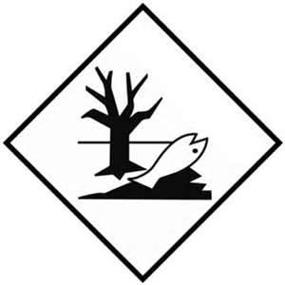

* the Limited Quantities (LQ) marks .

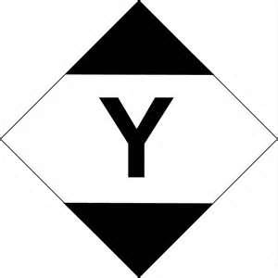

▌The labelling of packages is described under ADR 5.2.2.

For flammable aerosols, the label “2.1” described under ADR 5.2.2.2.2 must be affixed to the package.

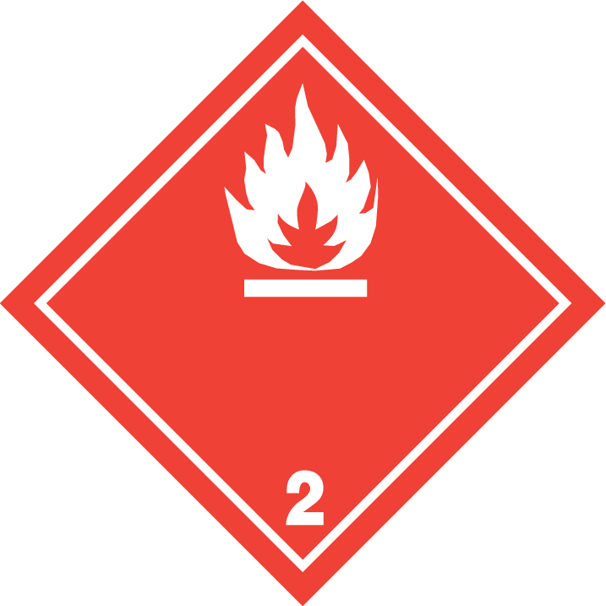

Vehicles, containers, tanks are placarded and marked.

A placard is defined in ADR 5.3.1.7and placarding is described under ADR 5.3.1.

A placard must correspond to the label required for the dangerous goods in question.

The orange-coloured plate marking of vehicles is described under ADR 5.3.2.

## Limited Quantities

### Do I need documentation for transport under the LQ regime?

Shipping papers (dangerous goods notes) are not required for road or rail transport in Limited Quantity. However it is a requirement that the consignor informs the carrier of the details of the consignment in a traceable form e.g. text message.

Shipping papers are required for air and sea transport in Limited Quantity.

### How do I properly label an outer packaging for shipment in LQ that contains several combined packaging (e.g. promotion/gift packs) including an aerosol, another dangerous good (e.g. a fine fragrance) and another non-dangerous good?

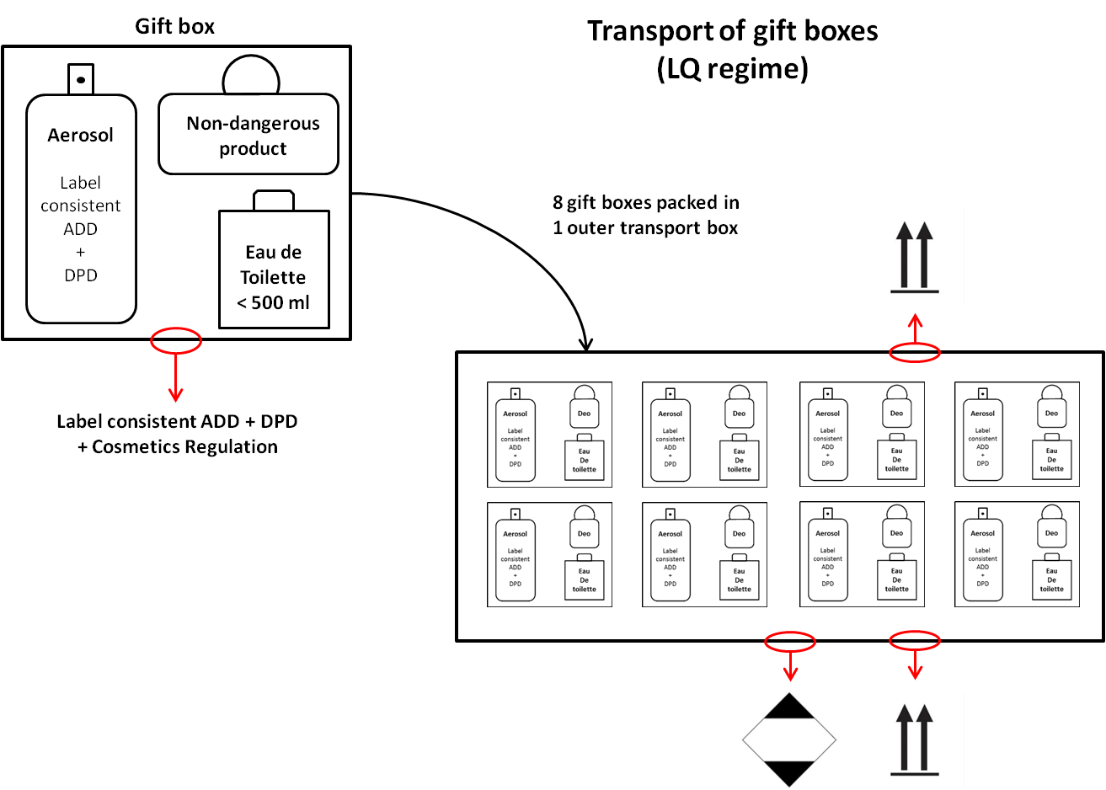

Reminder: In cases where a shipping document is required, the documentation needs to mention the class and the packaging quantities by type of products. Some products can be re-classified, packed, labelled, marked and documented for air transport as “ID8000 Consumer Commodity” with a single entry in the document.

### Do I have to put the "dead fish" symbol on the boxes in addition to the LQ symbol?

The environmentally hazardous substance mark is not required in addition of the LQ mark.



### Can LQ boxes with aerosols products inside be transported in a car?

If the car is a company business one then Chapter 3.4 applies.

In some cases the transport could be exempted by 1.1.3.1. c) ADR for example when a sales person transports samples for demonstration purposes.

It is recommended to notify the car insurance company that dangerous goods may be transported

### May the LQ mark be directly printed in black only on the boxes?

Yes, it is generally the case that when the fibreboard colour, which is then the LQ mark background, is contrasting enough, there is no need for an additional white background.

### Does an outer transport box used under the LQ regime need to be tested and type-approved (UN 4G/...)?

No. ADR 2017 3.4.1 d) makes no reference to 4.1.1.3 which means type approval is not required. However the use of a strong box of good quality is needed, which is in conformity with the Cobb Test (water absorption test).

## Aerosol Containers

### Do I need to take into account TDG container provisions if I follow the ADD provisions?

In the ADR the requirements of section 6.2.6 are deemed to be met if the aerosols comply with the Aerosol Dispensers Directive 75/324/EEC (as amended and applicable at the date of manufacture).

### How should I ship waste aerosols discarded from my production?

See ADR chapter 3.3, Special Provision 327 specifies packaging requirements for transporting waste aerosols (UN1950 Waste Aerosols).

## Security

### Aerosols are not high consequences dangerous goods. Do I have to apply security provisions?

Security provisions are laid down in ADR 1.10.

The general provisions (1.10.1) and the security training (1.10.2) apply.

## Shipment by Road

### Is there a list of all category E tunnels in Europe?

Tunnels are categorised using the letters A to E. For category E tunnels, there is a restriction for all dangerous goods transported under the LQ regime if quantities carried exceed 8 tonnes total gross mass carried on a single vehicle with a maximum mass exceeding 12 tonnes..

FEA is not aware of any complete list of tunnels but the UN website on dangerous goods does provide under country information tunnel codes where they have been notified:

<http://www.unece.org/trans/danger/publi/adr/country-info_e.html>

Eurotunnel has its own rules, but they are based on ADR. Packages containing aerosols packed in accordance with the LQ restrictions are permitted through the tunnel. The aerosol types and codes specified in ADR must be supplied to the Tunnel Authorities when planning to send shipment by this route.

For further advice see

[www.eurotunnelfreight.com/uk/safety-and-security/dangerous-goods](http://www.eurotunnelfreight.com/uk/safety-and-security/dangerous-goods)

## Shipment by Air

### Is the LQ label for air transport also permitted for road transport?

The LQ label for air transport is also permitted for road and sea transport.



The packaging must be in full compliance with the packing instruction of the air mode (“Y-Packing Instruction”) i.e. is in a fibreboard box not shrink-wrapped onto a tray.

## Shipment by Post

### Can I ship samples of aerosols to my professional/industrial customers by post?

International (cross-border) shipment of aerosols by post is prohibited.

However the shipment within some countries by post of certain types of aerosols is allowed under conditions, check National postal websites for up to date information.

### My company sells products directly to consumers (general public) by e-commerce. Can I send aerosols (alone or mixed with other products) by post?

International (cross-border) shipment of aerosols by post is prohibited.

However the shipment within some countries by post of certain types of aerosols is allowed under conditions, check National postal websites for up to date information.

# Appendix 1: Limited Quantity regime across modes – Summary table

|  |  |  |  |  |
| --- | --- | --- | --- | --- |
|  | **Road and Rail**  **(ADR and RID)** | **Sea**  **(IMDG Code)** | **Air**  **(ICAO TI or IATA DGR)** | |
| **Reference** | 3.4 | 3.4 | 3.4 (ICAO TI)  2.8 (IATA DGR) | Consumer Commodity |
| **Packing Instruction** | NA | NA | Y203 / Y204 | Y963 |
| **Training[8]** | Mandatory | | | |
| **Class** | 2 | 2[9] | 22 | 9 |
| **Classification Code** | NA for Limited Quantity loads | NA | NA | |
| **UN No** | UN19503 | UN1950[10] | UN1950 | ID8000 |
| **Proper shipping name** | Aerosols3 | Aerosols3 | Aerosols[11] | Consumer Commodity |
| **Capacity**  (per aerosol) | 1L | 1L | 1L | 500ml / 820ml[12] |
| **Packing**  (for Limited Quantities) | Combination package: 30 kg, or shrink/stretch-wrapped: 20 kg | Combination package: 30 kg, or shrink/stretch-wrapped: 20 kg | Combination package: 30 kg.  (Shrink/stretch-wrapped trays are FORBIDDEN) | |
| **Marking** |  |  | [13] | |
| 100 x 100mm7  Line thickness 2mm | 100 x 100mm[14]  Line thickness 2mm | 100 x 100mm7  Line thickness 2mm | |
| **Labelling**  (Hazard Diamond)  (Orientation arrows) | None  None | None  None | Required  Required | |
| **Overpack** | Permitted, repeat marks and labels if not visible on packages and add word OVERPACK | | | |
| **Documentation**  (Dangerous Goods Transport document) | None[15] | Required | Required | |
| **Transport Unit marks** | Mark above but 250 x 250mm[16] | Mark above but 250 x 250mm | None | |
| **Applicable** | 1 July 2014 | 01 January 2014 | 1 January 2013 | |

**TRANSPORT MARKS AND LABELS**

**Shrink/stretch wrapped trays – Not permitted for air transport**

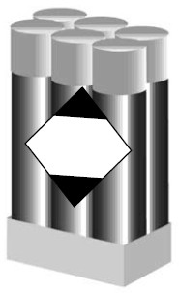

**Boxes – Road/Rail/Sea**

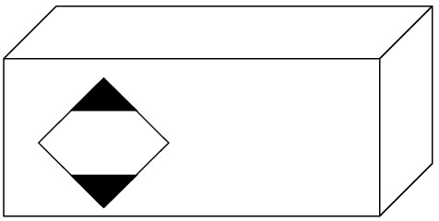

**Boxes – Air only – Aerosol Class 2.1 (Flammable)**

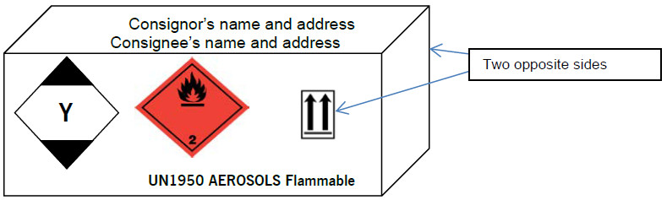

**Boxes – Air only – Aerosol Class 2.2 (Non-flammable)**

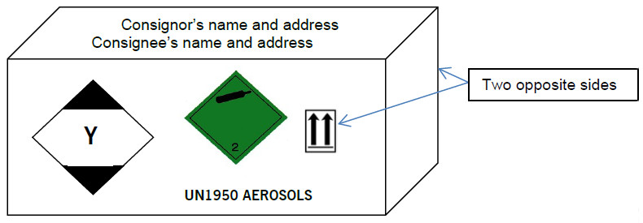

*Notes: 1) GHS Labelling may be different from the above*

*2) Orientation arrows are required on two opposite sides of packages*

# Appendix 2: Package sizes and requirements – Summary

The following table lists package sizes are available for transporting aerosols as dangerous goods under UN/RID/ADR/IMDG and the requirements placed on transport operations when using them are:

|  |  |  |  |  |
| --- | --- | --- | --- | --- |
| Package mass | 0 – 20/30kg1 Gross | 30kg – 55/125kg2 Net | 55/125 - ≤400kg Net | ≥400kg Net |
| Ref. | 3.4 | P207 (P207(b)) | P207(a) | LP02 |
| Type | Limited Quantity | Regulated | Regulated | Regulated |
| Mark | LQ mark | UN 1950 | UN 1950 | UN1950 x2 |
| Label(s) | No label | Label (flammable, non-flammable toxic as appropriate) | Label (flammable, non-flammable toxic as appropriate) | Label (flammable, non-flammable toxic as appropriate) x2 |
| Document | None | DGN3 (not UK road) | DGN3 (not UK road) | DGN3 (not UK road) |
| Instructions in writing including equipment | None | None if total load below 333kg | None if total load below 333kg | Required |
| Vehicle marking | None | None if total load below 333kg | None if total load below 333kg | Orange plates |
| Fire extinguisher | None | 1 x 2kg unit if load<333kg4 | 1 x 2kg unit if load<333kg4 | 2 units –size depends on vehicle size |
| Driver training | Awareness | Awareness if total load <333kg | Awareness if total load < 333kg | Full driver training |
| DGSA | None | None if total load <333kg | None if total load <333kg | Required |

1 20kg for shrink/stretch wrapped on trays, 30kg for boxes

2 55kg for fibreboard, 125kg for other than fibreboard

3 DGN = Dangerous Goods Note/Dangerous goods transport document

4 If above 333kg then two fire extinguishers, capacity is determined by vehicle size

1. A substance or preparation which, even in small quantities, ignites within 5 minutes of contact with air (usually Class 4.2).
2. More information available at: <http://www.dhl.de/content/dam/dhlde/downloads/pdf/dhl-infoblatt-gefahrgutregelungen-e-201507.pdf>
3. A: asphyxiant
4. F: flammable
5. O: oxidising
6. C: corrosive
7. T: toxic
8. Training for personnel involved in the shipment of aerosols must be commensurate with their duties (regular shipments by air require additional training)
9. The applicable division (2.1 or 2.2) must be declared on documents
10. Not required on the package
11. The word aerosols must be supplemented by the text in bold type in the air dangerous goods list
12. 500ml for flammable aerosols
13. UN/ID number plus proper shipping name must be shown on the package but not in the mark
14. The mark may be reduced for smaller packages to be not less than 50mm x 50mm
15. No documentation, BUT the consignor must provide the carrier with the total quantity being consigned in a traceable form
16. For road transport only required when vehicle exceeds 12 tonnes maximum mass and the load exceeds 8 tonnes