Health and environment classification of aerosol dispensers

Position paper

Executive summary

At the last CASG-ATP on 11-12 October 2017, it has been discussed with no conclusion to change the way aerosol dispensers are classified for decades in health and environmental hazard classes, in excluding arbitrarily the propellant when using the conservative calculation method. The issue was also raised at the last CARACAL meeting on 15-16 November 2017.

Obviously if the propellant is not included in the calculation method, the result is likely to be a stricter health or environment classification.
However FEA does not see any sound reason to exclude any substance from the CLP hazard-based scheme reason – apart the wish to make the calculation method even more conservative, or to include an incomplete risk assessment approach in the CLP. In aerosol formulations liquefied propellants act as co-solvent replacing other solvents that would otherwise be necessary for the product to function as required.

This would become a unique classification approach which will diverge from all other mixtures in the CLP, from the approach on physical hazard for aerosols, and which will also diverge from the UN GHS.

This proposal also ignores the complexity of the aerosol technologies.

[Following expressed concerns on CMRs, FEA is ready to further discuss the health classification of aerosol dispenser using CMRs. However these uses represent a very minor proportion of the aerosol market and should not justify to completely change the classification rules for all aerosol dispensers.]

In the meantime ECHA published the FAQ 1456 without supportive legal base in the CLP.
FEA separately requested to put it “on hold” pending the issue reaches a legal conclusion.

What is an aerosol dispenser?

Any non-refillable receptacles …
… made of metal, glass or plastics and …
… containing a gas compressed, liquefied or dissolved under pressure, …
… with or without a liquid, paste or powder, and ..
… fitted with a release device allowing the contents to be ejected …
… as solid or liquid particles in suspension in a gas, as a foam, paste or powder or in a liquid state or in a gaseous state

It means that a product with no propellant is not an aerosol dispenser.
It means that the propellant can be of different natures (liquefied, compressed or dissolved).
The released device plays an important role on the spray performance and is an intrinsic part of the aerosol dispenser.
Aerosol dispensers can be traditional (all substances in same compartment) or compartmented (different substances in different compartments).
It means that the way the product is expelled can be very different.

The propellant of the aerosol dispensers is a substance under CLP (CLP, Article 2, item 7).

Role of the aerosol propellant

The key roles of the propellant are:
- to provide the energy to expel the product from the container
- to be a co-solvent of the active ingredients
- to disperse the formulation by creating spray droplets, foams, mousses

How the product is expelled depends on different parameters:
- percentage of propellant
- solubility of ingredients in the propellant
- internal pressure

Solvent/propellant ratio

As stated above, the propellant can also play a role as co-solvent.
To avoid deceptive products, the quantity of propellant must be sufficient to expel the entire products.
In certain cases the percentage of propellant can be decreased, then the percentage of solvent needs to be increased, but playing with different proportions drive to different spray patterns (see embedded presentation).

Propellant evaporation

Liquefied propellants evaporate when expelling the product out of the container. This mechanism allows to disperse the formulation by creating the adequate spray droplets, foams or mousses for the best product performance.
In comparison solvents will also evaporate. The evaporation rate depend on the intrinsic solvent property.
Here again the propellant/solvent ratio will impact the spray pattern.

Comparison with other products

Please find below an exercise comparing a traditional aerosol using a liquefied propellant with
- an aerosol using a compressed gas propellant and
- a pump spray

 | Formulation with a liquefied propellant  (% w/w) | Formulation with a compressed gas propellant  (% w/w) | Formulation without propellant  i.e. pump spray  (% w/w)
Propellant | 50 | 2 | 0
Solvent(s) | 49 | 97 | 99
Active (classified) | 1 | 1 | 1
Total | 100 | 100 | 100

As reminder, liquefied propellants also act as co-solvents.
This is a theoretical exercise because the performance of the final products will not be the same in practice.

These products containing the same quantity of a classified ‘active’ are normally classified identically with the calculation method. Note: solvents could be classified too.

If the propellant would be excluded in the calculation method, the formulation using a liquefied propellant will be over-classified compared to an aerosol using a compressed gas propellant or a pump spray.
This would trigger an unfair competition among technologies.

Practical impact on labelling

Example of a foam cleaner for the general public containing:
- 5-15 % aliphatic hydrocarbons (including propellant)
- < 5% anionic surfactants, non-ionic surfactants

The first case includes the propellant for the classification and labelling when using the calculation method (classified Aerosol Cat.1)

 |  | With propellant
Pictogram(s) |  | 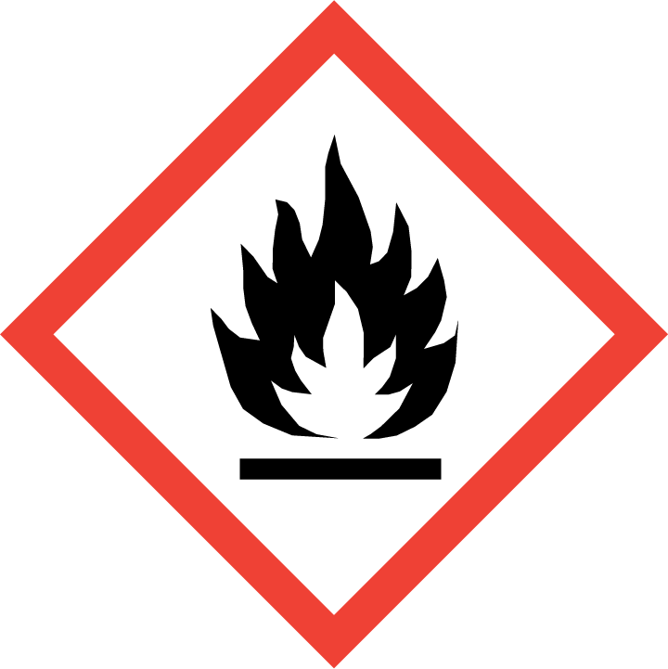
Signal word |  | Danger
Hazard statements (for physical hazards) | H222  H229 | Extremely flammable aerosol  Pressurised container: may burst if heated
Hazard statements (for health hazards) |  | --
Precautionary statements (for consumer products) | P102 | Keep out of reach of children.
Precautionary statements (for physical hazards) | P210  P211  P251  P410+P412 | Keep away from heat, hot surfaces, sparks, open flames and other ignition sources. No smoking.  Do not spray on an open flame or other ignition source.  Do not pierce or burn, even after use.  Protect from sunlight. Do not expose to temperatures exceeding 50°C/122°F.
Precautionary statements (for health hazards) |  | --

The second case shows the impact on classification and labelling if the propellant would be excluded when using the calculation method (classified Aerosol Cat.1, Skin Irrit. 2, Eye Irrit. 2)

 |  | Without counting the propellant for health hazards
Pictogram(s)
Signal word |  | Danger
Hazard statements (for physical hazards) | H222  H229 | Extremely flammable aerosol  Pressurised container: may burst if heated
Hazard statements (for health hazards) | H315  H319 | Causes skin irritation  Causes serious eye irritation
Precautionary statements (for consumer products) | P102 | Keep out of reach of children
Precautionary statements (for physical hazards) | P210  P211  P251  P410+P412 | Keep away from heat, hot surfaces, sparks, open flames and other ignition sources. No smoking.  Do not spray on an open flame or other ignition source.  Do not pierce or burn, even after use.  Protect from sunlight. Do not expose to temperatures exceeding 50°C/122°F.
Precautionary statements (for health hazards) | P264  P280  P302+P352  P305+P351+P338  P321  P332+P337+P313  P362+P364  P337+P313 | Wash contaminated skin thoroughly after handling.  Wear protective gloves/protective clothing/eye protection/face protection.  IF ON SKIN: Wash with plenty of water.  IF IN EYES: Rinse cautiously with water for several minutes. Remove contact lenses, if present and easy to do. Continue rinsing.  Specific treatment (see medical advice on this label).  If skin irritation occurs or eyes irritation persists: Get medical advice/attention.  Take off contaminated clothing and wash it before reuse.  If eye irritation persists: Get medical advice/attention.

Physical hazard

The classification criteria and test methods for the hazard class Aerosols are laid down under CLP Annex I, 2.3.

No substance are excluded. Tests are carried on the aerosol dispenser itself.

Introducing different approaches for physical, health and environmental hazards seems illogical and will be at least confusing.

Environment hazard

FEA does not understand neither the relevance nor the rationale in excluding arbitrarily the aerosol propellant when using the calculation method for environmental classification.

Bridging principles - CLP Annex I, 1.1.3.7

In the case of the classification of mixtures covered by sections 3.1, 3.2, 3.3, 3.4, 3.8 and 3.9, an aerosol form of a mixture shall be classified in the same hazard category as the non-aerosolised form of the mixture, provided that the added propellant does not affect the hazardous properties of the mixture upon spraying and scientific evidence is available demonstrating that the aerosolised form is not more hazardous than the non-aerosolised form.

CMRs classes were not included because classification of mixtures for CMRs should be based on data on substances only, not tested mixtures.

FEA commissioned law firm Mayer Brown which provided a legal opinion on how to apply 1.1.3.7. FEA also developed a user-friendly decision tree (see below). Both documents were provided to EC, ECHA and Member States involved in HelpNet CLP.

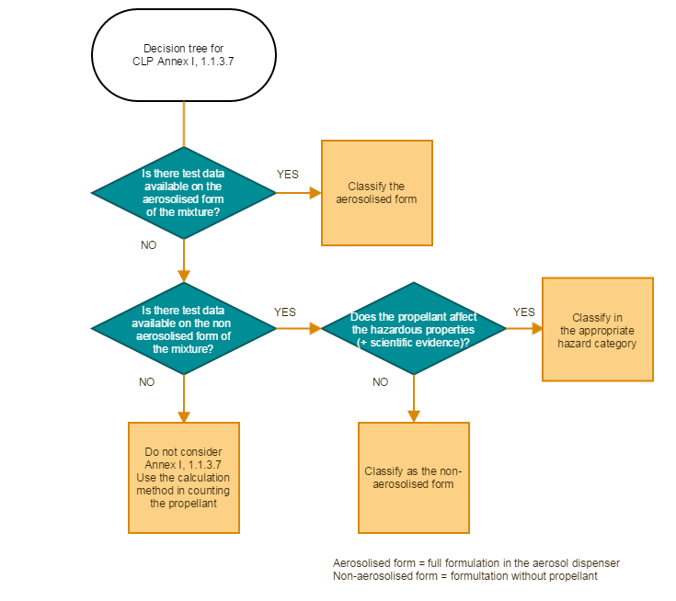

In the case of compartmented aerosols, where the propellant is outside the compartment i.e. is not expelled with the rest of the formulation, the propellant should not be counted when the calculation method is used for health and environment hazard classification.

Use of CMRs in aerosol dispensers

FEA understands the specific concerns related to CMRs.

Vast majority of aerosol products are consumers products in which CMRs are already strictly restricted to either the relevant specific concentration limit (CLP, Annex VI, Part 3) or, the relevant generic concentration limit (CLP, Annex I, Part 3), i.e. generally 0.1%.

From a quick consultation, FEA understands that CMRs, such as [substances], can be used in [product types].

[Following expressed concerns on CMRs, FEA is ready to further discuss the health classification of aerosol dispenser using CMRs. However these uses represent a very minor proportion of the aerosol market and should not justify to completely change the classification rules for all aerosol dispensers.]]

UN GHS

Excluding arbitrarily the propellant when using the conservative calculation method for health and environmental classification of aerosol dispensers would deviate from the UN GHS, and the normal practice globally.
This particular approach should first be discussed at UN SCE-GHS level, but would potentially create a precedence for the purely hazard-based UN GHS and CLP.

Contact: Alain D’haese, FEA Secretary General, alain.dhaese@aerosol.org

When deciding on the classification of aerosol mixtures concerning health and environmental effects, does the propellant have to be excluded?

